

The V-Pen
RoHS

Instruction Manual




Unlimiter

Please Note
This manual covers the operating instructions for the V-Pen. For instructions on the use of associated products, please consult the relevant product manual from Ability World.
The information contained in this manual is subject to change without notice. Ability World assumes no responsibility for errors or omissions, and makes no commitment to update the information contained herein.
No part of this document may be reproduced, transmitted, transcribed, or stored in a retrieval system in any form or by any means, mechanical, magnetic, electronic, optical, chemical or otherwise, without the written permission of Ability World.

Trademarks & Intellectual Properties
VoiceInk, VoiceSymbol, and Voice Design are copyright
Assistive Technology Engineering Lab Inc., Taiwan 2010
Uni-Symbols are the intellectual property of
Assistive Technology Engineering Lab Inc., Taiwan
Microsoft® is a registered trademark of Microsoft Corporation
Windows® is a registered trademark of Microsoft Corporation
All other brand and product names mentioned are trademarks or registered trademarks of their respective holders.

Warning
Non-compliance with the instructions as set out in this manual may result in system malfunctions.

Note
Illustrations in this manual may differ from your program.



RoHS
compliant
product

Warnings
- Avoid repeatedly dropping the U-Pen or subjecting it to strong impact. This can cause damage, malfunctions, electric leakage, etc. Always use the pen in conjunction with the lanyard supplied.
- Do not disassemble or tamper with the device hardware. Warranty will be voided if the pen has been disassembled.
- Do not place the pen for long periods in direct sunlight or other areas of high temperature.
- The V-Pen is not waterproof and therefore cannot be used in the shower, bath, swimming pool etc.
- Keep away from excessive moisture, dust, smoke and steam.
- Ensure that the batteries are installed in the correct direction.
- Do not use old or different batteries types at the same time. This can cause overheating, corrosion, and device malfunction.
- Ensure the battery cover is properly replaced after changing the batteries.
- Keep the Micro SD card away from children. It is a choking hazard.
- Do not put the Micro SD card, batteries, or any parts of this device into any parts of the body. In case of accidental swallowing of parts of the device, consult a doctor immediately.
- Do not wind the lanyard around the neck to avoid any possibility of choking.
- Keep devices with magnetic strips (such as credit cards) away from the speaker which can demagnetize the card strips and prevent them from functioning properly.

Unlimiter Ltd,
Level 5-1, No.18-1,
Section 3, Ren-Ai Rd.,
Taipei 106, Taiwan
Tel: +886 2 2704-7620 ext.20
Fax:+886 2 2703-5359
E-Mail:cl@unlimiter.com.tw

What is a V-Pen?
The V-Pen™ is a revolutionary new concept from Unlimiter Ltd. Unlimiter is a Taiwanese company based in Taipei the capital city. While the V-pen appears a very simple system, the technology that is involved in making it seem so simple is very advanced. For several years, a team of over 20 software engineers, together with input from a considerable number of other professionals; have worked to put together the technologies that enable the V-Pen to give a voice to paper and ink.

The V-Pen is a code reader. It is similar to the bar code reader that is used at the check out at the supermarket. However, the V-Pen ‘converts’ the codes into a spoken out. As such, the V-Pen is a new form of Speech Generating Device (SGD). The ‘codes’ are contained within the ink that is used to print the page. Not all printed materials have these codes ‘hidden’ within the ink, so it is no use picking up a Bible and trying to read Genesis with the V-Pen: that simply will not work! However, if Genesis were to be printed using the VoiceInk™ system then that is exactly what will happen!

VoiceInk is one of a range of patented programs that can be used to create your own printed materials for the pen to read. VoiceInk can import any document from a Microsoft office source (2003 and above only) and convert it to a form that can be printed with the codes hidden inside the printer’s ink. Any good quality colour or laser ink jet printer will work. You will find that laser printers are a little quicker to load the coded pages than ink jets, with the latter taking a couple of minutes for a larger document.

There are several software programs that are available from Ability World, Unlimiter’s UK representative. While you do not necessarily need to purchase any of these software programs (as the pen can work with a number of ready produced communication Boards and Books), without them, it will not be possible to create your own materials for the V-Pen to read.

As the V-Pen can ‘read’ text, photographs, drawings and symbols, there are a variety of programs from Ability World that can deal with one or more of these aspects. Each provides a different form of printed output:

VoiceInk

Voice Ink can take any Microsoft office document (2003 and beyond only) and convert it into a form that can printed to be read by the V-Pen. The document will not change its format, or look, or feel: it will just contain the necessary codes for it to be read when used with the V-Pen. Take any Word document, import it into VoiceInk (it is really easy to do) and print! It is that simple. If there are words that VoiceInk knows are not already stored in the V-Pen’s memory (over 45,000) it will automatically generate the necessary speech files and let you know that ‘synchronization’ is required. Don’t panic! This is simply a matter of connecting the V-Pen to the computer via the USB cable provided and letting VoiceInk do the rest. It’s similar to learning a completely new language by connecting your brain to a computer via a cable for a few seconds … suddenly you know all the new words! Likewise, the V-Pen knows all the new words from your document that it didn’t have stored in its memory before. If your document uses everyday English, it may not be necessary to synchronize at all.

With VoiceInk you can use Word to create any educational materials that you want to bring to life in the classroom: text can be read, pictures can speak, questions can be asked. This very manual could be imported into VoiceInk and printed so that it could be read by the V-Pen. However, the manual has not been printed using VoiceInk technology so the V-Pen will not work with it.

VoiceSymbol

VoiceSymbol™ is an easy way to create communication boards and books. Simply choose the size of overlay that is required, select and place symbols into the cells and print. Your No-Tech communication board instantly becomes a Uni-Tech (see below) SGD! When the pen is placed on the symbols, they speak out their vocabulary. If a number of symbols have been selected to create a sentence, then whole sentence can be read back as a single unit by selecting the SPEAK function (see below). As the cells are not simply limited to vocabulary, but can store any sound file, each location could play a favourite piece of music. Thus, the symbol overlay could become a jukebox!

VoiceDesign

VoiceDesign™ is the bigger brother of VoiceSymbol. It has a number of additional features for the creation of customized communication overlays, cards, story books and many other voice-enabled printed materials. However, this product is presently under development.

VoiceBoards
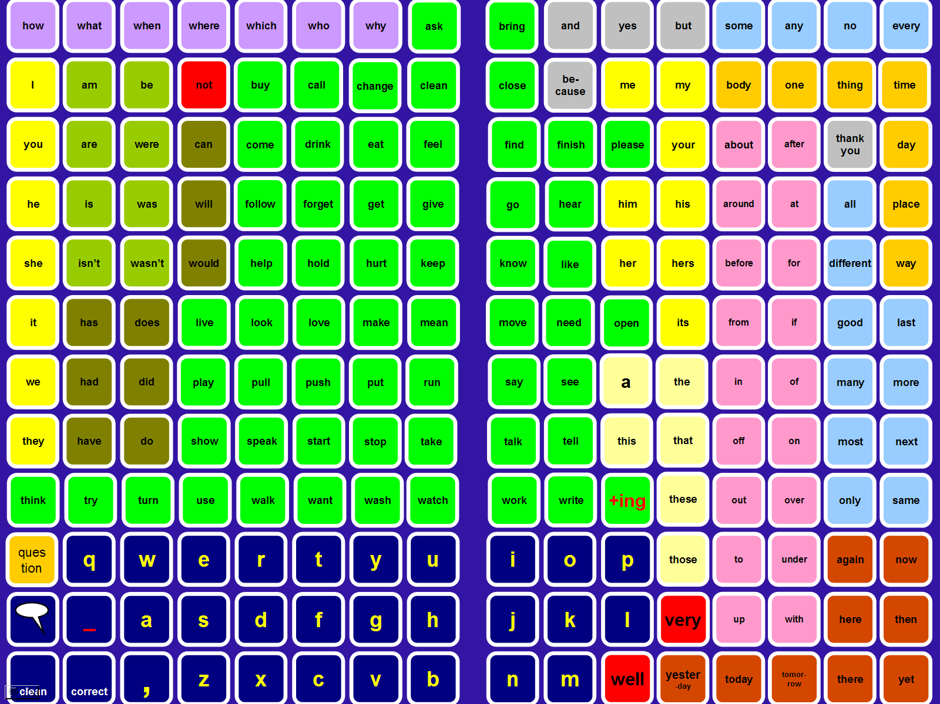
V-Boards are ready printed communication boards featuring either text or symbols. They come in a variety of sizes with a different number of locations providing access to different vocabulary sizes. There are presently 6 communication boards available: three texts boards and three symbol boards. Each of the V-Boards contains a range of frequently used vocabulary (CORE) that has been arranged by part of speech and colour coded (Fitzgerald key) for easy retrieval. The three sizes presently available are 96 location, 216 location 432 location. If it is considered that the V-Boards are not suitable for the particular needs of an individual or individuals then it is possible to create your own V-Boards or Books using the VoiceSymbol software (see above) purchased separately.

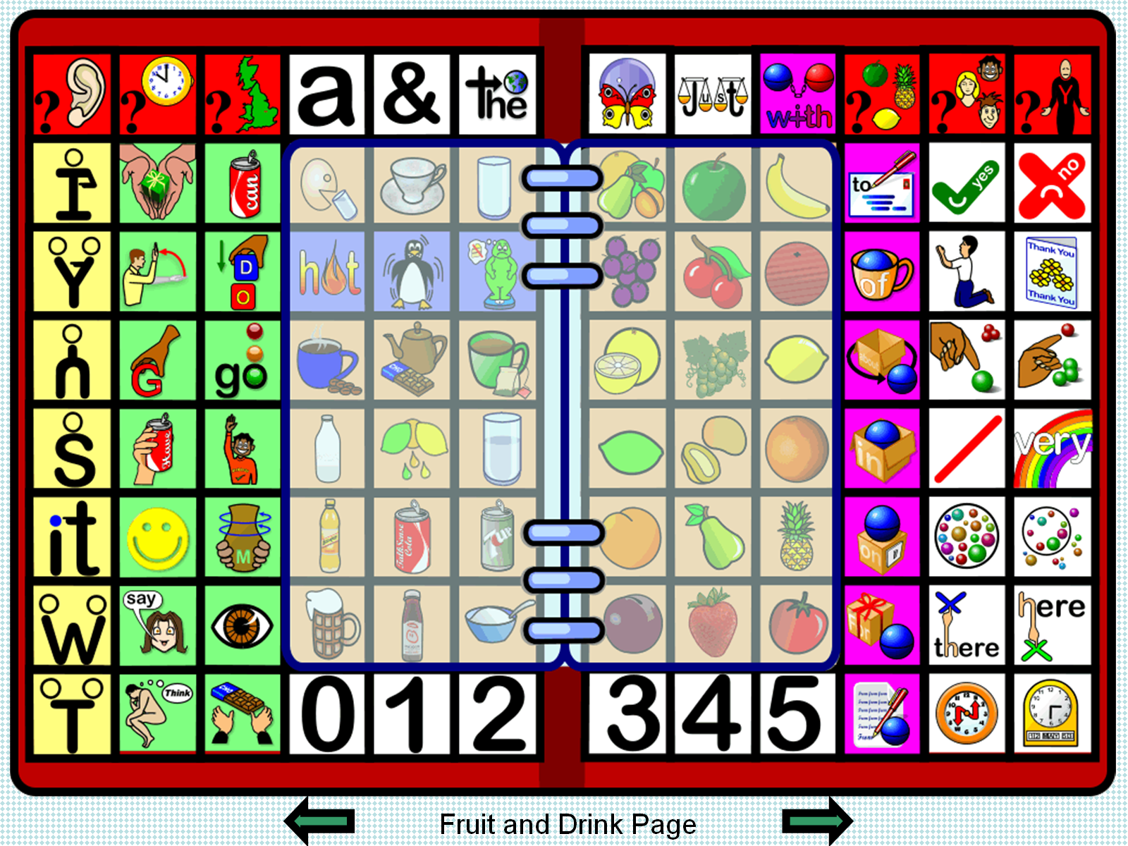
VoiceBooks

Presently V-Books are in development but will feature easily accessible Core Vocabulary as well as Fringe vocabulary in a unique design. Such systems will provide access to a larger range of vocabulary than is presently possible with V-Boards.

VoicePads

Voice Pads are small blank ‘tabs’ that will affix to any clean, smooth surface. The V-Pads may be stored with any vocabulary that has been created using the V-Pen in conjunction with any V-Board or V-Book; that is, they are reusable memory locations. Each V-Pen has memory allocations for up to 1,000 V-Pads (or similar).
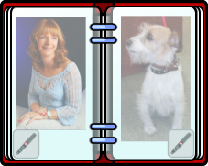

One use of V-Pads is to create a Voice Album. Simply purchase a standard photo album to house one or two (or more) photographs per page and then place the pads on the corners of each pages so that any picture can speak out an associated message.

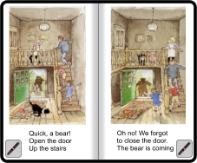

Another use is to attach the symbols to the separate pages of a child’s book such that touching the pads reads out the book out aloud.

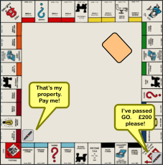

A further idea for the use of V-pads is to bring a board game alive. The V-Pads can be attached to appropriate positions on the board to make relevant comments as needed. As the pads can be re-recorded again and again, they can be quickly re-programmed, repositioned, and re-used in different ways as the game progresses.

VoiceCreate

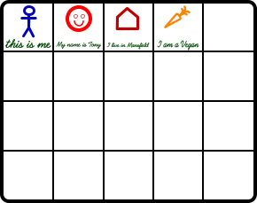Voice Create is an A4 wipe clean white board consisting of 20 locations on one side and 6 Voice Lines on the other. Draw your on symbols (or write some text) into a location and use the V-Pen to store any vocabulary there. Each time the location is accessed subsequently the message will be spoken out loud. At any point it is possible to change the stored message.

With coloured, wipe-clean, felt-tipped pens it will be possible to create an almost instant disposable augmentative communication system!

Please note that you may not use a BLACK felt-tipped pen as the black colour may confuse the V-Pen resulting in message mistakes.

Use it to do the shopping list, to order in a restaurant, to conduct a survey, or in any other creative way. Then, wipe it clean and create a new instant communication system!!
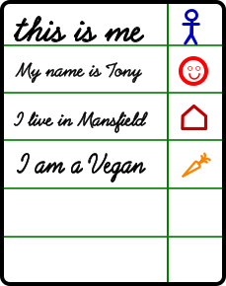
On the reverse of the V-Create board is the Voice Line system. This is a variation on the system above. Write a message onto any one of the lines and store the message in the location provided. By turning the board around, you can create a right or left handed version.
By touching the symbol the message is read aloud.

Please note that you may not use a BLACK felt-tipped pen within the Memory cells (although it is OK to write the message in black as depicted) as the black colour may confuse the V-Pen resulting in message mistakes.

The Voice Create board can be used to store:
- a recorded message (record directly into the pen)
OR
- a saved sentence or spelled message create with a spelling or Voice Board.

V-Pen Components
- Front
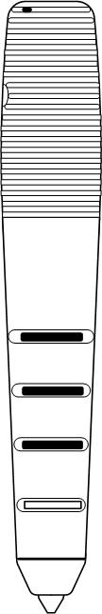
Reader
Power indicator
Volume －
Volume ＋
Power key
Speaker
Ear phone jack
Strap hole
- Back & Top


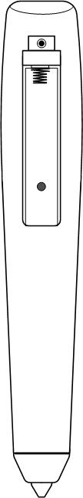

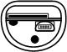
Lift top cover
Mini USB slot
Micro SD Card & slot
Reset button
Make sure the battery direction is correct
Battery compartment
Battery cover
V-Pen Functions
Power On:
Press the power key for 1~2 seconds and the power indicator will light up with a ‘ping’ sound. If the power indicator flashes after it powers on, please turn the pen off and make sure the Micro SD card (open cover on top of pen) is properly inserted into the card slot.

Power off:
Press the power key for at least 2 seconds. You will hear the power off sound (goodbye) and the power indicator will turn off.

Volume adjustment
On the V-Pen:
Press the “Volume＋” or ”Volume－” keys to adjust the volume. There are 10 levels of volume and, every time you press a key, the volume goes up or down one level.
From a Board:
The volume of the pen can also be adjusted from the overlay by touching the Volume Up and Volume Down function buttons (see below).

Battery

The Pen is powered by two standard AAA batteries. Rechargeable AAA batteries can also be used.

Auto Power off:
The power will turn off automatically after 3 minutes of non-use.
Low power prompt: The power indicator will flash when the device is getting low on power.

Battery replacement:
Remove the battery cover and put two AAA batteries into the battery compartment before replacing the battery cover. There are “＋”and “－” signs marked on the battery compartment. Please ensure the batteries are facing in the right direction.

Note: It is also possible to tell when the battery power is getting low and the batteries need replacing if the LED flashes before powering off.

Using the V-Pen
Turn on the V-Pen and touch the pointed end of the pen to either:
- symbol on a communication board;
- an item of text from a document;
- an item on a V-Create Board;
- an item on a line of V-Paper;
- a stored item on a V-Pad.

The symbol or text will be spoken aloud! A symbol might contain a word or a sentence or a complete mp3 file.

Speak Sentence
If each symbol contains a separate word, it is possible to combine the words that have been selected into a complete sentence by selecting the ‘Speak Sentence’ function at any time.

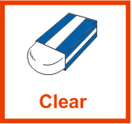
Clear
The V-pen will retain up to 255 items before it starts to remove ones from the front of the list. When a sentence has been spoken, the V-Pen will automatically clear the previous sentence. However, if you are part way through a sentence and wish to start afresh, simply touch the ‘clear’ button to clear the pen’s memory.


Back Space
If the wrong symbol or text item is selected, the back space button will remove the last item. Multiple selections of back space will continue to remove words from the pen’s memory of the selected vocabulary.


Female
The female symbol changes the V-Pen’s spoken output to a female voice.


Male
The male symbol changes the V-Pen’s spoken output to a female voice.

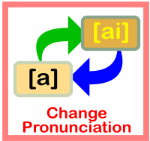
Change Pronunciation
If the pen pronounces a word (which can have an alternative pronunciation) the wrong way, selecting the ‘change pronunciation’ symbol will provide the alternative enunciation.

Memory

You can store any word, phrase, or sentence you build (either through spelling or by using individual words) into any memory location. To do this:

- Build you message
- Speak your message (to check it)
- Touch the pen to the MEMORY button.
- Pen will beep
- Touch you pen to the desired memory cell.
- Pen will beep
- When complete pen will play a series of tones.
- The memory cell has stored the message.

When the memory cell is accessed in future, it will always speak the stored message until a new message is stored there.


Record

You can also record a message by directly speaking into the pen and have the pen store your voice into a memory location.

To do this:
- Touch the pen to the RECORD symbol
- Pen will start flashing
- Touch your pen to the desired memory cell
- Wait until pen plays a series of tones
- Wait until pen flashing rate slows which indicates it is recording
- Speak your message into the pen
- Touch your pen to the desired memory cell to stop the recording

When the memory cell is accessed in future, it will always speak your recorded message until a new message is stored there.

Volume Up and Volume Down



You can either turn the volume up and down using the controls on the pen OR use the control cells on your communication board or in your communication book. You can also use the different fill bar controls on the function pad.

Memory Cells

Memory cells are (typically) blank cells with a letter M in one corner followed by the memory cell number: M1, M2. M3, etc. Memory cells can be stored with anything that can be create with the pen: a word, a phrase, a sentence, a sound … The memory is not permanent, it can be changed at any point by simply storing some new message.

Note: If VoiceSymbol Plus is used, it is possible to create memory cells that contain symbols. This process is detailed in the VoiceSymbol Plus Manual.

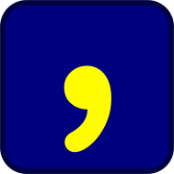Pauses and Prosody

To create a pause during playback of a sentence, insert a comma while creating the sentence. For example: “Hello everybody” ”how are you?”
，


Speaking with Alphabet Boards
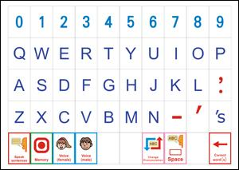

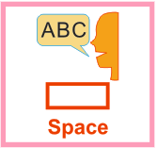
The V-Pen is able to work with alphabet boards like the one illustrated above. The pen will NOT speak out each individual letter unless the ‘spelling bee’ symbol is first selected. Activation of the ‘space’ symbol, after selecting the letters comprising a word, will speak the word aloud. However, if the word if misspelled or the pen does not recognize the word, the pen will simply repeat the letters back in order.

The alphabet board system can be used in conjunction with both symbols and text. Thus, if the person using the V-Pen is able to spell, the main message can be composed using symbols and any ‘missing’ vocabulary can simply be spelt.

Amplifying the V-Pen
For some conditions the V-Pen’s audio output is insufficient. However an external speaker may be easily attached to the audio out socket of the V-Pen. Small, reasonably-priced, powerful, lightweight, battery-powered, portable speakers are available over the web. These can easily and discretely fit in a top pocket and provide enhanced volume in noisier conditions. 3.5mm audio cables in varying lengths (from Amazon and other on line cable stores) can provide connectivity without greatly impeding the functional access of the V-Pen for relatively low cost.

The audio out can also be used for headphones so that the user can listen to any music files (etc) contained on a paper overlay without disturbing others!
Holding the pen
The pen can be held easily in the hand by those that have the necessary ability. However, there may be many people who find holding the pen difficult. There are a number of ways to assist individuals with this:

- The pen comes with a sheath which has a Velcro-friendly panel. By sourcing a cotton glove, removing the fingers and attaching the hooked portion of the Velcro fastening system to the palm, it is possible to create a system that will prevent pen loss during use.
- The string attachment to the lanyard may be lengthened so that the lanyard can be worn during use which will prevent accidental damage cause by repeated drops to the floor.
- Discuss the problem with your Physiotherapist and or Occupational Therapist who may be able to provide other solutions to assist with pen management.
- Consult your V-Pen Retailer who may be able to provide prosthetic attachments for the pen.

As with all other AAC systems, there will be some individuals for whom the V-Pen is not a suitable solution.

Targeting the V-Pen
The V-Pen can provide a communication system for a wide range of people:

- It can be used with all ages from tiny tots to senior citizens. More mature individuals (following stroke for example), who have retained literacy skills may reject High-Tech systems but will find the use of the pen very intuitive and simple. The V-Pen will require very little training.
- It can be used with a wide range of conditions both congenital and acquired. Providing the person is able to manipulate the pen, any condition can benefit from the use of the V-Pen system.
- It can be used with a wide range of cognitive abilities. The cognitive demands can easily be varied according to individual needs: bigger symbols, larger overlays, less icons, and speech to objects are just a few of the techniques that can reduce cognitive loading.
- It can be used with specific sensory deficits. For example it can be used to assist people who may have a visual impairment to read documents, texts, or labels. It can assist those with an auditory impairment, who find it difficult to make themselves understood, to communicate with others.
- It can be used to facilitate language training although the vocabulary range of languages other than English and Chinese is variable the pen will instantly change to another language (English to French for example).

As the pen is:

- light weight
- extremely portable
- very discrete
- easy to learn and simple to use
- durable and reliable
- suitable for all lighting conditions
- suitable for most weather conditions

and has a long battery life (it runs on just two standard AAA batteries), it is the perfect solution for many individuals. While other systems can have complicated vocabulary storage and retrieval methodologies, the V-Pen is practically intuitive and can be used directly out of the box.

What is Uni-Tech?
A Communication Board (without the V-Pen) is a Light-Tech (or No-Tech) system. No-Tech systems rely on the individual user pointing out (or otherwise indicating) a particular location to a communication partner to convey a word or a message. If the same overlay design were to be stored into a high-price Speech Generating Device (SGD), the High Tech equivalent would be created. Communication Boards and Books are examples of No-Tech systems. The Dynavox V and the PRC Eco are examples of High-Tech systems. Both No-Tech and High-Tech systems have advantages and disadvantages. The biggest advantage of a No-Tech system is the relative lack of expense (there is always some cost in the materials used and the labour of the person creating the system). An advantage of a High Tech system is its ability to speak.

In addition to No- and High-Tech systems, there are also Low(er)-Tech systems (sometimes called Easy-Tech systems) which, while being relatively inexpensive, have a relatively limited vocabulary potential.

What is needed is a Unifying Technological system (Uni-Tech) which would combine the advantages of all three systems into one. Such a system would give easy access to vocabulary at an expenditure not far removed from that of Low Tech systems. Unifying Technology would have a number of advantages:

- simple to use and understand;
- light weight and very portable;
- lower cost than high tech;
- inclusive;
- if the technological component stops functioning, the board or book component can still be used as No-Tech system;
- voice output;
- longer battery life;
- low maintenance costs;
- reliability;
- durability;
- suitable for most weather and all lighting conditions.

Of course, a Uni-tech system has disadvantages too when compared to High Tech systems:

- it is difficult to conceive of such a system being available to people who need to use switching;
- small lightweight systems currently have difficulty in providing enough volume in noisier environments without additional amplification;
- could it provide environmental control or computer access?

Accessing Core vocabulary books and boards as a part of a Uni Tech system could change the face of AAC.

The V-Pen is an ultra High-Tech system utilising patented, cutting edge technologies to bring the power of speech to Light/No-Tech systems. Thus, when used in such a combination, the V-Pen product is the first Uni-Tech System to reach the market! Communication Boards and Books can now speak when designed and printed through VoiceInk™ or VoiceSymbol™ or VoiceDesign™.
Troubleshooting

Please use the following troubleshooting guide before contacting your retailer.

Cases | Possible causes | Solutions
No power | The battery has run out. | Replace batteries.
No power | The batteries are installed incorrectly | Install the batteries in correct direction.
Power indicator flashes after power on | No micro SD card is inside this device or card has come loose | Insert the micro SD card into the card slot.
Power cuts out during operation | The battery has run out | Replace batteries (Note: It is possible to tell the battery power is getting low if the LED flashes before powering off)
No sound is played while using the device to make selections | Volume is too low. | Adjust the volume.
No sound is played while using the device to make selections | Volume is still too low after trying to adjust the volume. | Please reset this device with a ball point pen or a paper clip.
Nothing happens when pressing the keys | Temporary malfunction | Please reset the device and/or remove the batteries and replace them.

Care and Cleaning

The V-Pen has been created using very high standards of manufacture and craftsmanship. To ensure the V-Pen’s continuing performance, please follow the following guides for care and maintenance:

- Do not leave the V-Pen in direct sunlight;
- Do not expose the V-Pen to sources of heat;
- Do not expose the V-Pen to dust;
- Do not expose the V-Pen to water or damp conditions;
- Do not suck or chew the end of the pen;
- Do not drop the V-Pen onto hard surfaces.
- Always use with a lanyard, adapted lanyard, or alternative holding system;
- Clean the V-Pen only with a soft cloth;
- Do not use solvents to clean the V-Pen;
- Never tamper with any part of the V-Pen’s electronic or internal systems;
- If your V-Pen should develop a problem, contact Ability World immediately.

TECHNICAL SPECIFICATIONS
Processor | AF3372
Memory | Micro SG Card (2Gb – 4Gb)
Optical Head | Red Infarction
Supply Voltage | Two 1.5v AAA batteries
Weight | 41g (Doesn't not include battery)
Size | 17.5cm x 2.6cm x 2.6cm
Auto-Power Off | After 3 minutes of non-use

43 Svenskaby
Orton Wistow
Peterborough
PE2 6YZ
Tel: 0845 47 47 245
Skype: david.ability-world
Email: enquiries@ability-world.com

