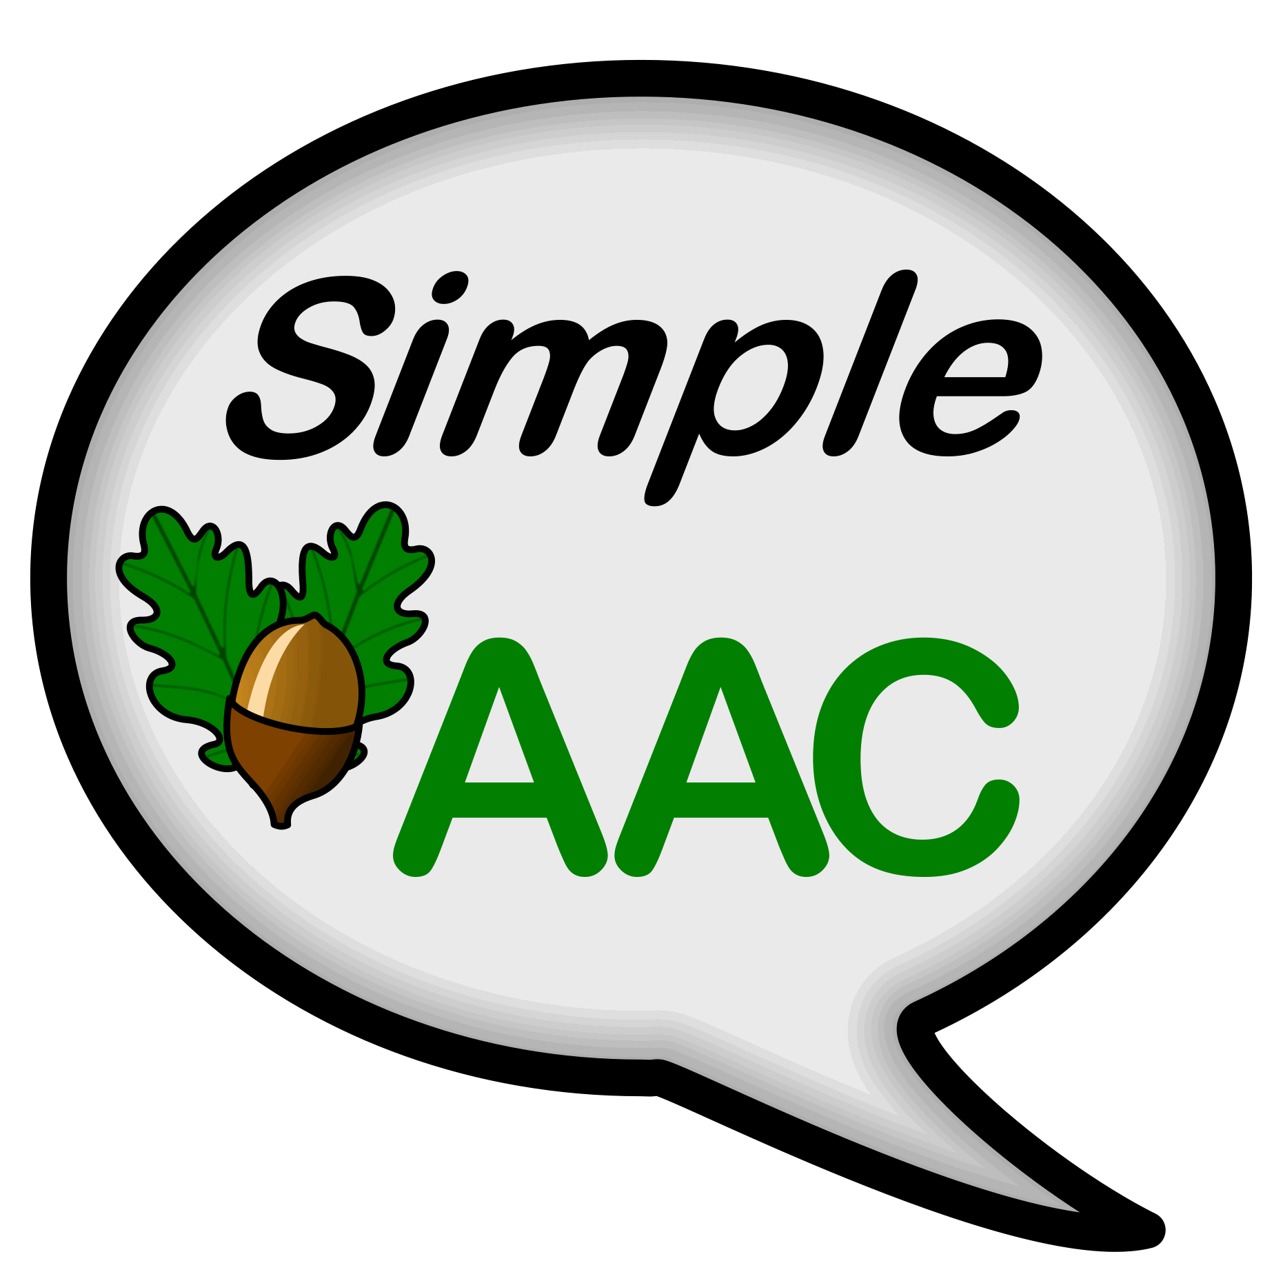

SimpleAAC
Unlimiter Ltd 2012
Simple AAC
Ten steps to grow.

SimpleAAC is, as its name implies, a simple AAC system for the iPad: simple to set up and both simple and friendly to use.

Although it is simple, it is also powerful and can be used with all ages: It allows Little Learners to grow and Bigger Learners to develop further.

Simple AAC offers ten different overlay configurations beginning with just a single cell (whole screen iPad) single message and growing to a twenty cell (5 x 4) speech system.

Although SimpleAAC has English Text To Speech embedded, it is language independent as it is very easy to record a message into a cell.

A Simple Start to Communication

Learners experiencing Profound or Severe Learning Difficulties need to begin to understand that, with communication comes control: control over what others may do (or not do) for you and control over the environment (an ability to affect what happens in the world you inhabit). Simple AAC offers a means to develop such awareness.

Simple AAC allows the recording/adding of a word, a message, a sound, a song, a video ... into an iPad quickly and easily. Simple AAC allows the message to be attached to a symbol or a picture and displayed on the iPad’s screen such that, when the screen is touched (anywhere on the symbol or picture cell) the message (sound, song, video) is played.

Once set up, a message and its selected symbol/picture may be saved for future use or discarded if not required again. Boards may also be exported so that they can be used by other Users of Simple AAC on other iPads.

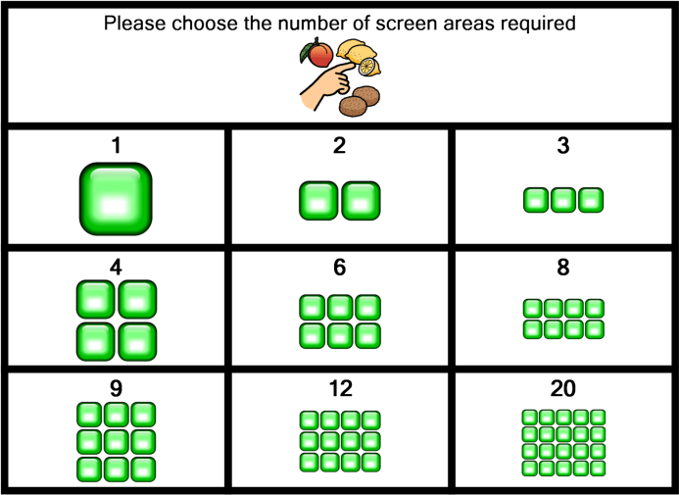
Grow with SimpleAAC

SimpleAAC is both able help a Learner to develop as well as developing with a Learner. It can grow from a single cell system (whole screen) to a two cell system (half screen per cell) and beyond, moving through three, four, six, eight, nine, twelve, and twenty location overlays. Each cell on any overlay can contain a different message or sound.

Toolbar

At the bottom of each screen, in the bottom right hand corner, is a red ‘Toolbar Tab Ear’. This opens and closes the blue toolbar. The Tab Ear can be turned off, if desirable, to prevent unauthorised editing of screens etc! Thus is explained in a section below. Touching the Tab ear either opens or closes the toolbar. The toolbar of the Home Page is different to that of the overlay pages.

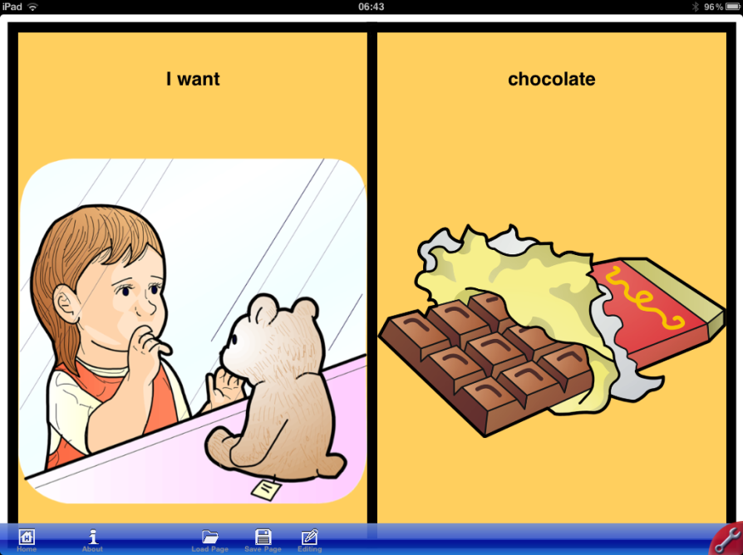
Selecting a Screen Configuration

There are nine possible configurations from which to choose as shown above. To select a particular screen configuration:

- If you are not already on the Home Page, select the Home icon from the blue Tool Bar at the bottom (Home icon is at the far left) of the iPad screen. If the blue tool bar is not showing then activate the Red toolbar Tab Ear that is located in the red quadrant in the bottom right corner of the screen. The Tool Bar will appear.
Tool Bar
Tab Ear
Home Icon

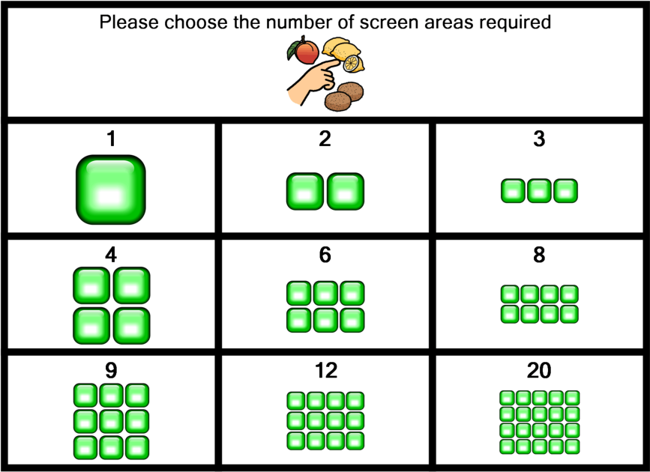
- On selection of the Home icon
Simple AAC moves to the
Home Page.

- The home Page permits the selection of one from nine overlay configurations. Touching one of the configurations moves the system to the area.

- It is not possible to create your own overlay configuration in this version of Simple AAC. You cannot create a 32 overlay, for example.

Editing An Overlay

The two location overlay will be used as an example. However, all the overlays work in an identical manner. The single overlay has additional capabilities (this is addressed later in this manual).

On entering a particular overlay area, the cells are initially blank. However, after creating, using or loading an area the system remembers and displays the last overlay used.

To edit an overlay:

- Select the editing icon from the pop out blue
tool bar. If the tool bar is not visible (as in
image left), select the tool icon in the bottom
right corner. The blue tool bar will appear. The
editing icon is rightmost and depicts a pencil
drawing on some paper.

- On selecting the editing icon the overlay will
dim and each cell will be outlined in red. This
indicates that SimpleAAC is in editing mode.

- Once in Editing Mode, the Editing Icon
changes to a ‘Finishing Icon’ which may be
used when all editing is complete and it is
desired to return to User Mode. Repeatedly
accessing the icon therefore, toggles between
editing and user modes.

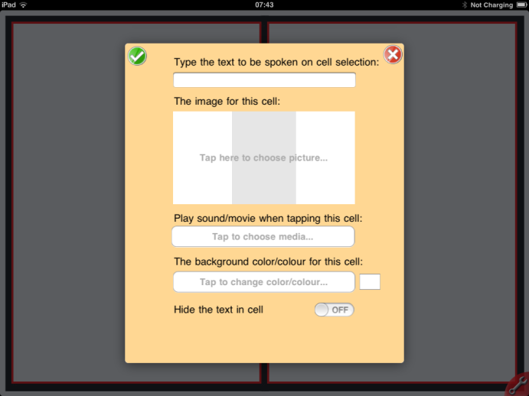
- Touching a particular cell while in editing mode
opens the cell for editing.

- The Editing Window will appear (see left).

- The Editing Window permits six separate
actions:
- Add text to be spoken;
- add image;
- play sound or movie;
- add background colour;
- Hide text;
- Delete Image (does not appear if
cell is blank).

Each of these is detailed separately in the pages that follow. To select any of the options, simply touch it with your finger tip. Touching an option within the editing window will cause the display additional tools specific to the selected item.

The tick and the cross in the top left and right corners of the editing window respectively are selected when editing for the selected cell is complete. The tick accepts all the current editing while the cross rejects it in favour of the previous state of the cell. The tick should therefore be accessed when editing of the cell is complete.

Add Text to be Spoken to a Cell

Touching the ‘Type text to be spoken on cell selection’ section of the editing window opens the iPad keyboard. The text to be spoken can now be entered. When the message is complete select the keyboard symbol to remove the keyboard from the iPad screen.

Add an Image to a Cell

Touching the ‘Image for this cell’ section of the editing window opens the ‘Choose Picture Source’ box. This box has three options: Choose Photo, Choose Symbol, and Take Picture. Select the item required.
- Choose Photo opens the iPad’s photo library from where a particular image may be selected for use. Please see the section entitled “Importing and using your own images” later in this guide for details on how to use your own symbols.
- Choose symbol opens the Simple AAC symbol library from where a symbol may be selected for use. If you have already typed in text to be spoken for the cell, the symbol library will attempt to find a suitable symbol. If the symbols displayed are not exactly what is required, delete the words from the text box (touch it and the iPad keyboard appears and use the remove function) and type in another or scroll through the symbols and select an image directly. Typing an initial letter moves the symbol display to that particular area for selection.
- Take Picture opens the iPad’s camera and permits the iPad to take a picture. The picture is then added to the cell.

Note that, in all cases, the image is auto-sized to fit into the cell on the screen. However, using finger and thumb, the selected image may be enlarged and moved around. The shaded portion of the editing window shows what part of the expanded image will then be seen within the cell when editing is complete. The image may NOT be shrunk in size to make it smaller than the cell size.

Play sound or Movie

Touching the ‘Play Sound or Movie’ section of the editing window opens the ‘Choose Media Source’ box. This box has three options: Choose Sound, Record Sound, and Choose Movie.
- Choose Sound opens the Mp3 file selection window such that a song (or other sound file) may be added to a cell.
- Record Sound opens the recording window. Select record to begin recording and speak into the iPad’s microphone. Select Stop when the message is complete. Select Play to listen to the recording. If not suitable, begin over by selecting ‘Record’ once more. Select ‘Done’ from the top left corner of the window when the recording is satisfactory.
- Choose Movie opens the video window such that an imported video or movie or, a film taken with the iPad’s camera can be activated when the cell is selected. To stop the video simply tap the screen anywhere! Note that the iPad will not play any format of movie; it only works with MP4 videos. However, there a free downloads on the web that will convert a movie into this format for you so that it can be imported to the iPad and used within SimpleAAC.
- YouTube Video allows the system to link to a video from YouTube when the system has a wi-fi link. It requires that the unique video identifier from the address bar in YouTube be typed exactly into the box provided. When this is done and providing that the area in which the Learner is operating has an internet link then touching the symbol will play the video.
- Alternative Text Sound allows the TTS system to say something that is different to what is written in the text line on the screen. For example, the symbol can be a dog and the word/text above the symbol can say ‘dog’ but the alternative text sound (if completed) can force the system to say ‘cat’!! This can be very useful if the TTS system mispronounces a word and you want it to be spelt correctly but also pronounce correctly. Simple type the ‘correct’ enunciation of the word into the Alternative Text Sound box.

Note that, once a media file has been added to a cell, a sixth option appears: Remove Choose Media. Remove Choose Media does at it says, it removes the media that has been added from the cell.

Background Colour

Touching the ‘Background Colour’ section of the editing windows opens the ‘Pick Colour’ window. Select from the colours that are available to add a background colour to the selected cell. Once a colour has been selected, activate the ‘Done’ button in the top left of the window.

Hide Text in Cell

The text to be spoken can either be displayed in the cell or hidden. Set the slider to ON if it is not desirable to show the text in the cell.

Delete this setting

Once a cell has some content, a further menu item will appear in the editing window. Delete this setting returns the cell to a blank state.

Swapping Cells

Sorry! In this version of SimpleAAC it is not possible to swap cells around on an overlay. Be sure that you plan your overlay first on paper so that you do not need to swap cells around on completion.

Exiting the Editing Window

To accept all the edited settings, select the green and white ‘tick’ in the top left corner of the editing window.

To reject all the edited settings (and return to the precious cell state), select the red and white cross in the top right corner of the editing window.

On exiting the Editing Window it is important to remember that Simple AAC is still in editing mode and, thus, touching any cell will open it for editing! You will probably make this mistake several times before learning to leave editing mode! Do not worry, making this mistake causes no damage or loss of data. To leave editing mode (and return to user mode) select the Finish icon from the toolbar. If the toolbar is not displayed select the Tools Icon.

U

Hiding cells

Sorry, there is no hide cell button. However, it is possible to do it quite simply by another method. It only takes a few seconds. Simply use the ‘Delete this setting’ button to erase the cell completely. If you require a colour then it is easy to put that back. Then SAVE the new page with the ‘hidden’ cell with the same page name with a H suffix such that you now have two pages: one with the cell present and the one with the cell ‘hidden’ (<Page Name>, <Page Name> H)
User Mode

After editing and exiting from editing mode (use the ‘finish’ icon from the toolbar to exit editing mode) cells will perform the functions (as set) when touched.

Linking Pages

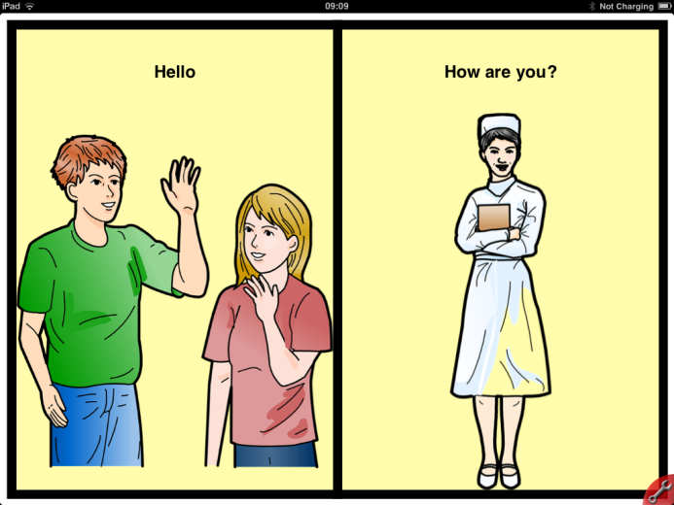
Sorry, in this version of SimpleAAC it is not possible to link pages or cells to other pages in Simple AAC. However, if the Learner is able to slide a finger across a page and understand the concept, it is possible for the Learner to move between pages. This feature is OFF by default on the preferences page and can be set to ON if desired. However, it should only be used where the Learner is both physically and cognitively able to cope with it. If you are in any doubt, it is probably better to leave this feature set to OFF.

Saving an Overlay
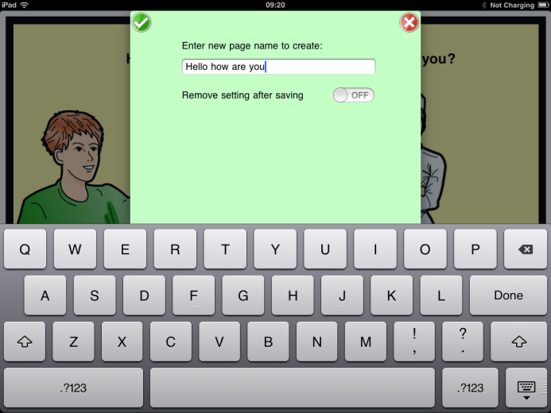

To save an overlay for future use (and to begin the creation of another) simply select Save Page from the toolbar. The iPad’s keyboard will appear and a name for the overlay can be entered. Select ‘done’ from the keyboard when the name has been entered. Your overlay is saved! Once saved, the overlay can be loaded at any time by selecting ‘Load Page’.

The remove setting after saving option clears the overlay and the overlay name after saving. If it is desirable to continue working with the same overlay after saving, ensure this feature is off. If you wish to start a new blank overlay set this feature to ON.

Note that, if you try and save an overlay with the same name as an existing overlay of the same size you will be asked if you want to overwrite the existing overlay or change the name of the overlay you are saving. It is not possible to erase an overlay accidentally.

Loading An Overlay

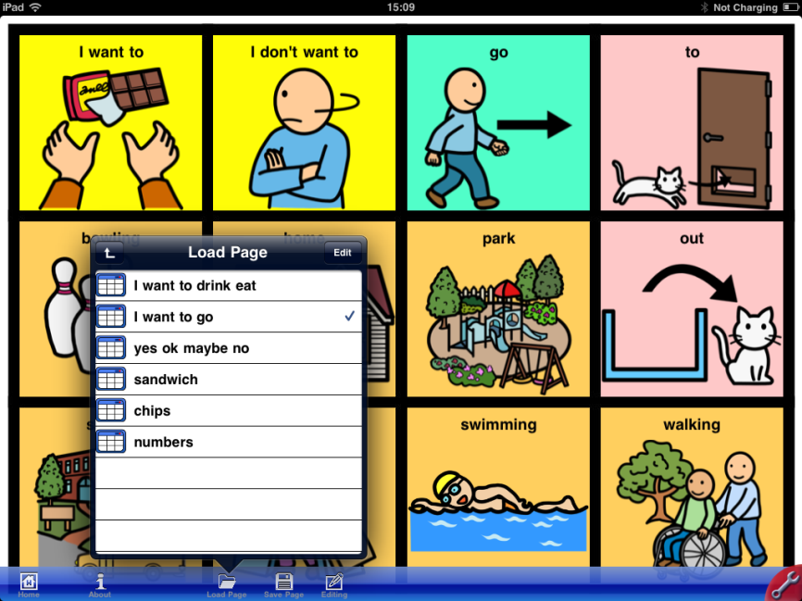

Select the load page icon from the Toolbar and the Load Page window will appear. Touch the page that you want to load. NEW PAGE loads a completely blank overlay ready for editing. For many of the overlay configurations (1, 2, 4, 8 …) there are already many pre-programmed examples available. In some instances there are over 100 pages from which to select! Over one hundred selections cannot be displayed on the iPad’s screen at one and the same time and, thus, the Load Page window scrolls up and down to reveal other choices. Use the tip of your finger to scroll down through the choices and then make a selection by tapping it once.

Deleting An Overlay
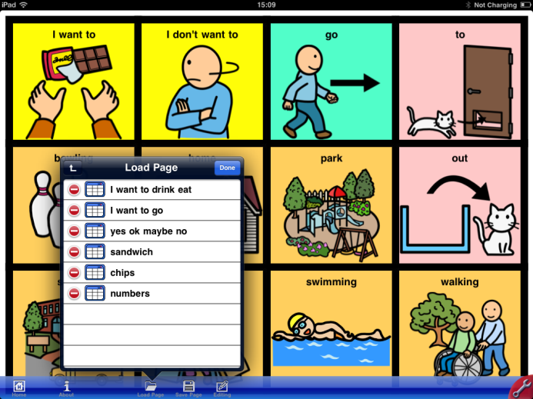

Select EDIT from the Load Page window.

Touch the red circle with the white line next to the page that you wish to delete

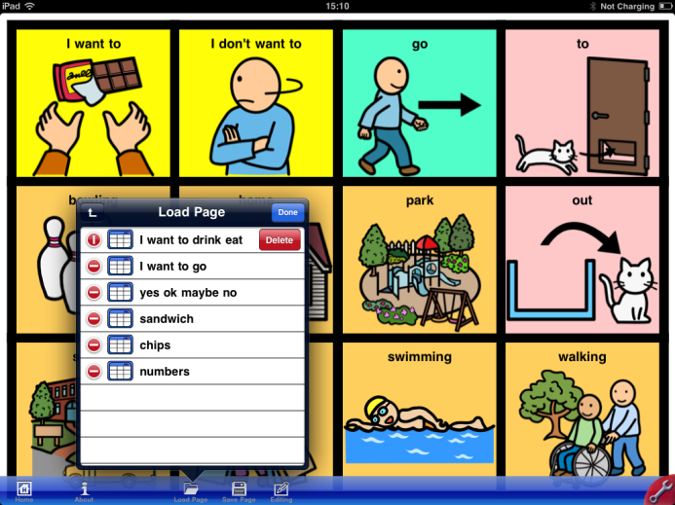

A Delete Button will appear.

Select the Delete Button to delete the page.

To reorder the Load Page listing

The Load Page list of available overlay reflects the order in which the pages were built and saved. Once the list is longer than the available window space it will be necessary to use a finger to scroll up and down the list to reach those pages that cannot be viewed. There may be a particular page that is used very frequently and you would like to move to the top of the list such that it is the easiest to reach: this is possible! To do this;

- Select edit from Load Page.
- On the right hand side next to each page listed there is a three line grid.
- Use your finger tip to slide a page up or down the list.

Alphabetise the Load Page list

The Load Page listing can be instantly put into Alphabetical order when desired by touching the AZ button from the Load page menu bar. This will put the current pages into A through Z order for the selection. However, the order in which the pages will not be affected as the list will revert back following the page selection.

To Quit any Window or Selection Process

Either select the top left up arrow OR touch anywhere on the screen outside of the window. Touching outside of a window causes SimpleAAC to quit the current process and move to the area selected.

Note that quitting a window might not save the data in the window (if relevant).

To create A New Overlay

To create a new overlay/blank overlay, select the Load Page Icon form the menu bar. The topmost option is always LOAD NEW PAGE creates a blank page already in editing mode. Please Note, if you have not saved the previous overlay you will be warned that you will lose it if it is not saved and asked what you want to do.

OR

Save the previous overlay and ensure that the ‘remove setting after saving’ option is set to ON. A blank overlay will appear after the previous overlay is saved.

OR

Simply go ahead and edit the existing overlay on the screen so it becomes a completely new overlay and then, when it is complete, save it with a different name.

To Download Page Sets

A free download of page sets for Simple AAC is available by moving to the Home Page and touching the Download button. This will NOT erase your previously created pages but will rather merge with them. To be completely safe, always EXPORT (see section below) your page sets before downloading or importing another. In this way, you can be sure that nothing is lost.

Adjusting Simple AAC Preferences
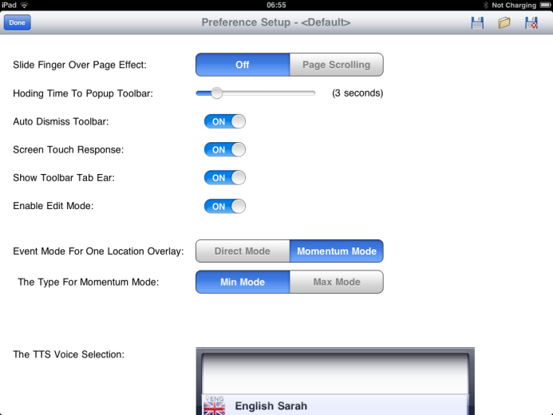

Specific access preferences can be set (and saved) by accessing the Preferences Setup Window. This is reached by selecting the Preferences icon from the Toolbar on the Home page. Preferences are retained in the iPad’s memory even when it is turned off. To re-adjust preferences return to the preferences window.

There are a number of preference options; each is detailed separately in the pages to follow.

Slide finger over page effect.

Typically this should be set to off as it prevents the Learner from accidentally moving the screen when trying to access a cell. However, if the Learner is capable of working with this feature it becomes a method of moving between overlays that can make SimpleAAC more powerful.

Holding time for Popup Toolbar.

If the show toolbar ear (see below) is set to off, there is apparently no way to access the toolbar! Actually, it can be accessed by continually touching the iPad screen for a set length of time. The time can be set by using the slider bar. The maximum time setting is fifteen seconds. If this feature is necessary, choose a time setting where it is unlikely the Learner will hold the screen continually for such a length of time.

Auto Dismiss Toolbar

The toolbar will automatically disappear (leaving just the red Tool Icon in the right corner) if this is set to ON. If set to ‘off’, the toolbar will remain on the screen, unless the Tool Icon is selected. Leaving the toolbar on the screen may be too tempting for some Learners!

Screen Touch Response

To indicate when a cell has been selected, it will darken a little for a short period. If the screen touch response is set to ‘off’ then the cells do not show any response to touch other than performing their function. The performance of the cell’s function may be enough feedback for some (set to OFF) but not for others (set to ON).

Show Toolbar Tab Ear

The Toolbar Tab Ear (Tool Icon) is the red quadrant that appears in the bottom right of the iPad’s screen. It is used to open and close the Toolbar. However, for some Learners, it might be accidentally activated and permit them to change overlays etc. If this is a concern, the Toolbar Tab Ear can be removed from the screen by setting this feature to OFF.

If ‘Show Toolbar Tab Ear’ is set to off, the only way to access the Toolbar is by a continual activation anywhere on the iPad’s screen. The timing of this activation can be set in by using the ‘Holding Time for Popup Toolbar’ feature as detailed in an earlier section above. The holding time should be set to something higher than the Learner is likely to do by accident.

Enable Edit Mode

As a further precaution against accidental editing (!) the Enable Edit Mode feature prevents any editing at all when set to OFF. Using a combination of the above features it should be almost impossible for a learner to accidentally enter edit mode and begin to change overlays! Once all boards have been set up and saved and the system is being given to a Learner for communication use, it is a wise precaution to set Enable Edit Mode to OFF.

Event Mode For One Location Overlay

The one location overlay can be set to operate within a specific mode. There are two modes available: Direct and Momentum.

Direct Mode is very simple: One touch, one response. The entire screen performs as a single messaging system. It is the most basic of all the Simple AAC options possible.

Momentum Mode: allows pages to be linked in a continual loop. It is akin to linking several direct mode pages together. After a page is activated in Momentum Mode, the system moves to the next page which, when activated, moves to the next page, and so on. When the final page is reached, the system loops back to the first page once again and begins over. Using Momentum Mode it is possible for a Learner to say ‘hello’ and then, by activating the screen again, “How are you?” and then, by activating the screen again, to respond to the retort (how are you?) with ‘I am fine thank you’. All this is available from the whole screen acting as a single cell. Momentum mode is, thus, a ‘stepping’ action. There are no limits to the number of pages within any one Momentum Mode

There are TWO forms of Momentum Mode: Momentum Mode Max and Momentum Mode Min

Type for Momentum Mode

Max and Min refer to the spoken output from SimpleAAC.

Min Mode: In Min Mode each screen must be activated by the learner. If screen one says ‘hello’ and screen two says ‘how are you?’ then it will require two activations to say the whole message. Each activation says the minimum amount (hello OR how are you)

Max Mode: In Max Mode it is only necessary to activate the first screen, for the whole set of the single overlay messages to be spoken! The system automatically moves from page to page and speaks each message. Thus, there is maximum spoken output. When the final page is reached the system loops back to the first screen and waits for another activation before repeating the process. When Max mode is selected an additional setting appears in preferences: Time delay between screens. This allows the delay between each screen (each part of the message) to be set (to a maximum of 15 seconds). Please note that, in this version of SimpleAAC, it is NOT possible to have different time delays between different parts of a message.

TTS Voice Selection

Select either a female (Sarah) or Male (William) Voice.

The TTS system in use is the Cereproc system (http://www.cereproc.com/). Cereproc are based in Edinburgh, Scotland and have a range of voices from across the world available for use. Sarah and William are just two of the UK voices available. It may be possible to add further voices for other languages if desirable. However, remember, it is not necessary to use TTS as the speech output as messages may be recorded in any language using SimpleAAC’s recording system (detailed earlier).

Saving, Loading and Deleting Preference Profiles

In the top right hand corner of the Preferences Screen are three icons: A disk for SAVE, a folder for LOAD, and an x-disk for DELETE.

If SimpleAAC is being used with more than one Learner (as an assessment tool for example) then it may be necessary to change preferences. Rather than having to continually set up preferences anew, it is possible to save a set of preferences for a particular Learner (for example; Jane’s Preferences) and to load them back in next time Jane is using SimpleAAC on the iPad. If a Learner leaves an establishment and the saved preferences are no longer required then the DELETE option can be used to remove a previously saved set.

Leaving Preference Setup

Once preferences have been set (and saved if desired) then the screen may be exited by selecting ‘done’ from the top left of the preferences screen. The preferences that have been set will remain in force even when the iPad is turned off until they are altered or a new set of preferences is loaded.

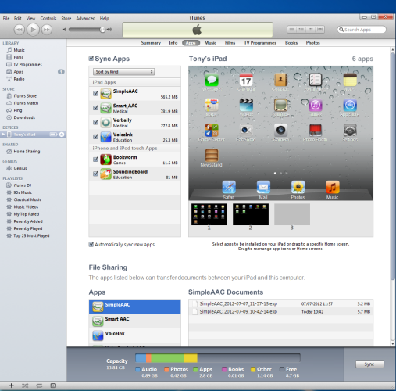
Exporting and Importing Pages

On the Home Page Toolbar is a further tool: Export/Import. This tool allows all saved pages to be exported. The process is very simple: a single touch exports all current pages. To access these pages to use on another iPad then it is necessary to use the iTunes facility.

- Connect your iPad to a computer and start iTunes;
- Select your iPad (Tony’s iPad in image left);
- Select Apps;
- Select the Simple AAC app;
- The currently exported file set is displayed (together with any previously saved sets);
- An exported page set can be dragged to the desk top or copied to any folder on your computer.
- At this point, a page set can be renamed to something meaningful BUT be sure to keep the same file extension.

To import a page set simply repeat the above in reverse order. On syncing the iPad, the page set will be available to import using the export/import tool from the Home Page toolbar. Imported page sets are added to your existing page set.

NOTE: It is a good idea to export all your pages from time to time as a precaution against data loss. Things can go wrong, even on the iPad! Backup your SimpleAAC data by exporting the pages to your PC and keeping them safe!

Exporting and importing SINGLE pages/overlays

To export a single overlay (to use with other Learners), use the EXPORT/IMPORT page icon from the toolbar at the bottom of the overlay which is required to be exported. If the toolbar is not visible select the red Tool Tab Ear in the bottom right hand corner of the iPad screen.

On selecting Export/Import you will be requested to specify whether you want to Export or Import a page.

You are requested to provide a name for the exported page. The current page name is automatically filled in for you but you are not obliged to use this name. When the naming process is completed, select DONE from the keyboard or, alternatively, select the tick in the upper left corner. To complete the export process, follow the same set of commands as in the above section on this page (for exporting page sets).

To import a single page simply repeat the above in reverse order. On syncing the iPad, the page set will be available to import using the export/import tool from the Home Page toolbar. Imported pages are added to your existing page set.

If a page has the same name as an existing page then it will be given a number addendum (name-2). If you import a page which is identical to an existing page you will end up with two identical pages! However, it is an easy matter to delete one of the pages (Process outlined earlier in this manual)

Importing and using your own images

When selecting an image for a cell in edit mode there are three options: photo, symbol, or take picture. Selecting the PHOTO option displays the imported folders from iTunes. To bring in your own images therefore, it is important you ensure that iTunes is directed to a special folder where you have set up your symbols in categorised sub-folders. Each time you sync your iPad to iTunes the folders will be updated and new symbols added and unneeded symbols removed.

To do the above:

- Create a folder somewhere on your PC. Call it something that you will remember (something like ‘iTunes Images’)
- Within this folder create subfolders for different categories of words (drinks, fruit, appliances, animals, transport, weather, people, etc)
- Populate the subfolders with the symbols that you want to be available on the iPad to SimpleAAC.
- Link you iPad to your computer and run iTunes
- Once linked, you will be able to select ‘your iPad’ from the option in the left iTunes Panel.
- Once ‘your iPad’ has been selected, select PHOTOS from the top menu bar on the screen.
- The window will change. In this window, point iTunes at the folder you have just created which includes all the subfolders. Sync photos from …
- Ensure that ALL folders is selected OR if you don’t require ALL the subfolders, it is possible to specify which ones should be imported during the synchronisation process.
- Select APPLY from the bottom of the window
- Your iPad should start to sync.
- When the sync is complete the symbols in the folders should be available in the PHOTOS option of ‘Choose Symbol’ within SimpleAAC.

WARNING… if you use this method, you may create an image that has a white background (see illustration on page below). There does not appear a way to avoid this. If you are not using coloured backgrounds in the cells, it will not matter as white on white does not show. However, if the background colour is orange (for example), the white image background will block out some of the cell colour background. This can look very messy and may be more confusing for some Learners

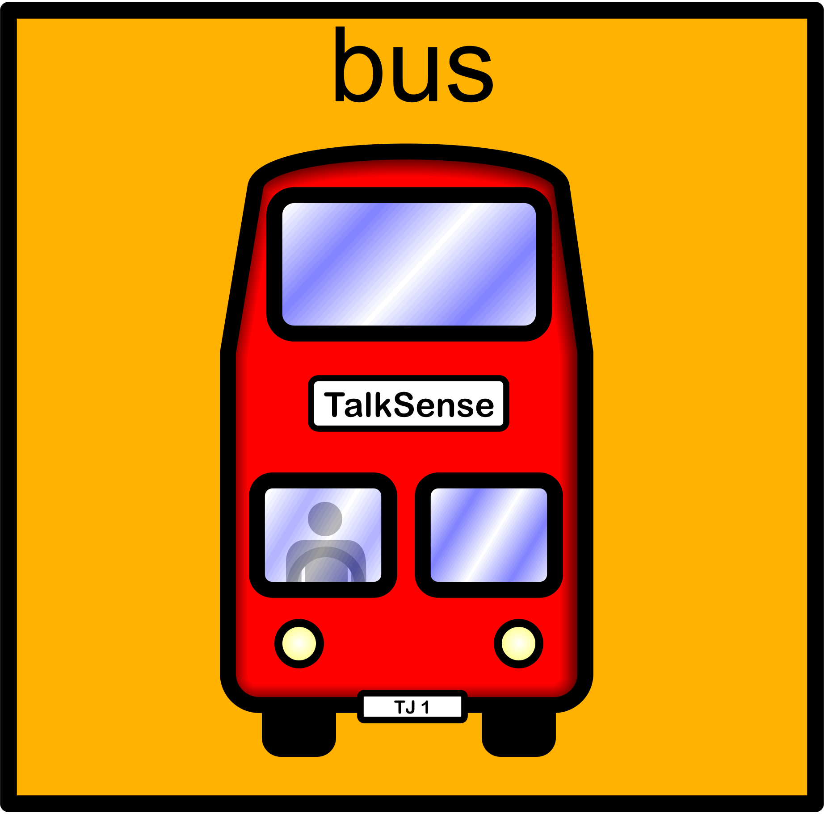
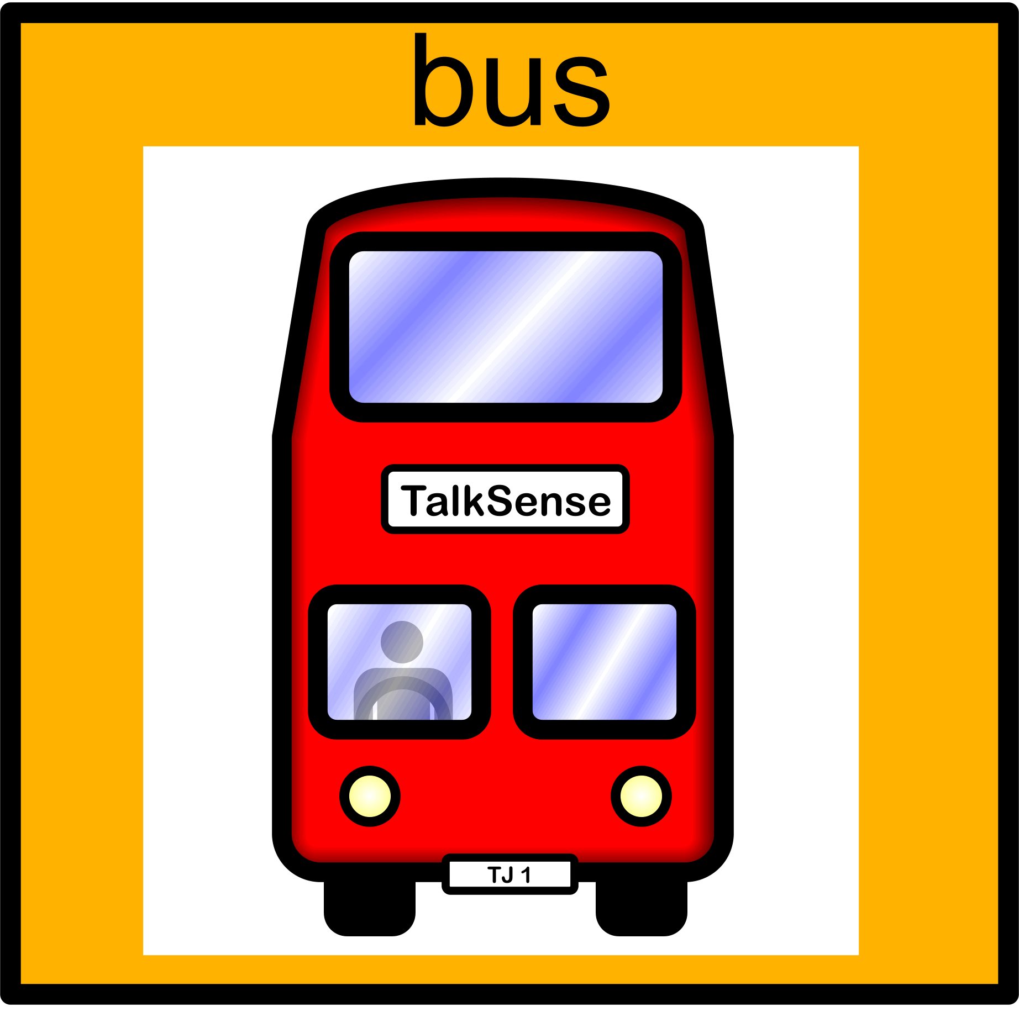

As can be seen in the images above, the white background blocks out some of the cell background (image left) but, if images/symbols can be imported with a transparent background (image right) then none of the cell background is lost. As previously stated, this cannot be achieved using the iTunes methodology outlined (as far as I am aware presently). However, there is a way to add symbols to the photo library on the iPad with a transparent background. It is a little complex but, once it is set up then, it will work every time.

- You will need to export your images from a good art package:
- with the colour depth set to true colour plus alpha
- the ‘transparent’ background option set as on and
- a resolution of 300 dpi
- as either .png or .gif files
- You will also need to install a piece of software called Dropbox (www.dropbox.com) to both your PC and your iPad. Dropbox is free and is safe for both systems. It allows the wireless and instantaneous transfer of files between computers. Drop images into Dropbox on your PC and they will appear on any other computer on which you have Dropbox installed. It easy to install and very easy to use. It’s actually a very useful piece of software for general use. I recommend it to you.
- Export your symbols to folders within Dropbox. The same folders will appear in Dropbox on your iPad and so it will be easy to locate the symbol that you need. Your iPad must be connected to the internet of course.
- On the iPad, Select the Dropbox folder and select your required symbol. You can then save the symbol to the photo library on the iPad. You can decide where it goes within the photo library.
- Open SimpleAAC and go to overlay for which your imported symbol is required.
- Select the required cell.
- Import a photo to the cell as previously detailed in this manual. Chose the symbol from the photo library. The image will have no background as in the bus image above right.

There are a number of image types that can have clear transparent backgrounds (for example .gifs and .png). However, some images types cannot have such backgrounds and will always import with a white surround (.jpg for example). If this does not matter to you then you need not worry about the type of image you use for imports and can import your images through iTunes.

If your symbol set is from a third party then it may not have been provided in the way described above. There is one way to find out; try a single symbol in the methodology above and see. As Dropbox is free, you will only have wasted a little time and, at least, you will have discovered the benefits of using Dropbox!

Simple AAC Symbol set

Simple AAC contains approximately 6,000 of Unlimiter Ltd’s ‘Unlimiter Simple Line Drawing Symbol Set’ (there are 11,000 symbols in the set). If you do not want to use the symbol set provided, you are free to import your own symbols (as detailed in the previous section). If you do not find the symbol for which you are searching under one name, try searching under another name: for example – if you can’t locate a ‘big’ symbol try searching for ‘large’ or ‘huge’ instead.

The full simple line drawing symbols (as well as four other sets) are also available in the Voice Symbol software for AAC. Voice Symbol can be used to create communication programs for AAC that will run on paper, PC, iPads, and androids! Contact your local distributor (listed at end of this manual) for further details.

SimpleAAC Page Sets

SimpleAAC comes complete with over 500 page sets for your use. Feel free to adopt, adapt or reject these pages as you see fit. You may not like the choice of background colour – change it. If you would prefer different symbols – change them! Whatever is going to work best for the Learner is what is required and we do not claim that our sets will serve every Learner perfectly; one size does not fit all!

If you design an overlay and think that it might be good for others around the world to use, please export it and send it to Tony Jones at Talksense@live.co.uk and I will add it to the downloadable set. Ensure you reference SimpleAAC in the title to the e-mail so that it is not treated as spam or junk by the e-mail filters.

Eventually, we will add an upload and download page feature to a SimpleAAC website where new pages can be easily downloaded and used.

Remember, there may be copyright on certain symbol sets and on certain sound files (music and video in particular) and, as such, we may not be able to use a particular page without some modification. The Unlimiter SimpleAAC symbols are fine for this purpose. However, you can send pages with any symbol set, we will convert them to our symbols before making them available to others.

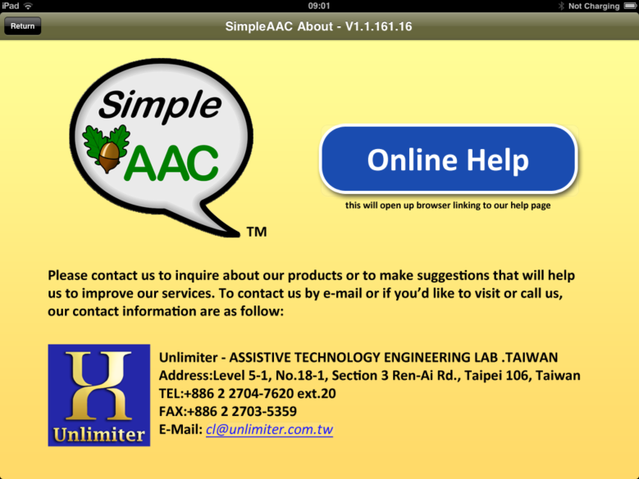
About Simple AAC

The About Screen can be reached from the Toolbar icon on the Home Page. The About Screen provides the Version of Simple AAC (Top Grey title bar) as well as the company E-Mail address and the internet Online Help page.

KEEPING IT SIMPLE: WORKING WITH SIMPLE AAC

Purchasing SimpleAAC is the first step of the journey. However, acquiring a system and being able to program it is not all there is to it! As there can be both good and poor practice with any AAC system so there can be good and poor practice with SimpleAAC. The following pages lay out ideas for SimpleAAC’s use at home, in school, in college or wherever you are. SimpleAAC can be used with Learner’s of any age as a tool for starting on the journey to communication. SimpleAAC should not be considered as a language system because there is no way that it can be set up to cope with any language (although SimpleAAC PLUS (when available) will move one step nearer to that position). SimpleAAC is a tool that can be used to promote the learning of basic communication. Many Learner will progress beyond its capabilities although there will undoubtedly be some who need its services for a longer period and a few who may need it for a lifetime.

Some Learners will need to begin using the Single Symbol System: that is, the one location overlay. However, there is no requirement that a Learner begins in this way. If a Learner is already using a communication book with several cells to a page then it may be best to start at the same level. As this is a generic guide to the implementation of the system, each Page Configuration (1 location, 2 location, 4 location, …) will be detailed separately in turn in the sections that follow.

Single Location Pages (SLPs)

As has been detailed previously there are three forms of SLPs: Direct, Momentum Max, and Momentum Min. Each has potentially different uses and, therefore, different implication for its implementation. Both potential uses and implementation issues are addressed below. While an attempt has been made to be comprehensive it is not claimed that the ideas or issues are exhaustive.

Working in Direct Mode

The Talksense website has detailed over 100 ways in which a single location AAC system operating in direct mode may be used (http://talksense.weebly.com/feature-101-ideas-for-a-bigmack.html). As this comprehensive guide freely available to all, it is not intended to reproduce it here rather to list some of the ways Direct Mode may be used and leave it to the Reader’s initiative to pursue the matter further by following the link provided.

Direct Mode can be used to (alphabet of uses):

- Ask for a favourite item: “Can I play my ball game please?”
- Buy an item(s) in a shop: “A big box of your best bourbon biscuits please!”
- Call for a Significant Other: “Miss Cook, can you come here please?”
- Develop Cause and Effect Skills
- Educational Explanations: The system can repeat a set of instructions to a Learner who is likely to forget them after completing the first one. The Learner can listen over and over as many times as required during the task.
- Finish: Let a Significant other know you have finished a task.
- Give your news to group or Significant Other.
- Help: Ask for help if needed in class
- Important Information: give a Significant Other a piece of important information such as “Dad, Mum says your dinner is ready and you have to come now!” or, perhaps, tell a Significant Other (who is out of the room) when a programming is starting or …
- Join in a Sensory Story by making a sound effect, “Moooo”!
- Knowledge: Prove your knowledge to Significant Others. For example, an item is placed in a shoe box such that the Learner can see it. A Significant Other (who does not know and cannot see what is in the box) presents a set of items one by one to the Learner. The Learner uses the system to say when the item presented is the ‘same’ as the item in the box.
- Listen to some music you Like
- More please: Ask for more of a food or drink when being assisted with eating or drinking
- Narrate: Tell a short story to others.
- Order: “A Big Mack please!”
- Perform: take Part in a Play and give your line.
- Quote a repeated line in a story (Oh No, I can’t stand this, Going on a bear hunt, Not now Bernard, But he was still hungry …)
- Recite a poem, Request an item, Read a Repeated story line. Reminders -Remember to buy
- Sing a Song. Say a Story, Shopping list
- Tell a (one part) joke
- Use it to say ‘Hello’ or any other social greeting.
- Video: Play a video
- Worship: Say a prayer
- Xtra goes: Request Repeats of an action: “Again please”. For example, A Significant Other rocks a Learner on her knee then stops and waits. The Learner says ‘Again’ and another rock is provided.
- Yes: Answer ‘Yes’ when appropriate for example… make a choice (respond YES to one of an array of presented items)
- Zounds and Zikes! Support your team at a match by shouting out!

That’s the letters of the alphabet covered!

When presenting a single messaging system, it was always argued that any device should always display an appropriate symbol. This was a problem when symbols had to be physically printed, cut out and then attached to devices but it is no longer a problem for SimpleAAC where symbols are an integral part of the system and the resulting page format can be saved for future use. However, another problem concerning the use of older technologies still remains: fly swatting!

What is fly-swatting and what problems arise from it? Let us imagine a situation in a special education establishment: a staff member is moving around a group sitting in a classroom and offering a Single Messaging Device (SMD) to each Learner in turn. The Learners are required to activate the SMD which then says some message or plays some sound. The staff member makes a comment and then moves away. The SMD does not carry a symbol. What do we make of such an activity? What is the Learner actually learning? If we were to ask "and you are doing that because?", what would be the response?
In such situations the Learner is (most likely) presented with SMDs throughout the day; maybe an identical SMD several times. Each time it is presented, the SMD says or does something different and, without even a symbol to give some clue as to what is happening, what is the Learner to make of it all (especially if that Learner is experiencing PMLD)? A Learner may learn to 'fly swat' the SMD as it is presented and views the staff member's response as a desirable reward to that behaviour. However, such 'fly swatting' activity is viewed entirely differently by the staff member concerned: Staff may assume the Learner's 'co-operation' equates with an understanding of their objective(s) for the session. This may be far from the truth. Of course, some Learners may understand the intent of the session but how do we sort those that do from those that don't as both activate the SMD when presented?
Fly swatting is a feature of passivity not activity, or inclusion or involvement, although it may be proffered as evidence of such by some staff.
Fly swatting is therefore defined as a conditioned response to a stimulus with minimum cognitive engagement. The Learner is simply conditioned, over a period of time, to respond in a certain way to the presence of a SGD (Speech Generating Device), switch, communication board and can do so with the very minimum of cognitive engagement. As such, evidence of fly-swatting is an indicator of passivity.
A Learner may have to go through some form of fly-swatting stage in the beginning to interact with any system. However, the difference here is, once the interaction is established, the Learner is tasked to move beyond simply the act of activation and to engage in a task which is cognitively challenging. Consider learning to ride a bike ... at first it is a difficult process but eventually it becomes automatic and we are not conscious of what we need to do to achieve this feat. If we were cycling along a straight road without any obstacles we would not now be cognitively engaged and, like driving a familiar route, suddenly realise that we have reached a point on the journey without being conscious of how we got there! Once the task has been mastered therefore and automaticity is acquired, we need to move on to a further objective. It is the cognitive engagement with the new objective that moves the Learner beyond the act of merely fly-swatting.
How can you tell if a Learner is just fly swatting? That is a difficult question to answer. However, if the Learner has been using a particular system for some time (T) which is greater than the time taken to Automaticity (A) then, unless there is cognitive engagement (C), there is a potential for fly-swatting (F):
If T > A & C = 0 then F
The question then becomes, 'How can I tell if the Learner is Cognitively Engaged'?
How can you avoid introducing fly swatting activities? Answer the following questions about the activity:
- Could I achieve a result with my eyes closed? Yes 0 No 1
- Does the action demonstrate a competence beyond
that of the action itself? Yes 1 No 0
- Could I continue to get a correct response by accident? Yes 0 No 1
- Is it part of a progressive sequence towards a particular
goal? Yes 1 No 0
- Is it a didactic strategy designed to teach awareness of the
activity? Yes 1 No 0
Let us take an actual example and work through the above questions: A child is presented with a communication board at break time and asked to choose a drink. The board has previously been presented many times. It is not just being introduced.

The child reaches out and touches the board. A drink has been chosen!
Could I achieve a result with my eyes closed? YES (0)
Does it demonstrate a competence? NO (0)
Could I get a correct response by accident YES (0)
Is it part of a progressive sequence NO (0)
Is it part of a didactic strategy NO (0)
What is the score tally? Zero! Not a single point has been gained. The nearer the score is to zero; the more likely the activity is fly-swatting.
In this situation, anything the child touches provides a correct answer to the staff member's question: there is no possibility of being wrong, especially if all are drinks the Learner likes. The Learner could be responding in a fully cognisant manner, of course, but how would we know? So often, staff assume cognisance rather than testing for understanding.

Even if the Learner and the board have previously been tested and it has been shown beyond any doubt that the Learner is aware of all the symbols, the activity might still be considered as fly-swatting because, in any educational establishment, the goal should continually be to move beyond what has been learned and to progress the Learner further towards the Three I's. Admittedly, this is a lesser form of fly-swatting than the scenario in which it has NOT been shown that the Learner is fully cognisant of all the symbols on the board.

Cognitive engagement therefore removes an activity from mere fly-swatting. Cognitive Engagement (CE) may be defined as,
'The intentional and purposeful mental processing of session content.'
Cognitive Engagement refers to the thinking skills that a Learner needs to bring into play in order to understand the activity in question and participate successfully.
CE therefore requires strategies that promote:
- inclusion rather than exclusion;
- communication rather than silence;
- manipulation rather than (rote) memorization;
- involvement rather than non-participation;
- exploration rather than immobility;
- challenge rather than automaticity;
- clarity rather than confusion (learning is 'scaffolded');
- structure rather than disorder;
- confidence rather than insecurity;
- arousal rather than boredom;
- safety rather than fear;
as the means through which Learners acquire both knowledge and deeper conceptual insight.
CE can be elevated through a variety of activities such as:
- introducing and exploring the new;
- the inclusion of 'incorrect' responses;
- inducing cognitive dissonance;
- posing 'argumentative' questions requiring the development of a supportable position,
- asking Learners to generate a prediction or rationale during a session.
For further information go here and here
See also Corno, L, & Mandinach., E.B., (1983), The Role of Cognitive Engagement in Classroom Learning and Motivation, Educational Psychologist, Vol. 18, No. 2, 88—108
Please Note it is not practical (and probably not desirable) to have CE every second of the day: there are times when we all need to switch off and 'chill out'.

The child being assisted to eat at a table by a Significant Other can be said to be cognitively engaged and NOT fly swatting if, after eating each mouthful provided expertly by the SO, s/he activates SimpleAAC and says ‘More Please’ without any form of prompt (other than the SO NOT just providing the next mouthful automatically) and assuming that the Learner does not activate the device repeatedly at other times.

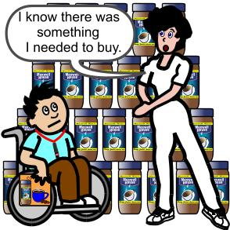
Reminders (remember to buy) can be an effective use of direct mode. The Learner is tasked to remind you that you need to purchase a particular item. The facilitator can tell the Learner that s/he has to remind them to buy the item when they get to the store because s/he is likely to forget. The facilitator can prompt the Learner on this matter all the way to the store and even on entering the door BUT, once inside, the prompting should cease. The Learner’s task is to use the system to remind you to buy the item while you are on the aisle where the product is on sale. If the Learner forgets to do so, LEAVE the store without buying the item! It is important that you do not simply remember and buy the item anyway because the Learner will not learn anything from this action other than s/he does not have to do anything because you will sort it out anyway. If it's not an important item, you could go all the way home before 'remembering' or you can 'remember' when you are but a few yards away from the shop door (especially if it’s an important item!). As you 'remember' you must now gently rebuke the Learner for forgetting to remind you. That was his/her job after all. When you go back into the store, after a few minutes of wandering around say, "I've forgotten what it was I wanted to buy!!" and the process begins again. If the Learner does the job first time then you can increase the difficulty by increasing the number of reminders s/he has to give on the next visit!

Record your own sound library. Using Direct Mode it is possible to record your own sound library direct to the iPad from ambient sounds found in and around the establishment. Create a page with an appropriate symbol and then use the record feature to capture the sound.

In a learning environment, asking for ‘more’ or requesting that an action should be performed ‘again’ are good uses of SimpleAAC. However, there is an element of danger here: what if a Learner keeps on asking for ‘more’ or requests a POLE (Person Object Location Event) event which cannot be supplied? It is always important for staff to be aware of specific techniques which can help alleviate such problems. The first of these is to set limits: limit the amount of any POLE a Learner can obtain. While asking for another mouthful of food while being assisted with eating is limited by the size of the meal that is often not the case in other situations; a Learner may go on asking for more and cause a bit of a problem for the Significant Others involved.
It is important therefore to set limits on the availability of the POLE (Person, Object, Location, Event) rewards that are provided when requested via the use of SimpleAAC. We will illustrate this with a particular example although the same thing can be achieved with any POLE. When working with individuals experiencing learning difficulties it is good practice to establish a BEST POLE where best is an acronym for Best Ever Stimulating Thing. Let's assume that the particular Learner with whom we are working loves chocolate and the particular BEST for him/her is chocolate buttons.
The first task is to establish a motivational minimum. That is, what is the minimum amount of the POLE that the Learner still finds motivating? If the BEST POLE in this instance is a chocolate button perhaps there is no need to provide a whole button on request as a half or even a quarter will do! Sure that means cutting the buttons carefully into quarters but the goal here is not to over feed a Learner and spoil their appetite for the main meals of the day but, rather, to motivate the Learner into working with the AAC system and understanding that using the system is an effective means of controlling the environment. It also means that we are not wasting resources on providing complete bags of buttons for a single activation of the system: the relationship is inversely proportional - the more limited the POLE the more activations of the system can occur in any one session.
Once a motivational minimum has been established for the BEST POLE, the second task is to set limits on the availability of the POLE in a way that the Learner will be able to comprehend. This might involve a little subterfuge on the part of the Significant Others involved! For example, continuing with our buttons idea, it is found that the motivational minimum is a whole button and it is decided by the professional team involved that a limit of just 5 whole buttons in any one session is the maximum amount that can be allowed. A few packets of chocolate buttons are purchased and the contents are kept safely in a refrigerator in a Tupperware or similar container. However, the packets are NOT discarded: each session, the Significant Other concerned takes five buttons and puts them into an empty packet. The packet complete with its five button content is taken into the classroom for use as BEST POLE motivator for the Learner. The packet is emptied onto a plate in front of the Learner. The Significant Other should make a point of noting that there are ONLY five buttons left; "Oh there is only one, two, three, four , five buttons left. Never mind, I'll get some more for tomorrow." The Learner should be clearly able to see the five buttons on the plate. Each time a reward is earned, the Learner is allowed to take a button from the plate. Te Learner can see the buttons reducing in number. Each time the Significant Other counts down the remaining buttons such that the Learner is in no doubt as to the finite nature of the reward.

When the rewards are all used the particular activity using the BIGmack is complete and another activity should commence. The Learner should be shown the empty plate and informed that s/he has eaten all the buttons and there are no more (the empty packet can be used to reinforce this notion).
What if the Learner continues to request the BEST POLE?
The Learner is shown the empty packet and the plate and is told that the staff member is sorry but there are no more available. However, the Significant Other promises that s/he will buy some more for the next session. Of course, in the next session, the packet will yet again only contain the five buttons!
What if the Learner gets very upset and angry at the lack of BEST POLE?
Hopefully, the above technique will alleviate such an issue. However, the first time this procedure is attempted may be problematic in this way and so the Learner should be prepared for the next task even before the buttons have been eaten ("When all the buttons are gone we will go and work on the computer") and quickly moved to the next task on completion. After this procedure has been used in various forms with a Learner, s/he is more likely to come to accept (learn) that there is a finite amount of any pleasurable activity to be had and be more accepting of that fact.
Well, it's OK with chocolate buttons that you can put onto a plate but what if the BEST POLE is a walk in the school garden that it is not possible to restrict?
With such examples of BEST POLEs it is still important to introduce the concept of restrictions. You can link such POLEs to tokens or tickets that (again) just happen to be available in restricted numbers. For example you might produce five 'walk in the garden' tickets or tokens that the Learner can use at any point during a session by simply asking for it. Each time the Learner asks the ticket or token must be completely removed in a way that precludes its return or re-use (posting in a locked box for example to which the Significant Others involved do not have a key). The Learner can not only now see the tokens or tickets going down but is actively involved in posting them (as in the example) and, thus, can 'sense' the reduction in availability. The Learner may elect to use all the tokens one after another or spread them out to last during a session but, whatever; Significant Others must stick with the scheme and not simply provide more tokens when the set limit has been reached.
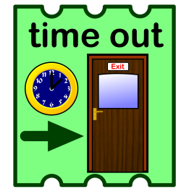

You have a swimming ticket above, we cannot possibly provide that on request!
Then do not provide the tickets for such a POLE and do not set up the AAC system so that such a request can be repeated. Only give access to what can be provided at any time.
Some days we might be able to provide staff to go for walks in the school garden but there will be equally other days on which we cannot.
As above only provide access and tickets for the things that can be provided or, if there is only staff availability for two walks only provide two tickets. Also remember to use the Motivational Minimum in all situations so that a walk around the school garden can be limited to just a few minutes and not an hour or more.

Working in Momentum Mode
There are two forms of Momentum Mode (explained in an earlier section). The following section can usually apply to either. Momentum Mode has many uses including the alphabetical ideas mentioned in the section above.

- Give greeting in order;
- Counting;
- Saying start and stop for others to follow orders;
- Giving instructions to another one by one;
- Telling a story piece by piece;
- Reading repeated lines in a story;
- Telling a nursery rhyme a line at a time;
- Saying your part in a play line by line or piece by piece;
- Telling a joke;
- Giving your news to mum (Significant Other);
- Saying a prayer;
- Singing a song line by line or verse by verse.

This list is NOT exhaustive. The idea is to enable a Learner to communicate a series of items that s/he may not have been able to communicate previously. There are a few guidelines to producing a Momentum Mode set of pages:

- Try to keep each part of the overall message short;
- Choose symbols that are relevant to the part being spoken;
- Choose vocabulary that is at the cognitive level of the Learner;
- Select images that the Learner is likely to comprehend;
- It is more practical to build pages that may be used more than once;
- If asking a question or telling a joke put in a non speaking page before the answer/punch line so that the Learner does not give away too much, too soon!
- Use repeated narratives such that the Learner can become accustomed to the vocabulary and the images;
- A single repeated line from a story (oh no, I can’t stand this) does not require Momentum Mode (rather use Direct Mode – see earlier section). However, where:
    - there is more than one repeated section/line and they always fall in the same order;
    - A single section can be split into more than one part (because a single part would be too long);
Momentum Mode is a must!
- Have a thought to the future. Where are we going? What is next? Can I expand what I am doing into the next challenge for the Learner? How is this work going to fit into an eventual communication system? …

How can we tell if a Learner is simply fly swatting in Momentum Mode?

It may be that each part of Momentum Mode (Min) relates to a different section of a task or event. If the Learner activates the different sections appropriately (without significant prompting) it suggests Cognitive Engagement and CE rules out fly swatting.

When would I use Min and Max Modes?

Max Mode (Maximum Output) is actually similar to Direct Mode and therefore may be used to address the POLEs (Persons, Objects, Locations, Events) that would normally addressed with this mode of operation.

Can I use both Min and Max modes interchangeably with a single Learner?

While there may be circumstances that a Significant Other would want to do that it is normally best avoided! Mixing both approaches may only serve to confuse a Learner as to the functioning of the device. Perhaps in a situation in which a Learner is under pressure to perform (performing lines in a play) then a switch back to Max Mode for the performance may be acceptable.

How can I encourage SimpleAAC’s use in the Development of Literacy?

That is too big a question to be fully answered here. It is best to look at a good webpage on this topic such as http://talksense.weebly.com/literacy-and-aac.html However, if we focus on using SimpleAAC to generate repeated story lines there are several points to note:

- A repeated story line(s) will occur on several pages in a child’s book. For example the lines, “Oh No!” said Mr. Bear. “I can’t stand this” appear regularly within ‘Peace at last’ by Jill Murphy.
- A repeated story line can be treated a single whole and, therefore, will be addressed with a single page overlay in Direct Mode OR,
- A repeated story line can be separated into individual parts and addressed by putting each part on a single page (three parts then a three overlay) OR,
- A repeated story line can be separated into individual parts and addressed by using the Single Page Overlay in Momentum Mode.
- When the repeated story lines occur one following the other, Momentum Mode can be set to either MIN or MAX.
- When the sections repeated story lines do NOT follow each other directly in the story then Momentum Mode Max cannot be used and the system must be set to Momentum Mode MIN OR the lines must be display on a two, three, four … location overlay depending on the number of lines.
- For advanced work , each word within the repeated story line could be placed separately in a single cell on a separate page such that the Learner can create the sentence required. The words could be placed in the correct order at the start but then moved around such that the Learner has to locate them for him/herself at a much later stage!

Initially, when reading the book to a Learner the Facilitator can have control of the SimpleAAC screen and as each repeated story line is reached the Facilitator activates the screen and allows the iPad to read. However, perhaps after doing this a few times, the facilitator encourages the Learner to participate. When the appropriate moment arrives, the facilitator can cue the Learner… “And what do you think Mr Bear says?”. Cues should always start with the least intrusive and move to the most intrusive. The most intrusive and, therefore the last thing that you should attempt to do, is a physical prompt: actually taking the child’s hand and placing in on the iPad to create the response. If you have to do this, please ensure that you talk the Learner through what you are doing and you give lots of accompanying body language cues such as looking at the Learner’s hand before reaching out a moving it. Always use a hand-under-hand technique with your hand supporting the Learner’s wrist (always support a bony structure – wrist, elbow, etc) from the underside. However, long before you attempt this method of cueing begin with much less intrusive forms such as:

- Stopping and pausing at the moment when it is the Learner’s turn and looking at the Learner and then at the iPad and waiting expectantly.
- Shining a light source on the iPad surface (small torch or a laser pen);
- Giving a verbal cue as a question, “And what do you think Mr Bear said then?” as though it is a part of the story. This prompt uses NO pointing.
- Associating another event with the Learner’s turn to speak. For example, a buzzer or bell is sounded very briefly.
- Pointing at the iPad.
- Stating that it’s the Learner’s turn to talk
- Physical Prompting.

The above list is not intended to be exhaustive rather to illustrate a progression from the least intrusive to the most intrusive. As with all prompting, the prompts should be faded over time.

Multi-Location Pages

One location Direct Mode naturally progresses to two location pages and two to three... However, it does not follow that Significant Others must now abandon all use of one location solutions.

The two location page splits the iPad screen into half such that touching either half of the screen produces a differing response. While there are well over one hundred and fifty pre-programmed two location pages from which you may choose, they will not meet every need and, as such, may be adopted, adapted or rejected as necessary. Other page sizes split the pages in a regular way according to the number of cells. Each page comes with a pre-programmed set of overlays from which you may select. However, if none of these meets your specific need they can be adapted as required or you can create a completely new page from scratch. If you adapt a page, always save it with a new page name such that the original page is retained and the number of pages grows.

Indeed, in any multi-location page, you may like a particular overlay but find that it is not quite right for a particular Learner. You do not need accept an overlay as it stands, you are at liberty to adopt, adapt or reject them at will. However, you are advised NOT to delete any overlays unless it becomes absolutely necessary (the iPad’s memory becomes full for example): keep them just in case they become useful in the future. Re-order the listing such that the overlays that you are using often are at the top of the list and the overlays that you hardly ever use are at the bottom. The methodology for re-ordering the list is described earlier in this manual.

You may not like a particular colour background to an existing overlay – change it.
You may not like a particular symbol used in an existing overlay – change it.
You may not like a particular word from an existing overlay – change it.
You may find that the TTS system mispronounces an individual word – record the message
instead.

However, when you have made significant changes, save the ‘new’ overlay/page with another name such that there are now two overlays where there used to be just one.

Rather than detailing each of the multi-location pages separately we will look at how they may be used …

Assessment
Base Line Understanding
Choice: (Juice or water, Beans or Peas or…)
Description: Big or Small, Hot or Cold, True or False, Big or bigger or biggest
Educational Evidence: Magnetic or Non-Magnetic, Expand or Contract
Feelings: Happy or sad, Interested or Bored, Angry or Calm … Fun
Getting attention: ‘Can you help me please?’, ‘I have finished’
Hearing: It is possible to assess a Learner’s listening skills using such an overlay.
Instructions: Learner provides instructions for others to follow (‘Go’ ‘Stop’, ‘Faster’, ‘Slower’)
Jokes and Japes: simple two part jokes or use the top row for part one and the bottom row
for the retort.
Know: Letting others see that you understand something because you can provide the right
response every time from a choice of two.
Learning a Language: that is, speaking in a foreign tongue (Oui and Non, Ja and Nein, etc).
Some Learners may speak one language at home and another in school. Overlays can be programmed to speak in multiple languages.
More or less: letting others know what your requirements are.
Numeracy: counting (one or two, three, four, five, etc)
Ordering: ‘Can I have a Big Mack’ ‘And a coke please’ ‘How much is that?’ …
Performance: Perform lines in a play …
Quoting repeated story lines
Recitation: a poem (or two). Requesting a favourite item
Singing songs; favourite songs are stored to create a juke box
Temporarily Restricted Vocabulary (TRVs pronounced ‘Trevs’). Teaching and Tuition
Use it for Social Greetings (Hello … How are you?)
Video choices: Choosing between two videos.
When: now or later, yesterday, today or tomorrow …
Xtra goes: ‘again’ and ‘please’, ‘more’ and ‘please’ …
Yes and No responses
Zounds and Zikes; ‘Making a comment ‘Oh No!’ ‘Oh wow!’ ‘Brilliant!’ ‘oh dear’ ‘that’s bad’

While it should not be assumed that the above listing is exhaustive, as can be seen there are a plethora of ways in which to utilise multi-location overlays. Obviously, they can be used to provide a choice between items: for example, at the two location level, whether Learners would like custard or ice cream with their apple pie or whether a Learner wants to go to Burger King or MacDonald’s.

The system can be used to make requests. For example, it could be used to ask for a particular item in a shop, request a particular condiment at meal times, state a preferred colour for an item of clothing, or request a particular activity. This can begin simply using the one location overlay in Direct Mode to provide ‘errorless’ learning but can soon progress to two, three and greater cell overlays depending on the Learner’s cognitive abilities. The system can grow with the Learner and also help the Learner to grow.

The system can also be used to TEACH concepts. If a choice is provided and a Learner makes a selection, what does that prove? That they understand the concepts involved? Not really. It only proves that they are capable of activating the iPad’s surface at a particular point (it does not prove they are capable of operating a two location overlay because the Learner may always activate the iPad at approximately the same point on its surface). However, if on activating the iPad and therefore making a ‘virtual’ choice (it was not really a conscious choice, it was just selected because that is the point that the Learner happened to access) we provide the choice as though it were a conscious decision, what does the Learner eventually understand (it may take many months for this to happen)? Hopefully, the Learner comes to understand that what they select is what they get. They also may come to understand that when they select a particular image that it is followed by a particular (favoured) POLE (Person Object Location or Event) and when they select another it is something that is not liked. Providing a two location overlay with one item that is known to be favoured and one that is known to not be in favour is one way of assessing a Learner’s ability with the system. The items should appear in different positions (make and save two separate overlays one which is the opposite way around to the other) so that the Learner cannot simply learn to select the one on the right.

One use of multi-cell pages is for second language use: a Learner may be speaking English at school and (for example) Polish at home. An overlay could be set up such that one row contains the word in English and the row below contains the row in Polish OR two separate but identical pages could be made such that the first is in English and the second in Polish. From the Learner’s perspective, s/he is accessing the same image on the same cell in the same position but, at school it is speaking in English and, at home, it is speaking in Polish!

Using multiple cell overlays it is possible to teach good manners to a Learner. The words ‘please’ and ‘thank you’ can be added as separate units for example. If please is added to the end of a request on a particular cell (Can I have some more please?) then the system is being polite on behalf of the Learner but if ‘please’ occupies a separate cell of its own ten the Learner has to choose to be polite. However, it should be noted that ‘please’ and ‘thank you’ are not concrete concepts and may be very difficult for some Learners to comprehend. Thus, they may be best left to an appropriate developmental stage when the team believe that it is appropriate that they are introduced. Typically, when children are developing, parents naturally using a fading technique for such word use:

- When you say ‘please’
- What’s the ‘p’ word?
- Haven’t you forgotten to say an important word?
- Parents don’t say or do anything until the child is polite.

Such strategies can also be used to good effect in the classroom. At first, a direct verbal prompt may be used (‘When you say please’) but after a while this may be faded and lesser prompts may be utilised.

SimpleAAC can be used to allow the Learner to play music, sing songs or watch videos. Such use of the system can prove to be intrusive on the ‘space’ of others especially if used inappropriately. Perhaps, a Learner has access to an overlay which includes a song or a sound effect and is operating this over and over in class much to the annoyance of one or more staff members. A staff member might react by switching the iPad off, removing the system, or asking for the offending cells to be removed (or a combination thereof). All of those ‘solutions’ to this ‘problem’ are to be avoided. The staff member should be asked what they would do if a vocal child were to start singing during their session or pretending to be a phone! Would they tape up the child’s mouth? Remove their vocal chords surgically? Ask for a specialist to remove knowledge of the song from the child’s mind? Of course not! They would address the behaviour. So what is different? Nothing! Staff should always address the behaviour they should not remove the system.

TRVS or Temporarily Restricted Vocabularies are a means of providing very rapid access to AAC such that a Learner can operate on a level commensurate with his or her peers.

The second vocabulary and language barrier relates to ‘verbal’ classroom participation. All students, at all grade levels, are asked questions, ask questions of others, take oral examinations, and are called upon to recite information. In some classrooms, even shy students who speak cannot get a word in edgewise. For augmented communicators, the possibilities of well timed speaking is even more remote. The pace of verbal exchanges is too fast to allow even the most efficient student using AAC to participate” (VAN TATENHOVE G. & VERTZ S. 1993)

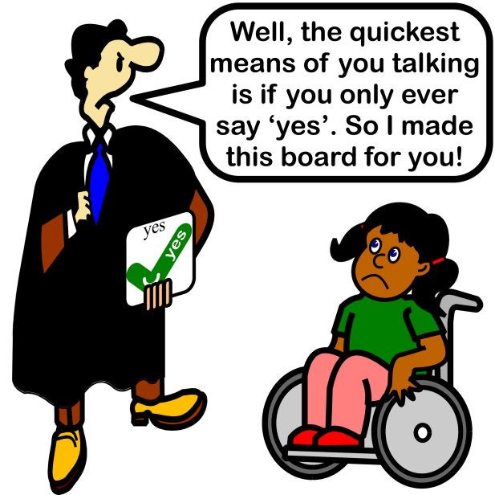
A TRV (pronounced TREV) is a small subset of the vocabulary normally contained within any Learner’s AAC system although it could be set up by a teacher as a standalone system to use on specific occasions. It allows a beginner to be involved in an activity on an equal footing with peers. The section below details more information about TRVs but is not limited to just the two location pages.
A TRV vocabulary may be set up to include phrases:
“That’s right!”, “That’s wrong!”, “I need to think about it, “I don’t know”
The class are told that they must use one of these phrases in response to the teacher’s questions in the session that will follow. For example, the maths teacher might say:
“If I am facing South and I turn two right angles clockwise I am now facing North.”
The pupil has to respond with one of the messages. People using an AAC system can usually access one of the responses in real time on a level footing with their verbal peers. There is a further benefit. The messages are a useful addition to the Learner’s vocabulary. They may be used in other lessons and other situations they may encounter:
“Jane you’re 14 now, aren’t you?” “That’s right”
Other TRV’s might include:
“I agree’‘ , “I don’t agree”, “I’m not sure”, “I don’t know”
“True”, “False”, “Sometimes”
TRV’s can be noun sets. For example, a set of materials:
‘wood’ ‘Metal’ ‘glass’ ‘paper’ ‘plastic’
In this instance, the response required is one of the given materials:
“Which material is transparent?”
“Which material is used to make books?”
“Which material is made from sand?”
“Which material is not man-made?”
The material set is taught and reinforced in this way.
In the cartoon the TRV is not valid. TRVs should always be a minimum of two words or phrases. If a person is tested for comprehension, the larger the TRV the less opportunity of obtaining a right answer by chance alone. At the other extreme, there is a limit to the size of any TRV. Too big a set becomes a sub-vocabulary or a category in its own right and does not allow a Learner to interact with peers on an equal footing in a classroom interchange. Ideally, a TRV is more than one but less than nine.
A TRV could be set up to give directions to a staff member in a treasure trail game or a game of hide and seek. For example:
‘Right’, ‘Left’, ‘Forward’, ‘Backwards’, ‘Stop’
‘Up’, ‘Down’, ‘Right’, ‘Left’
TRVs are ideal for games:
Each player starts with one point. Using a pack of cards the user has to state whether the next card is ‘higher’ or ‘lower’ or ‘red’ or ‘black’ for a doubling of their points total - OR - ‘hearts’, ‘spades’, ‘clubs’, or ‘diamonds’ to treble their points total. The user may stop at any time by saying ‘stop’. The person with the highest points at the end is the winner.
The TRVs give control to the augmented communicator with minimum effort and without the need for many hours of vocabulary instruction. Temporarily Restricted Vocabularies:
- allow augmented communicators to participate in lessons on an equal footing with peers;
- may be easily spoken in real time; the class is not made to wait for long periods while a user generates a response;
- can ease the pressure felt when asked a question;
- ensure users are not singled out as special - everyone is the same;
- are easy to set up; vocabulary may be quickly programmed into some systems by the tutor involved;
- involve subject tutors in the tuition of new vocabulary;
- do not require many hours of vocabulary tuition before their use;
- may be themed, paged, setted, or categorised for the ease of a scanning user;
- speed access to vocabulary for switch users;
- allow symbols to be displayed at a larger size to ease selection. Later these can be added to a user's symbol board at the standard size;
- may be used to teach and test key concepts;
- are best used with all pupils or students in a class or group;
- are always >2 but typically <8.

TRVs can be prepared specific to each subject of a Learner’s curriculum. Subject teachers can either suggest specific vocabularies or be shown how to build their own. However, too many teachers building too many pages each with its own unique style is likely to be confusing for and Learner: One staff member must take overall control and oversee the whole system.

SimpleAAC can be used for Learner assessments:

- A Learner’s knowledge of a particular topic area could be assessed by using a TRV as described above;
- A learner’s particular level of understanding might be gauged with SimpleAAC;
- SLTs may program pages to use with a particular assessment system (such as TROG) so that the Learner can provide an answer from a set of possibilities;
- A Learner’s hearing might be (basically) assessed by analysing responses to specific questions;
- A Learner’s ability to cope with a specific situation might be assessed using SimpleAAC.

With all the above ideas, it is better to begin small and simple and progress to larger and more complex overlays as time passes and the Learners show by their actions that they are ready to progress to a new level. Such progression is best made as a decision of the team involved with the individual and not on a unilateral basis. Staff should be informed that Learner ‘B’ is presently working at the ‘4’ location level and that all overlays should not exceed this size unless approved by the team.

Planning Pages

To help with the planning of pages there are a set of grids provided in the appendices which may be freely photocopied.

Scanning with SimpleAAC

The present version of SimpleAAC does NOT scan and therefore cannot be controlled by switches. However, there is a version to follow (first quarter 2013) that will be accessible via scanning:

SimpleAACplus
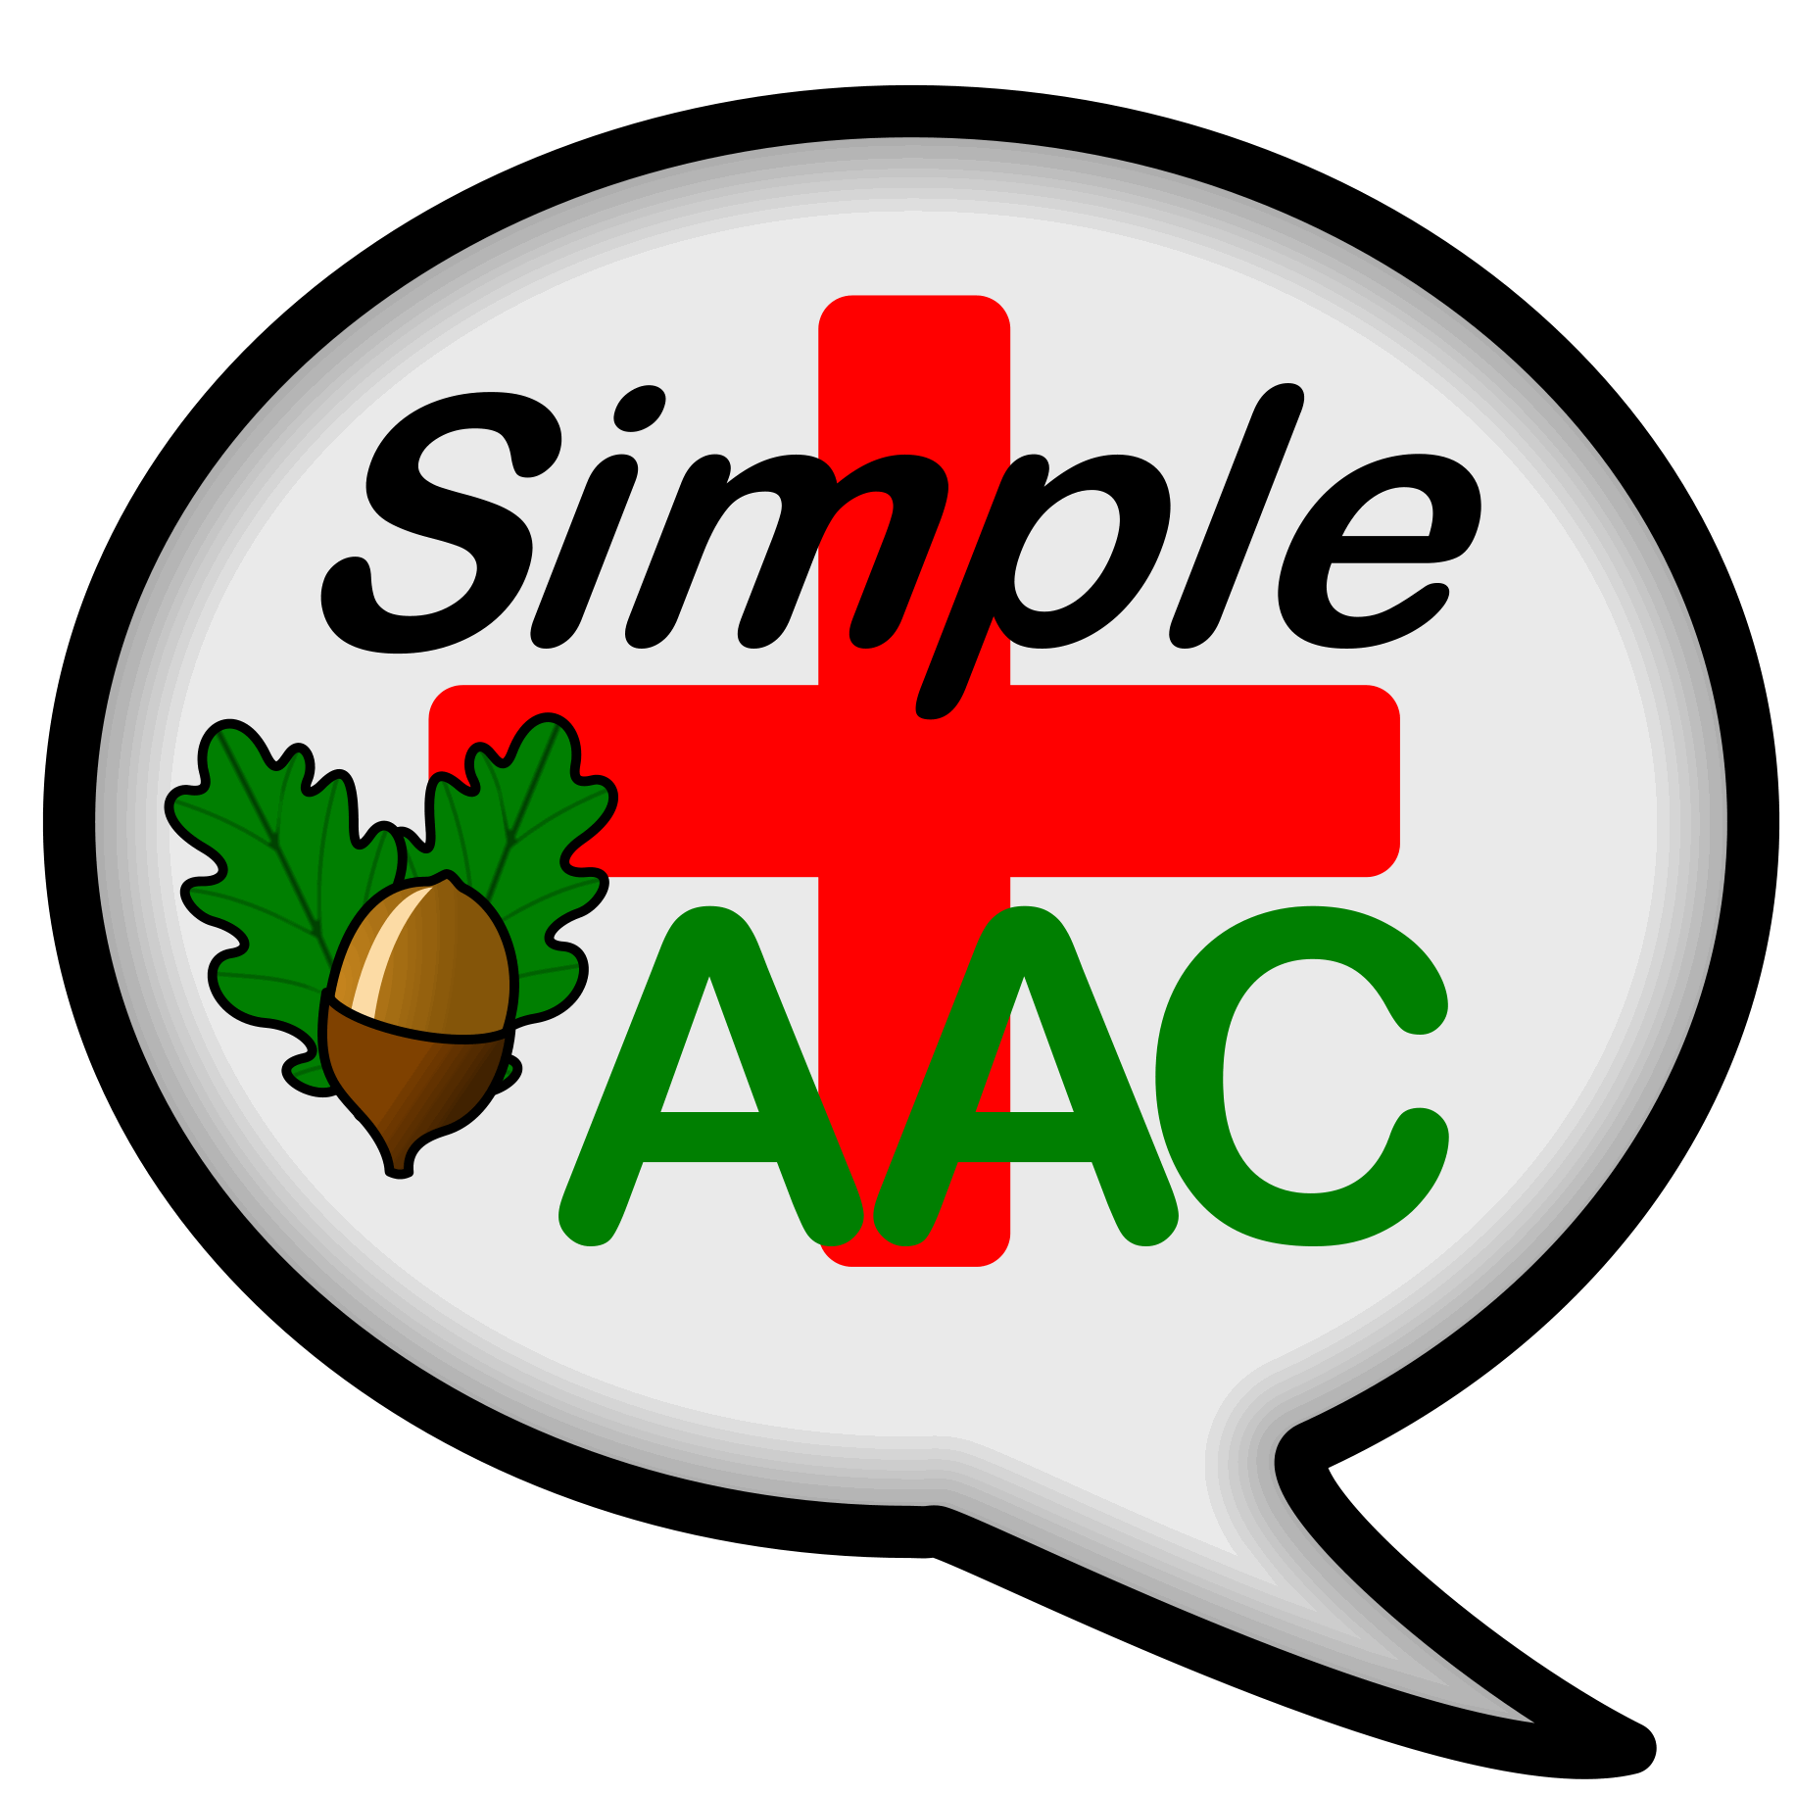

SimpleAACplus is packed with extra features:

- Scanning access
- Linked pages
- Swap cells on pages
- Custom Overlays
- Add columns/rows to existing overlays
- Speak a different message to text shown
- Differential time delays in Max Momentum Mode

SimpleAACplus is coming to an iStore in the first quarter of 2013.

An upgrade version from SimpleAAC will also be available at no financial disadvantage. So, don’t delay: buy SimpleAAC today!

From Simple to Smart
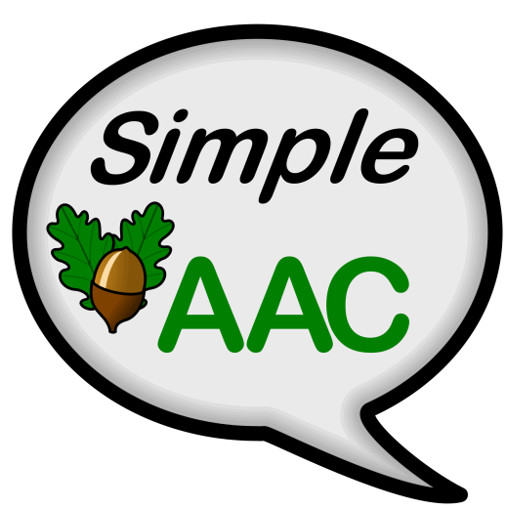

Also from Unlimiter Software, SmartAAC provides access to a large vocabulary from just 35 cells (7x 5). Using SmartAAC provides rapid access to language. In fact, we believe that SmartAAC is probably the quickest AAC system around! SmartAAC can be downloaded from the iStore. It is free for a week’s trial before purchase is necessary.

Appendices

Your Local Distributor

Unlimiter has distributors in several countries that can provide product support:

Australia
Communicate AT
Address: PO Box 389, BROOKVALE BC NSW 2100, Australia
Telephone: 02 9948 2665
Fax: 02 9948 2669
Website: www.communicateat.com.au
E-mail: Adam@communicateat.com.au

New Zealand
Zabonne Ltd
Address: 4271 Great North Rd., PO Box 69 203, Glendene, Auckland 0645, New Zealand
Telephone: 0800 351 151
Fax: +64 9 836 4668
Website: www.Zabonne.com
E-mail: sales@zabonne.com

Taiwan
Assistive Technology Engineering Lab Inc.(‘Unlimiter’)
Address: Level 5-1, No.18.1, Section 3, Ren-ai Rd., Taipei 106, Taiwan
Telephone: +886-2-2704-7620 ext.20 or +886-2-7729-7950 ext.20
Fax: +886-2-2703-5359 or +886-2-2703-4723
Website: www.unlimiter.com.tw
E-mail: Service-Unlimiter@Unlimiter.com.tw

United Kingdom
Ability World Ltd
Address: 43 Svenskaby, Orton Wistow, Peterborough, PE2 6YZ
Telephone: 0845 47 47 245
Fax: 0845 26 97 245
Website: www.ability-world.com
Email: enquiries@ability-world.com

USA
PCI Education
Address: 4560 Lockhill Selma Rd., Ste. 100, San Antonio, TX 78249-2075
Telephone: 210-377-1999 (Local) OR 800-594-4263 (Toll-Free)
Fax: 888-259-8284
Website: www.pcieducation.com
Email: via website

STAR: Shelton Technologies and Resources
Address: 213 E Bay St., Lakeland, FL 33801
Telephone: 863-603-7827
Fax: 863-603-0255
Website: www.staraac,com
Email: info@staraac.com

Page Planners

20 Location (5 x4) (please turn pages to landscape)

12 Location (4 x 3)

9 Location (3 x 3)

8 Location (4 x 2)

6 Location (3 x 2)

4 Location (2 x 2)

