Designing Communication Boards and Books with Core Vocabularies and Uni-Tech

Judy King, Kuo-Ping Yang, Chih-Kang Yang, and Tony Jones

Judy King, B.Sc., Cert HPC, MRCSLT, MASLTIP Independent Speech and Language Therapist
Professor Kou-Ping Yang, Ph.D., President, Assistive Technology Engineering Labs, Taipei, Taiwan
Chih-Kang Yang, Ph.D., Assistant Professor, Dept. of Special Education & Assistive Technology, National Dong Hwa University, Taiwan
Tony Jones, M.Ed., B.Ed. (Hons), Cert.Ed.Man., Cert.Ed.Res., Cert.Ed. Managing Director, TalkSense UK
There is an increasing amount of research data that shows that when we speak or when we write we use certain words much more frequently than others. These words are the same irrespective of age, profession, time of day or year, or the subject of the conversation. In the Oxford English Corpus of over one billion words (www.askoxford.com) just 10 lemmas (root words) account for an incredible 25% of the total vocabulary and 100 words account for 50%! Comparing this corpus to other research, we find that the same thing is happening in each list. The unusual aspect of the most frequently spoken and written vocabulary is that it contains very few nouns. Generally, only two nouns fall in the top 100 words: time and people. Typically, Augmentative Communication Boards comprise a greater proportion of nouns than would be suggested by evidence based research. This paper attempts to address that issue by developing new styles of communication boards and books and will demonstrate how a Uni-Tech approach might bring life to such systems.

No matter where you live in the world,

Our preliminary findings support the earlier attempts to identify Mandarin Chinese vocabulary using automated approaches or Mandarin Chinese databases. This early data analysis shows that a relatively small number of words (less than 200 words in this sample) will make up 80% of the spoken words used in conversation. These findings are similar to the vocabulary frequency studies in European languages and demonstrate that high frequency words or core vocabulary is consistent across different speakers and topics. (Chen, M.C., Hill, K.J., Yao. T. 2009)

or what age or sex you are, or what occupation you hold, or the subject of the conversation, evidence-based spoken and written language frequency studies show that some words are used much more frequently than others. The different research studies (see bibliography) show remarkable similarity in their listing of the top items of vocabulary with virtually every English speaking study placing the word ‘the’ in the number one position, for example. The Oxford English Corpus, probably the biggest of such corpora, used for the creation of the Oxford English Dictionary (www.askoxford.com), contains over one billion words. When analysed, an incredible 25% of the total vocabulary comprises just ten lemmas. A lemma is a head word or root concept: for example ‘go’ is the lemma for the set of words including ‘go’, ‘goes’, ‘going’, ‘gone’, and ‘went’ and even ‘goer’. Lemmas are the head words that appear as dictionary entries: there are not normally separate entries for ‘goes’ and ‘going’ and ‘went’. The ten lemmas are not nouns (nor social greetings) but rather: ‘the’, ‘of’, ‘a’, ‘and’, ‘be’, ‘I’, ‘in’, ‘of’, ‘to’, ‘that’, and ‘have’. These top ten items are not easily represented in symbol form: for example, try to draw the word ‘the’ or the word ‘of’ or the word ‘have’ in such a way that when the ‘symbols’ are shown to the person-in-the-street, most would correctly identify the word represented without any additional clues or training.

Other large vocabulary databases (for example the British National Corpus (1994) or the Brown Corpus (Francis W. and Kucera H. 1967)) also demonstrate that the most frequently used words are virtually identical across corpora. Some items of vocabulary, that people might believe are often used in conversation, have been shown to be of a lower frequency. Nouns, for example, are notable by their relative paucity in the lists of the highest frequency words. Nouns don’t feature in the top 50 words at all and. only two or three (notably people and time), just creep into the top 100.

Specialist corpora (for example: Raban B. (1988); Marvin C.A., Beukelman D. R., & Bilyeu D., (1994); Balandin S. & Iacono T. (1999)) also show the same pattern of words: it does not matter what age, what sex, what occupation, or the topic of conversation, the most frequently used words are virtually identical. Even when the vocabulary of augmented communicators is examined (where vocabulary selected is constricted by the words that have been stored and those that have been learned), we still find a similar pattern (Jones A.P. 1993, Hill K. 2001)

How is the evidence from this research data affecting practice in the design of communication books and boards? From the experience of the authors of this paper, there is often very little relationship between the communication boards typically found in Special Need environments and the evidence provided by the research. Evidence Based Practice (EBP) would suggest a different approach to the design of communication boards and books. The resultant books and boards would also suggest a different approach to the way that ‘language’ is addressed and to teacher - pupil interactions.

Sentence Vs Word Vs Spelling

In the early days of AAC in the UK, it was believed that a sentence-based approach would best serve the needs of Augmentative communicators. After all, a couple of activations of keys that generates a whole sentence is surely more efficient than having to spell or select individual words. However, when people were given both words-based systems and sentence-based approaches in the same device, it soon became evident that they were using the words-based approach almost exclusively even to generate a sentence that was already stored. The reason for this was that it was not possible to store all the permutations of a sentence that might be needed by an individual on any occasion and, therefore, the individual was generating their vocabulary requirement for a particular occasion word by word. Had it been possible to store every sentence ever required, the Learner would still have not been able to use such a system because it would require almost eidetic memory. Consider the number of possible permutations of sentences just on the topic of obtaining a drink of tea:
I want a cup of tea
I wanted a cup of tea
I want a cup of tea with milk and two sugars
I fancy a cuppa
I really fancy a cup of tea just now
Do you want a cup of tea?
…
The list is extremely large on the topic of ‘tea’ alone. Then, add ‘coffee’, ‘milk’, ‘water’ … and different drinking vessels (mug, glass, can …) into the equation and it becomes an almost infinite list that is impossible to store as complete sentences into any system.

“Oh, that is just semantics.” Exactly! That is the issue. To get across an intended meaning, a single sentence was proving to be inappropriate for the circumstance and therefore it was easier to remember and use a unique combination of the words stored in the system.

If that is the case then, surely, it logically follows that spelling provides the most flexible system of all, necessitating the smallest number of key requirements. That is undoubtedly a truism. However, spelling has two major disadvantages: the first is that there are a high proportion of people who require the use of an AAC system that cannot spell:

Given the critical importance of literacy skills for individuals who require AAC, it is of great concern that most individuals who require AAC experience difficulties in literacy development. Their skills lag behind those of typically developing peers, and these problems persist into adulthood.” Light, J. & Kent-Walsh, J. (2003)

and, secondly, spelling out a sentence l-e-t-t-e-r by l-e-t-t-e-r slows the rate of communication down to a point where it becomes painful for the communication partner.

Although the symbol set is small, spelling letter-by-letter is a slow and inefficient AAC strategy. Acceleration techniques such as abbreviation systems and word prediction are commonly used with spelling to reduce the number of keystrokes. However, disadvantages in increasing the memory and reading demands for these acceleration techniques can outweigh any advantages. Research has shown that word prediction is no faster than spelling. (www.aacinstitute.org/TheGoalofAAC/rules.html)

Once the rate of communication drops below a speed of 60 wpm, conversation partners start behaving differently in their interactions with the speaker. They begin to feel frustrated by the lack of conversational pace and will adopt strategies for increasing the rate at which conversation proceeds. This process may even begin to occur at rates as high as 100 wpm.

Speed is one of the main factors in normalizing the conversation between an AAC user and his or her partner. (Ruth Ballinger)(www.aac.unl.edu/yaack)

For the sake of conversational flow, the AAC users naturally adopted a more passive role, relying on their partners to steer the conversation in an attempt to increase the pace. Speed of communication is, in fact, considered one of the most important factors in normalizing conversations. Studies have found that normal speakers use 150 to 250 words per minute, but that AAC users average less than 15 words per minute (Beukelman & Mirenda 1992; Venkatagiri, 1995).

Spelling is often cited as a good means of communication because it requires no training. What should be remembered is the amount of time and training literate people have received in order to reach this state: From very early in their lives parents, family, teachers and others (as well as a significant input from the environment) have helped to nurture the development of literacy skills. In actual fact, a huge amount of time and effort goes into making each and every one of us literate. If such time and effort were spent in developing communication skills using a Core Vocabulary approach then there would be very few people who were communication impaired.

Core and Fringe Vocabulary

Core Vocabulary is defined as the set of the set of lemmas that make up the top 75% of speech when sampled across all environments by all populations and at all times (of day)(Jones A.P. 2010). This will typically be the top 1,000 words in most languages.

Fringe Vocabulary is defined as the set of words that is not contained in the top 1,000 words and, as such, can easily outnumber Core vocabulary by, at least, 1,000 to one. However, Fringe Vocabulary itself is a continuum with some words being used more frequently than others: a person might expect to say ‘museum’ more frequently than ‘oxymoronically’ for example. There will also be a set of Fringe words that may be added to the lower end of Core according to the professional or situational aspect of the individual: for example, a heart surgeon may say the words ‘heart’ and ‘scalpel’ more frequently than a member of the general public. Likewise, a person experiencing a communication impairment, may use the word ‘therapist’ more often. This aspect needs to be taken into account when creating communication systems.

Creating No-Tech communication boards and books

If we accept the evidence-based research that the top 100 words account for approximately 50% of the words we use then, any communication book or board that contains this vocabulary must be better at enabling faster, more efficient, ‘typical’ communication than any other design.

The system takes advantage of the fact that while we may have a normal speaking vocabulary of between 10,000 and 30,000 words, a core of just 100 words accounts for approximately 50 percent of words spoken. (www.inmaninnovations.com)

However, there still remains the question of how an individual obtains access to the remaining 50% of vocabulary which comprises more Core Vocabulary and a huge amount of Fringe. One solution would be to provide an alphabetic keyboard as a part of the layout with which a person could spell out any missing word. This assumes that the individual concerned can spell which, as we have already seen, maybe problematic. In a No-Tech system, another solution is to provide separate pages of ‘Fringe Vocabulary’ that are accessed by physically flipping through the pages until the necessary word is located. There are a number of problems with this approach:
- The extra pages obscure the core vocabulary making it much less accessible;
- Many people with physical disabilities find it difficult to flip through pages;
- How many extra pages are required and how is vocabulary to be arranged?
- Every extra page imposes an additional cognitive loading: on which page is a certain word located?
- How do we decide what additional vocabulary is really necessary for a specific user?

People often spend a great many hours of time creating fringe vocabulary overlays, for use with AAC systems, to provide access to words that may only be used once or twice in the future and then forgotten. The Learner may be taking a chemistry lesson on oxygen, for example, and several new words added to the system: ‘oxygen’, ‘atomic weight’, ‘Joseph Priestley’, ‘electrolysis’ … while such words may be used in the lesson, they may never be used again by the Learner. Ask yourself when you last used the word ‘electrolysis’!

The effort used in the creation of Fringe Vocabulary pages for a communication system by staff and or parents on behalf of the Learner is not justified by the amount such vocabulary is used.

The load is enormous and leads to the perception that augmentative communication is not worth the burden it places on staff and family. Baker B. (September 2008)

Indeed, if that effort went on teaching Core language instead, we would be seeing (hearing?) many more fluent communicators. Staff time would be freed to concentrate on teaching language rather than on endlessly preparing additional vocabulary sheets.

Thus, the focus should be on the architecture of creating Core Vocabulary systems and on the teaching the use of this vocabulary to individuals. If classroom practice were to change slightly, Learners would have many hours of practice using their communication systems each day utilising the same Core Vocabulary over and over instead of utilising separate sheets of Fringe words that may never be needed again.



There are several possible approaches to the creation of Core Vocabulary boards/books depending on whether a univocal or polysemic approach is adopted. Univocal Iconicity means, as its name suggests (uni = one, vocal = voice), one symbol to one word: thus, in a page comprising 32 symbols, a possible 32 items of vocabulary could be generated (one symbol to one vocabulary item). Polysemic Iconicity (Poly = many, semic = meaning) is an alternative to the univocal approach in which one symbol can take on different roles depending on the context. For example, a picture of a teacher might mean ‘teacher’ when used in the following context: “I went to school and I asked the XXX …” but might mean ‘school’ when used as “I am going to go to XXX now”. Normally, in a Voice Output Communication Aid, a symbol one any given page can only say one thing; however, when a Learner is pointing at a No-Tech communication board, the communication partner can interpret the use of a particular symbol according to the context in a very different way. Thus, No-Tech communication boards can use the secondary iconicity potential of any symbol to provide access to a wider range of vocabulary. Secondary iconicity refers to the alternative meanings that may be generated by any symbol (Sonesson, G. 2001). While primary iconicity is what a symbol may denote, secondary iconicity is what a symbol may connote. For example, the primary Iconicity of the symbol (right) is ‘house’ but it could also represent (connote) ‘home’, ‘family’, ‘security’. ‘mortgage’ … All of these are Secondary Iconicity items.

For the moment, let us assume a board and book restriction to univocal iconicity with a connotative aspect provided by the communication partner. We will also assume a double page A4 (210 x 297 mm) portrait layout. If each individual cell is 35mm square, it allows a 6 x 8 grid (6 x 35 = 210, 8 x 35 = 280) or 96 locations (2 x 48). At these dimensions the cells are large enough to display clear symbols.

Some may want to begin with a simpler communication book or board of perhaps just a few items. With such a restricted system, it becomes almost impossible to create a functional language system and therefore such ‘earlier designs’ are not covered in this paper. However, such boards should be seen as a ‘starting point’ with the facilitator having a focus on teaching access, vocabulary awareness, and communication, building towards a more advanced layout which will support the development of language.

While the focus in the design of such a system necessarily remains on Core Vocabulary there always remains the question of how the individual Learner will access commoner Fringe Vocabulary with relative ease. In the design below (there are other possibilities but space does not permit their detail here), the Core Vocabulary surrounds the Fringe which is placed on a removable, smaller, central, flippable, themed or categorized page. As such, at the start, only a few Fringe items may be made available (those that are the most motivating for the individual Learner). Then, as the Learner begins to grasp and make better use of the system, more Fringe items can be added.
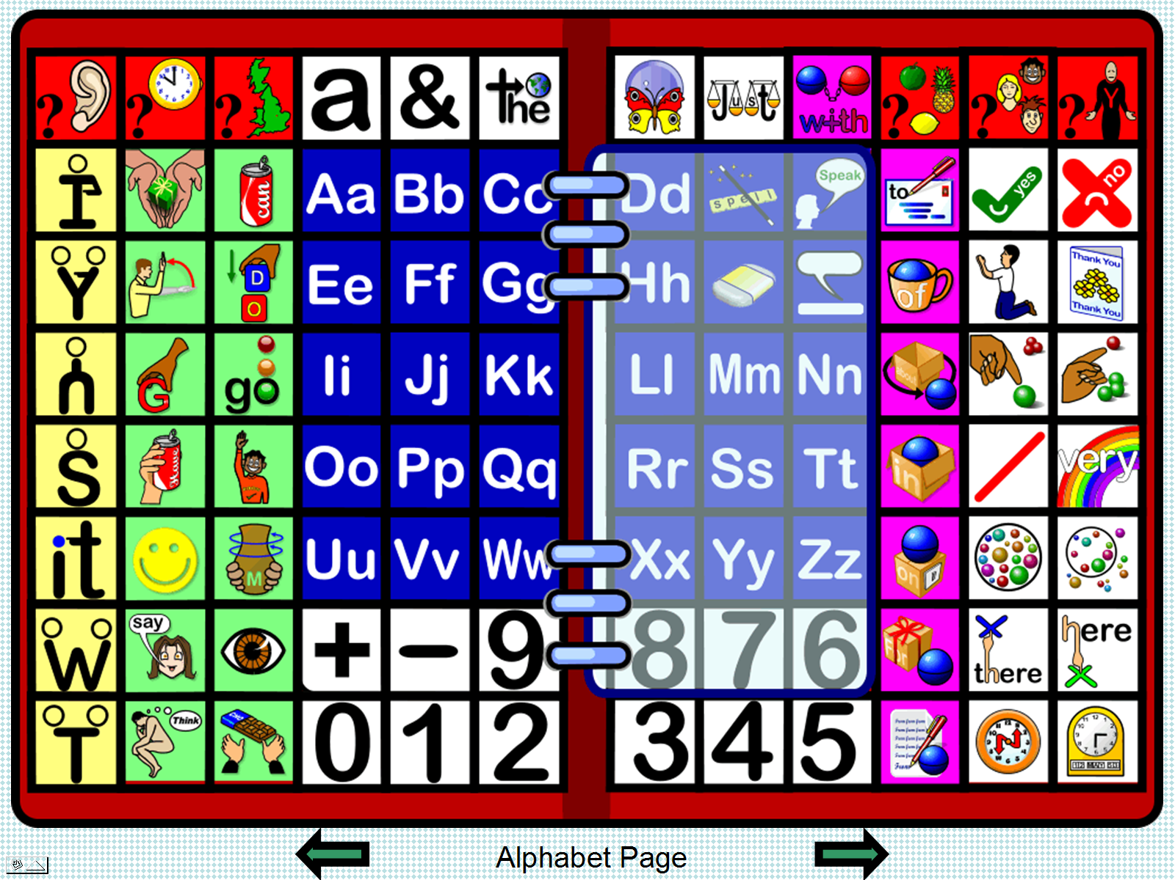
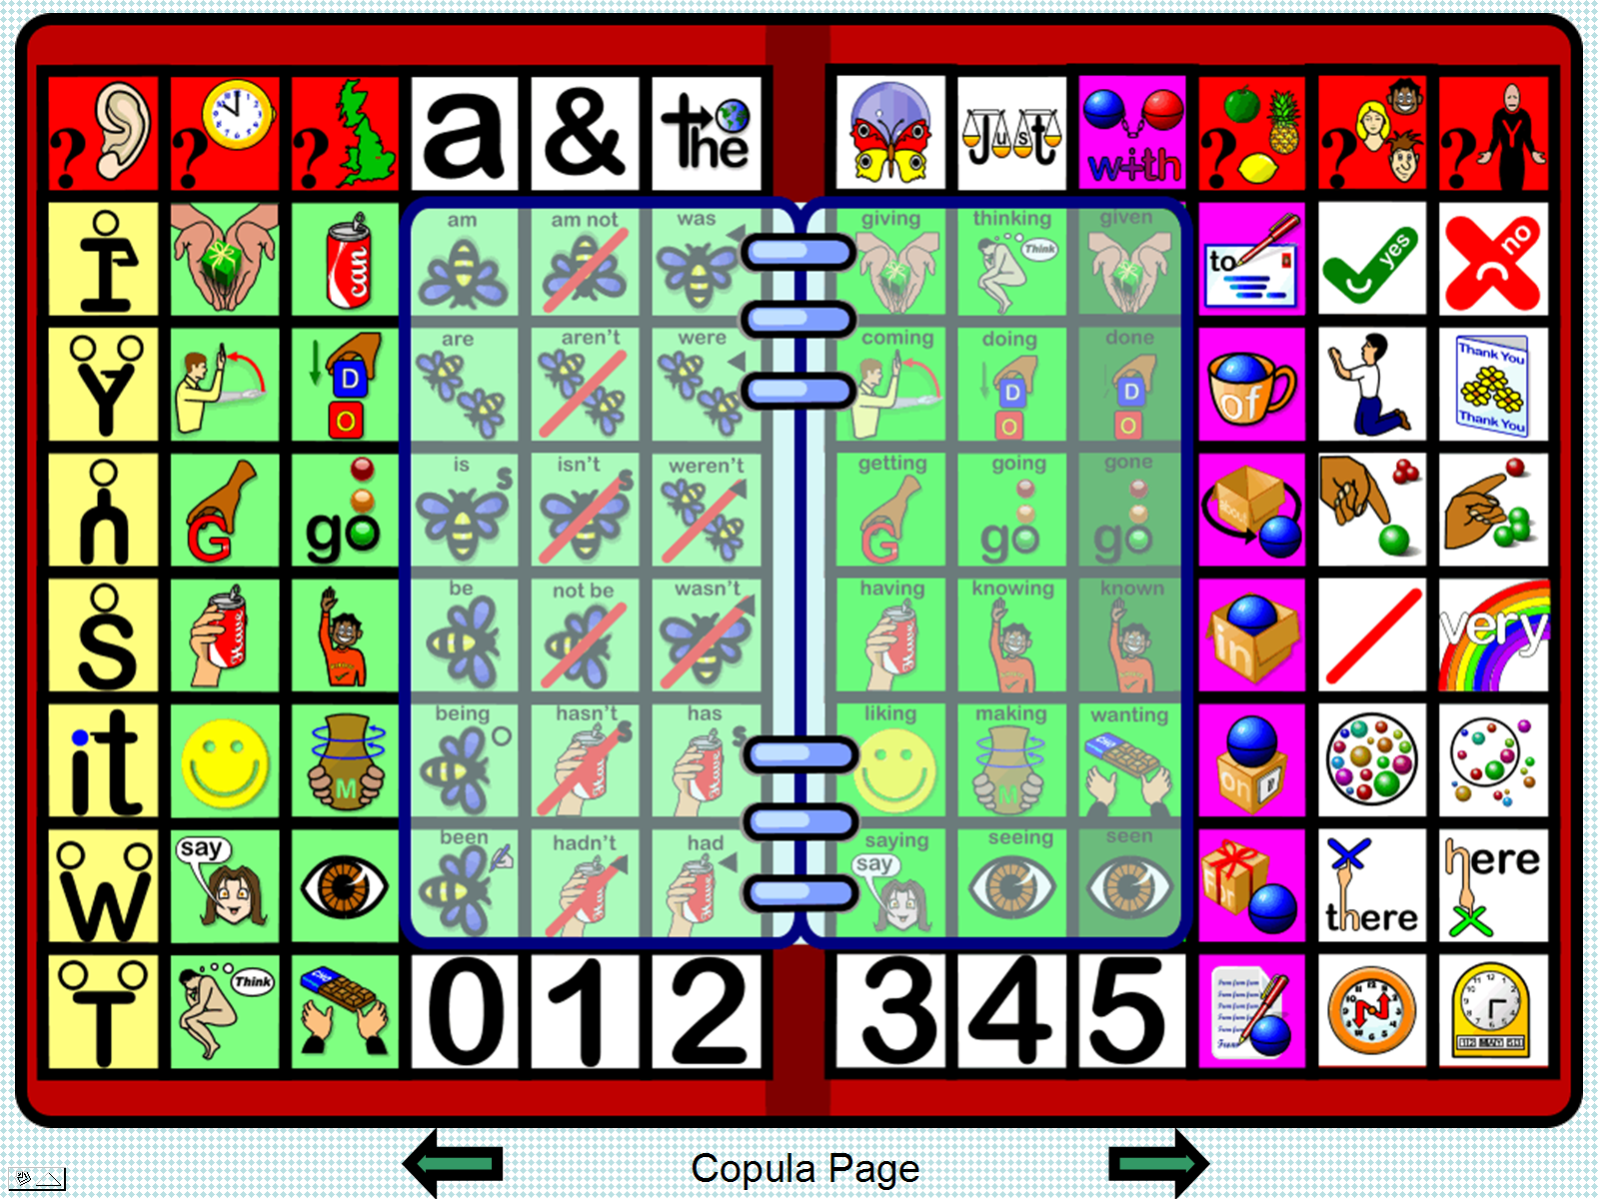
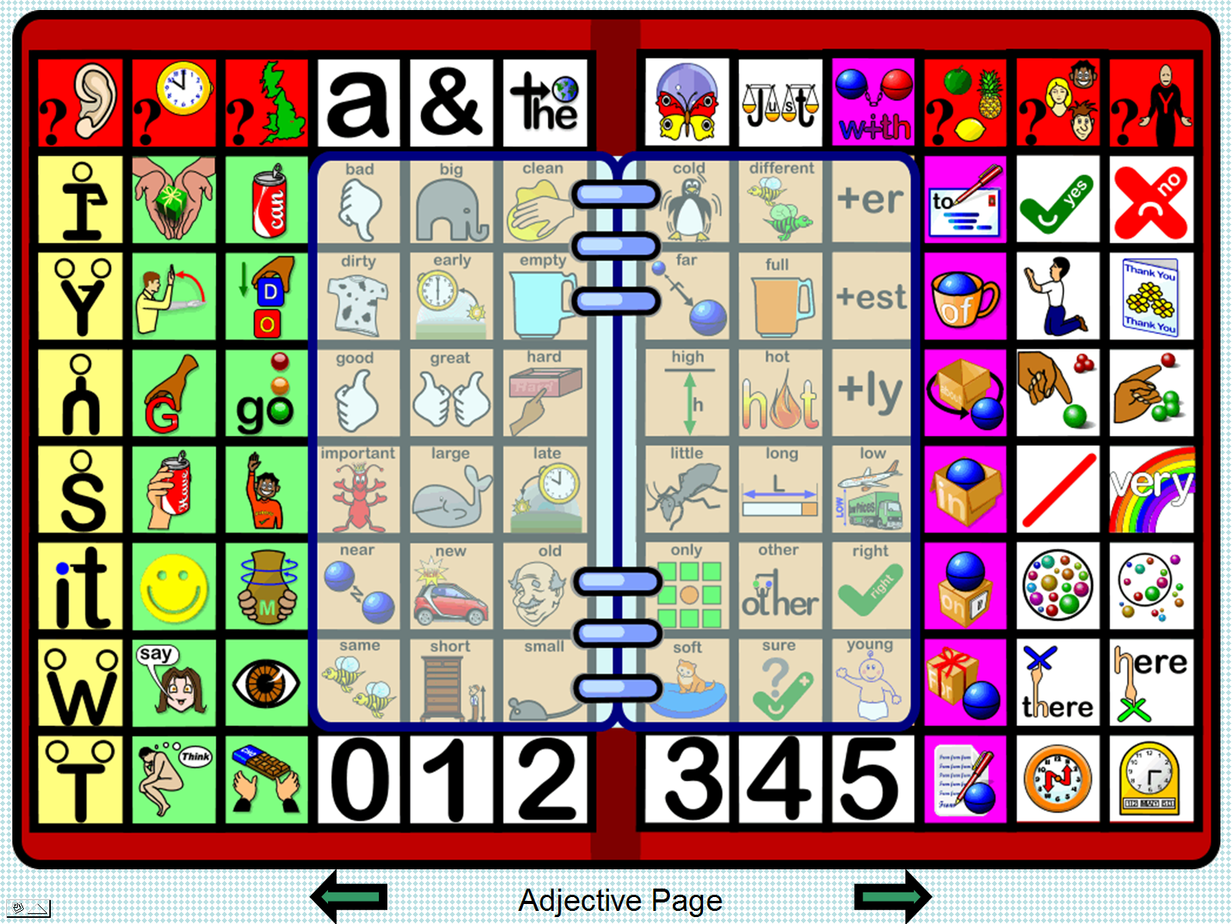
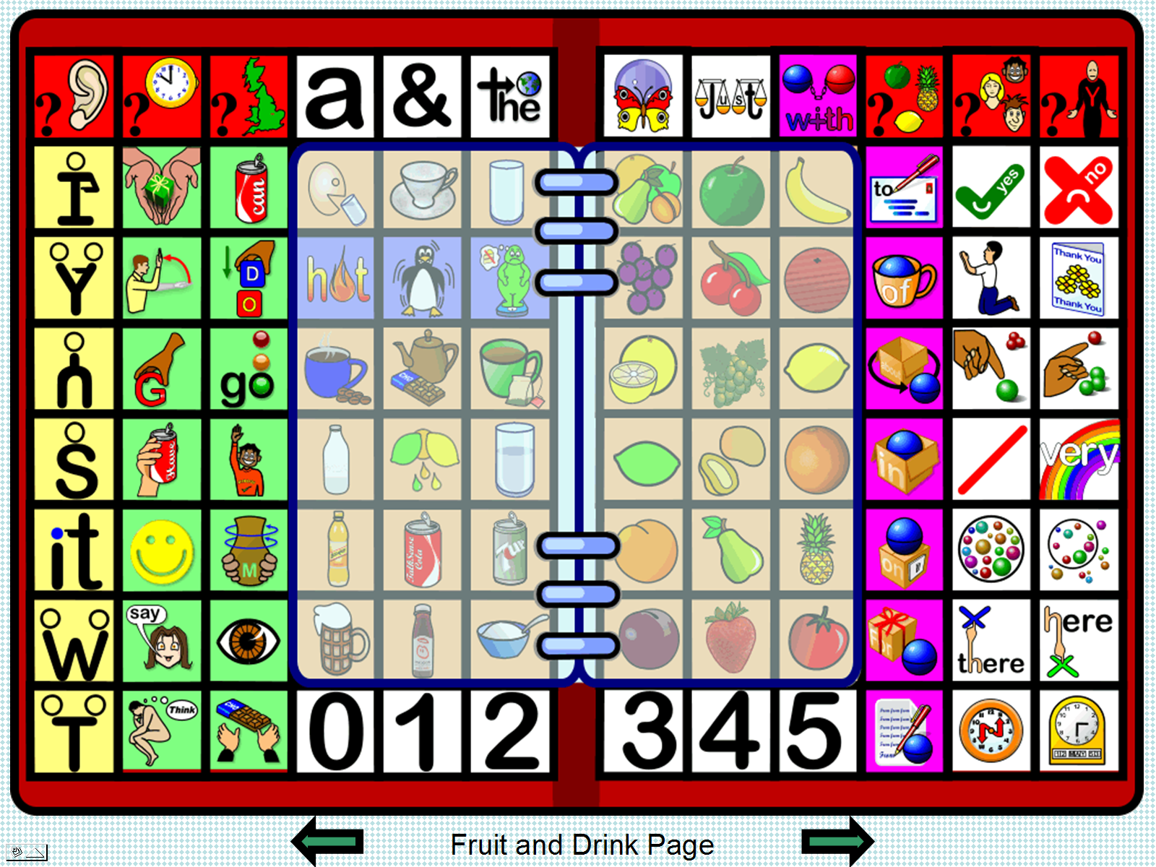
Thus, the Core Vocabulary is placed at the fringe of the layout and the Fringe Vocabulary is placed centrally at the core! Such a layout means that the Core Vocabulary is always available, static and unchanging.

The Fringe Vocabulary pages may also be used to provide additional access to the Core, as in the second image on the page, where verb aspects and tenses have been addressed.

Flipping through the pages therefore provides access to a greater number of words. Such fringe pages provide access to (36 = 2 x 3 x 6) additional items of vocabulary. This is somewhat equivalent to the pages utilised on a simple dynamic communication systems but at small fraction of the cost.

Using such a system it is possible to say, “I want a drink of cold, diet cherry coke in a glass now please” with only one activation per word when the fruit and drink fringe page has been selected.

The first and last pages are identical providing access to an alphanumeric layout that allows those that can spell to use literacy skills and those that have only emergent literacy to develop further. The learner will soon develop a familiarity and automaticity with the static Core and may eventually begin to use the fringe page items to connote additional vocabulary meanings in the mind of the communication partner.

Pages can use a Fitzgerald colour coded keyboard layout, although it should be noted that Edith Fitzgerald (1929) never actually suggested any such scheme of colour coding, although she did break language down into parts of speech to aid teaching to the deaf. Thus, the colour coding scheme was attributed to her at some later stage! Such a colour coding scheme can help make the location of a particular word form easier to locate and therefore speed the communication rate.
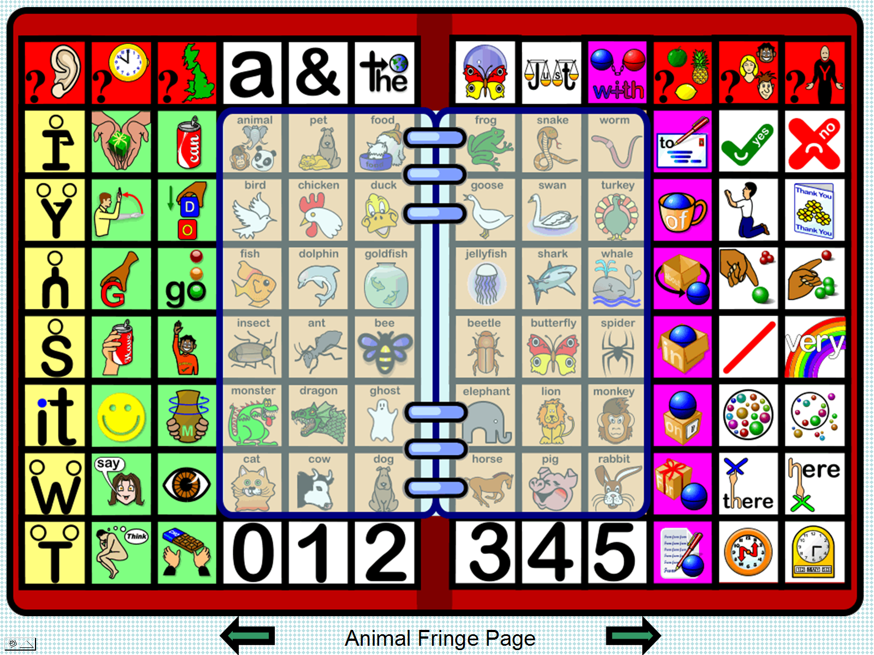
Greater access to core can be obtained by reducing the access to fringe by reducing the size of the fringe pages (make each only two columns wide, for example) or by reducing the size of individual cells and thus enabling access to more vocabulary on each page.

Adding additional fringe pages provides access to a greater range of vocabulary but increases the need to flip through and therefore the physical and cognitive loading.

However, the pages can be themed as well as categorized (the drinks page for example also provides access to some additional adjectives which are commonly used with drinks and the fruit can be used to create a particular flavour: ‘mango and orange smoothie’) which could reduce the need to move to a separate adjectival page, if other pages adopt a similar approach.

Referential Vs Descriptive Question formats

In our experience, educators in the classroom will use referential question formats when assessing the knowledge base of learners. For example, a teacher may ask the class, “Who wrote ‘Romeo and Juliet’?” or “What part of the body is used to pump blood?” Such questions are of the referential format in that they generally require a single or double word answer that is a noun or a proper noun. Referential questions require reference-book type responses which comprise fringe vocabulary. Both ‘Shakespeare’ and ‘heart’ are example of fringe vocabulary; we do not say them very often.

If, however, the process was turned on its head and teachers asked descriptive type questions then they would be assessing learner understanding:

“What do you know about William Shakespeare?”
“What do you know about the human heart?”

Such questions can be answered by using Core vocabulary:

“He is old time man write books … “,
“It part of man. Use to push red around body”

As such, core vocabulary words would be applicable in every situation and used very frequently. An individual would quickly learn where they were located on the communication board and begin to understand how to put them together to form increasingly grammatical utterances which would serve well in all other situations. However, ‘William Shakespeare’ (and other such vocabulary items) would remain on a fringe vocabulary page and rarely be used, if at all.

Asking referential type questions works well with communication books based on Fringe vocabulary. Asking descriptive type questions works well with communication books based on Core vocabulary. The difference is that fringe vocabulary books:
- are enormous;
- take hours, days, weeks to create (an on going process)
- contain vocabulary that is infrequently used and easily forgotten;
- are difficult to access because of the number of pages and because of the memory loading on the individual;
- do not teach the Learner language skills;
- are de-motivating for Learner and staff alike;
- emphasise failure;
- don’t promote AAC.

Core vocabulary boards and books:
- are smaller;
- take a smaller amount time to prepare (and are finite);
- contain vocabulary that is frequently used and therefore remembered;
- are easy to access;
- allow the Learner to develop language skills;
- are very motivating because the Learner can easily influence his/her environment;
- show the Learner’s ability and potential;
- promote AAC

Adopting descriptive question type strategies tells the teacher much more about the Learners’ understanding than do referential questions which simply access the Learner’s memory of a set of facts. Descriptive type questions are easy for staff to employ: simply start your question with … “Tell me what you know about …” and add a referential item (Shakespeare, the heart, the planet Pluto, a fox, …)

Core Vocabulary and Uni-Tech

Earlier, a design for a No Tech Core Vocabulary book was suggested. If the same approach were to be stored into a Dynavox (for example) we would be creating the High Tech equivalent. Removing all fringe pages effectively turns the book into a board. Boards and books are examples of No Tech systems. Both No Tech and High Tech systems have advantages and disadvantages. The biggest advantage of a No tech system is the relative lack of expense (there is always some cost in the materials used and the labour of the person creating the system). An advantage of a High Tech system is its ability to speak.

In addition to No and High Tech systems, there are also Low Tech systems which, while being relatively inexpensive, pose additional problems in the difficulty of accessing additional vocabulary not contained on the main overlay.

What is needed is a Unifying Technological system (Uni-Tech) which would combine the advantages of all three systems into one. Such a system would give easy access to vocabulary at an expenditure not far removed from that of Low Tech systems. Perhaps such a system is a pipedream but Unifying Technology would have a number of advantages:

- simple to use and understand;
- light weight and very portable;
- relatively low cost;
- inclusive;
- when not in use system could be used as No Tech;
- voice output;
- long battery life;
- low maintenance costs;
- reliability;
- durability;
- suitable for all weather and all lighting conditions;

Such a system would probably have disadvantages too when compared to High Tech systems:

- it would be difficult to conceive of such a system being available to people who need to use switching;
- small lightweight systems currently have difficult in providing enough volume in noisier environments without additional amplification;
- how would it provide environmental control or computer access?

Accessing Core vocabulary books and boards as a part of a Uni Tech system could change the face of AAC.

Is this the future?

Judy King,
Professor Kuo-Ping Yang,
Professor Chih-Kang Yang,
Tony Jones

References and Bibliography

Baker B. (2008), Presentations for the Liberator Road Show, Liberator Ltd.

Baker, B. & Chang, S. (2006), A Mandarin language system in augmentative and alternative communication (AAC). International Journal of Computer Processing of Oriental Languages, 19 (2006), 225--237.

Baker, B., Hill, K., Amato, J., & Menna, D. (2000) Do we liberate individuals by teaching wide context specific vocabulary? In Proceedings of the 9th International Society for Augmentative and Alternative Communication Biennial Conference(Washington, DC, August 1--3).ISAAC, Washington DC, 2000, 727-729

Baker, B., Musselwhite, C., & Kwasniewski, K. (1999), Literacy, language, and Minspeak: Core vocabulary is the key. Presentation for the Summer Seminar on Literacy and AAC, (Durham, NC), 1999.

Balandin, S. (1995), The topics and vocabulary of meal break conversations. Ph.D. Thesis, Macquarie University, Sydney.

Balandin, S. & Iacono, T. (1998a), A few well-chosen words. Augmentative and Alternative Communication, 14, 147-161.

Balandin, S. & Iacono, T. (1998b), Topics of meal-break conversations. Augmentative and Alternative Communication, 14, 131-146.

Balandin, S., & Iacono, T. (1999), Crews, wusses, and whoppas: Core and fringe vocabularies of Australian meal-break conversations in the workplace. Augmentative and Alternative Communication, 15, 95-109.

Banajee, M., DiCarlo, C., & Buras-Stricklin, S. (2003), Core Vocabulary Determination for Toddlers, Augmentative and Alternative Communication, 2, 67 - 73.

Barlow M. (1998), Corpus of spoken Professional American English, Athelstan and Rice Universty.

Bedrosian, J., Hoag, L., & McCoy, K. (2003), Relevance and speed of message delivery trade-offs in augmentative and alternative communication. Journal of Speech, Language, and Hearing Research, 46, 800-817.

Bergen Corpus of London Teenage Language (1993), University of Bergen, Norway

Beukelman, ‌D., Jones, R., & Rowan‌ M. (1989), Frequency of word usage by non-disabled peers in integrated preschool classrooms, Augmentative and Alternative Communication, Vol. 5, No. 4, Pages 243-248

Beukelman, D., & Mirenda, P. (1992). Augmentative and alternative communication management of severe communication disorders in children and adults. Baltimore, MD: Paul H. Brookes.

Beukelman, D., Yorkston, K., Poblete, M., & Naranjo, C. (1984). Frequency of word occurrence in communication samples produced by adult communication aid users. Journal of Speech and Hearing Disorders, 49, 360–367.

Burroughs, G. E. R. (1957). A study of the vocabulary of young children. Birmingham University Institute of Education (Educational Monographs No. 1). Edinburgh: Oliver & Boyd

Chang Liu & Sloane Z. (2006), Developing a Core Vocabulary for a Mandarin Chinese AAC System Using Word Frequency Data, International Journal of Computer Processing Of Languages, Volume: 19, Issue: 4(2006) pp. 285-300

Chen, M.C., Hill, K.J., Yao. T. (2009), Preliminary Vocabulary Frequency Findings for Mandarin Chinese AAC Treatments. Paper presented at the 2009 Clinical AAC Research Conference in Pittsburgh, PA.

Ching Y. Suen (1986), Computational Studies of the Most Frequent Chinese Words and Sounds, World Scientific Series in Computer Science, Vol 3

Clendon, S.A., & Erickson, K.A. (2008) The Vocabulary of Beginning Writers: Implications for Children with Complex Communication Needs. Augmentative and Alternative Communication 24:4, 281-293
Dark, L. & Balandin S. (2007) Prediction and selection of vocabulary for two leisure activities1. Augmentative and Alternative Communication 23:4, 288-299
Davies M., & De Oliveira Preto-Bay, A.M. (2008), A Frequency Dictionary of Portuguese, Routledge

Davies M., & Gardner D. (2010), A Frequency Dictionary of Contemporary American English: word sketches, collocates, and thematic lists, Routledge

Dew, J. E. (1999), 6000 Chinese Words: A Vocabulary Frequency for Chinese Language Teachers and Students, SMC Publishing

Fitzgerald, E. (1929), Straight language fro the deaf. First published in 1929

Francis, W. N., & Kucera, H. (1967), Computational Analysis of Present-day American English. Providence: Brown University press

Garside, R., Leech, G., & Varadi T. (1978), Lancaster Parsed Corpus, University of Lancaster

Green, E., & Peters, P. (1991), The Australian corpus project and Australian English. ICAME JOURNAL no.15, 37-53.

Graham, K. & Hill, K. (2007), A Pilot Study Comparing AAC Vocabulary Usage Patterns Based on User Experience. Poster presented at the 2007 Clinical AAC Research Conference (Lexington, KY, September 27--29).

Haiman, J. (Ed.)(1985), Iconicity in Syntax. Cambridge: Cambridge University Press.

Hill, K. (2001),The development of a model for automated performance measurement and the establishment of performance indices for augmented communicators under two sampling conditions. Dissertation Abstracts International, 62(05), 2293. (UMI No. 3013368).

Hwang, M. Y., Lei, X., Ng, T., Bulyko, I., Ostendorf, M., Stolcke, A., et al., (2004, December). Progress on mandarin conversational telephone speech recognition. In Proceedings of the Fourth International symposium on Chinese spoken language processing. (pp. 1-4). Hong Kong: Chinese University of Hong Kong.

Jones, A.P. (1993), A Communication Program for the Cerebral Palsied with Cognitive Problems: Vocabulary in use analysis. Unpublished Masters Dissertation, Sheffield University.

Jones. A.P. (2010), Working with Core Vocabulary in the design of AAC boards, presentation at Taipei University, March, 2010

Jones R. & Tschirner, E. (2006), A Frequency Dictionary of German: Core Vocabulary for Learners, Routledge

Kennedy, G. (1998): Introduction to Corpus Linguistics. London: Longman.

Lahey, M., & Bloom, L. (1977), Planning a first lexicon: Which words to teach first. Journal of Speech and Hearing Disorders, 42, 340–349.

Light, J. & Kent-Walsh, J. (2003), Fostering Emergent Literacy for Children Who Require AAC. The ASHA Leader. May 27, 2003

Liu, C. & Zachary, S. (2006), Developing a core vocabulary for a mandarin Chinese AAC system using word frequency data. International Journal of Computer Processing of Oriental Languages. 19(2006), 285--300.

Ma, W. Y., & Chen, K. J. (2003, July). Introduction to CKIP Chinese Word Segmentation
System for the First International Chinese Word Segmentation Bakeoff. Proceedings of ACL, Second SIGHAN Workshop on Chinese Language Processing (pp. 168-171). Sapporo, Japan.

Mair, C., (1996), Freiburg Brown Corpus of American English, University of Freiburg

Marvin, C.A., Beukelman, D.R., & Bilyeu, D. (1994), Vocabulary-use patterns in preschool children: Effects of context and time sampling. Augmentative and Alternative Communication, 10, 224–236.

Mein, R. (1961), A list of words used in conversation by severely subnormal patients, Ph.D. Thesis. University of London

Mein R. and O’Connor N. (1960), A study of the oral vocabulary of severely subnormal patients’. Journal Mental Deficiency Research, 4, 2, 130-143

Meyer, C. (2002): English corpus linguistics: an introduction. Cambridge: CUP.

Morrow, D., Beukelman, D., Mirenda, P., & Yorkston, K. (1993). Vocabulary selection for augmentative communication systems: A comparison of three techniques. Unpublished manuscript, University of Nebraska–Lincoln.

Nelson G. (1993), The International Corpus of English, University College London

Peters, P. (1987), Towards a corpus of Australian English. International Computer Archive of Modern English Journal No.11 , 27-38.

Peters, P., Collins, P., & Blair, D. (1986), ACE: Australian Corpus of English, Macquarie University, Sydney

Peters, P., Purvis, H., Martin, C. & Jenkins, R. (1990) Word frequencies from the Macquarie corpus: the newspaper files. Working papers of the Speech, Hearing and Language Research Centre 13-92. Macquarie University

Quirk, R., Greenbaum, S. & Svartvik J. (1988), London-Lund Corpus of Spoken English, University College London & Lund University

Raban, B. (1988), The Spoken Vocabulary of Five-Year Old Children, University of Reading

Sampson, G. (2000), Susanne Corpus (Release 5), University of Essex

Schlosser, R. W. (2003). Roles of speech output in augmentative and alternative communication: Narrative review. Augmentative and Alternative Communication, 19, 5-28.

Simpson, R.C., Briggs, S.L., Ovens, J., & Swales, J. M. (1997) Michigan Corpus of Academic Spoken English. English Language Institute, University of Michigan

Sinclair, J. (1980), Collins Birmingham University International Language Database, University of Birmingham

Sinclair, J. (1991). Corpus Concordance Collocation. Oxford University Press

Sonesson, G. (2001). From semiosis to ecology: On the theory of iconicity and its consequences for the ontology of the Iifeworld. VISIO: thematic issue: Cultural cognition and space cognition, 6.2: pp. 85-110.

Souter, C. (1989). A Short Handbook to the Polytechnic of Wales Corpus. . International Computer Archive of Modern English, Norwegian Computing Centre for the Humanities, Bergen University, Norway.

Spurk, E., & Hill, K. (2004), Frequency of use of vocabulary for individuals using dynamic display systems. Presentation for the Rehabilitation Engineering & Assistive Technology Society of North America Annual Conference(Lexington, KY, June 15—19, 2004)

Stenström, A., Andersen, G. & Hasund I. K. (2001), Trends in Teenage Talk: Corpus compilation, analysis and findings. John Benjamins publishing

Stuart, S. (1991), Topic and vocabulary use patterns of elderly men and women in two age cohorts.
Unpublished doctoral dissertation, University of Nebraska–Lincoln.

Stuart S., Beukelman D., & King J., (1997), Vocabulary Use by Older Adults in Extended Conversations, AAC, Volume 13, No. 1, March 1997

Stuart‌, S., Vanderhoof‌, D., & Beukelman‌ D. (1993), Topic and vocabulary use patterns of elderly women, Augmentative and Alternative Communication, Vol. 9, No. 2, Pages 95-110

Svartvik, J. (Ed.)(1990), The London Corpus of Spoken English: Description and Research. Lund Studies in English 82. Lund University Press, 1990.

Trembath, D., Balandin, S., & Togher L. (2007) Vocabulary selection for Australian children who use augmentative and alternative communication. Journal of Intellectual and Developmental Disability 32:4, 291-301
Trnka, K., Yarrington, D., McCoy, K., & Pennington, C. (2006), Topic modeling in fringe word prediction for AAC, International Conference on Intelligent User Interfaces, Proceedings of the 11th international conference on Intelligent user interfaces. Sydney, Australia

Tseng, S. C. (2004), Spontaneous mandarin production: Results of a corpus-based study. In Proceedings of the Fourth International Symposium on Chinese Spoken Language Processing (Hong Kong, December 15--18). Chinese University of Hong Kong, Hong Kong, 2004, 29--32.

Venkatagiri, H. S. (1995). Techniques for enhancing communication productivity in AAC: A review of research. American Journal of Speech-Language Pathology, 4, 36-45.

Vernon P. E. (1948), A preliminary investigation of the vocabulary of Scottish children entering schools. Studies in reading, Volume 1, University of London press

Wei M. (1973), A newspaper's vocabulary: A raw frequency count of the words in the South China morning post, Chinese University of Hong Kong

Wei-Yun Ma , Keh-Jiann Chen, (2003), Introduction to CKIP Chinese word segmentation system for the first international Chinese Word Segmentation Bakeoff, Proceedings of the second SIGHAN workshop on Chinese language processing, p.168-171, July 11-12, 2003, Sapporo, Japan

Yong Ho (2001), Chinese-English Frequency Dictionary: A Study Guide to Mandarin Chinese's 500 Most Frequently Used Words, Hippocrene Books

Yorkston, K., Fried-Oken, M., & Beukelman, D. (1988), Single word vocabulary needs: Studies from various non-speaking populations. Augmentative and Alternative Communication, 4, 149.

Yorkston, K., Smith, K., & Beukelman, D. (1990), Extended communication samples of augmented communicators: I. A comparison of individualized versus standard vocabularies. Journal of Speech and Hearing Disorders, 55, 217–224.

