A Guide to
SmartAAC
Copyright Unlimiter Ltd 2012

Chapter One
What is SmartAAC?

SmartAAC is a new way of working with AAC. This 35 location overlay system (7 columns x 5 rows) was created using the Voice Symbol program. Smart is an acronym for:
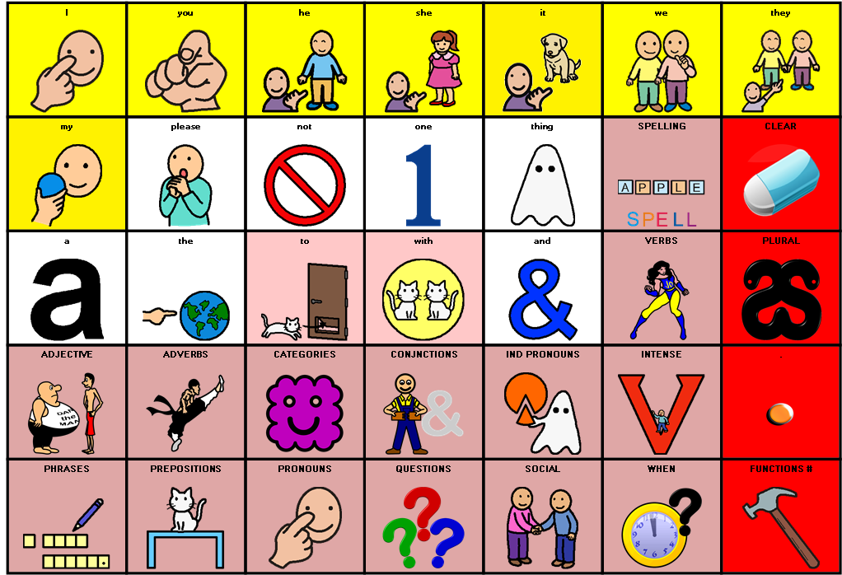
Special
Method for
Accessing
Rapid
Talking

Why is it smart?
It is because SmartAAC uses AI (Artificial Intelligence). Activating a button (cell) from any overlay can do a number of things:
- Speak a word (or phrase);
- Move to another page;
- Perform a function.

or a combination of the above.

However, most AAC systems can do that: what makes SmartAAC special is that a cell does not always move to the same page ... it decides where to move according to what has already been spoken! This means that, for the first time, a 35 overlay can provide rapid access to language. Its results are comparable to those of rival systems with overlays of 128 (or larger) cells (600 everyday sentences were fed into the system which was able to produce each one with an average of 1.4 activations per word). Using the system’s intelligence means that activating the ‘TO’ symbol on the main page (as just one example) will not always cause the program to move to the verb page (to go, to eat, to drink) but may go to the pronoun page (to my, to your, to his) or elsewhere (to the shop) depending on what is appropriate.
What if there is a choice and the program chooses the alternative?
No problem; on every page there is a HOME key: Activating the home key will cause the program to return to the Home Page, from where, virtually everything is accessible. However, the Home Key is also intelligent! If the program ‘knows’ it probably previously chose incorrectly, it will automatically go to another alternative! This means SmartAAC can generate sentences, built word by word, very quickly: the ideal (but practically impossible for any system with or without intelligence) would be one activation ... one word (1:1). Smart AAC is currently operating at an average rate of (1.4 activations per word [1.4:1]); which is incredible for a 35 location system!

SmartAAC is:
- Somewhat different to other AAC systems;
- Made to be attractive to teachers as well as therapists;
- Available for iPad and PC (and android is on its way);
- Rapid because of the system’s intelligence;
- The language system!

SmartAAC contains:
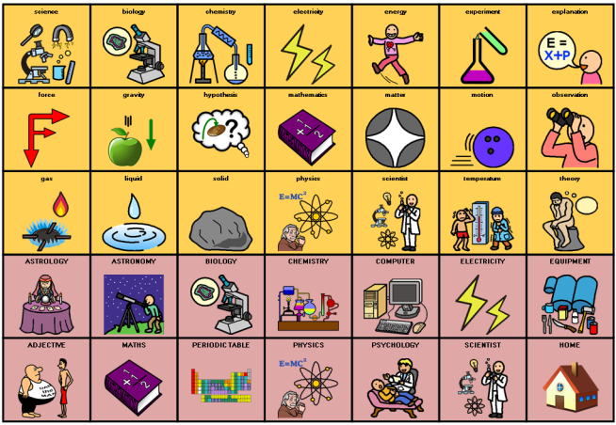
- Spell Mode for any word that is not already stored.
- Multiple colour-coded (Fitzgerald) pre-programmed pages (490 pages).
- A vocabulary of over 7,300 words.
- Room for additional vocabulary (Maximum capacity 16,600)
- Top 1,500 English Core Vocabulary words (according to the British National Corpus).

SmartAAC is accessible via:

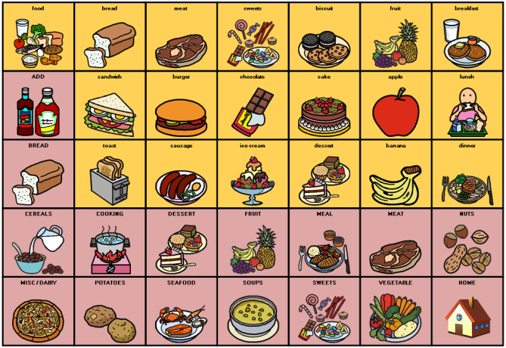
- Switch or switches (maximum four) for scanning (iPad and PC);
- Mouse (PC);
- Alternatives to a mouse (PC);
- Roller or trackball (PC);
- Touch screen (iPad and PC).

Speak with an appropriate voice for your gender and your country. SmartAAC comes with built-in Text-To-Speech to provide national dialects. Download the local SmartAAC version from your country’s iStore.
Maximum access to language with minimum requirement for keystrokes.
Make more use of limited key numbers (overlay size only 35 = 7 x 5)
Adapt SmartAAC for your particular needs with the simplified editing facility. Add/replace images/symbols, text, and sounds.
Rapid access means faster communication.

Try before you buy! Try SmartAAC for FREE for 7 days (timing begins on first use of the program after download).

Be smart: be sure to get the smarts!

Chapter Two
SmartAAC: Arrangement

How is the vocabulary within SmartAAC arranged? How can a word be located from a standing start (not using the system’s intelligence)?

This chapter attempts to answer those questions.

Colour Coding

SmartAAC is colour coded using a modified Fitzgerald key. The following colours have been consistently used throughout its pages:
- Adjectives are colour coded in a particular shade of BLUE.

- Adverbs are colour coded in BROWN. Where adverbs act as intensifiers
They may be colour coded in white.

- Conjunctions (& some other forms) are colour coded in WHITE.

- Nouns are colour coded in various shades of ORANGE. Typically, this is a single shade of orange unless there is a reason to differentiate between groups of nouns on a single page.
- Prepositions are colour coded in various shades of PINK. Prepositions feature a cat or cats illustrating the prepositional form.

- Pronominal forms are colour coded in various shades of YELLOW. Differing types of pronouns use different shades.

- Verbs are colour coded in various shades of GREEN. Darker green signifies a past tense where different tenses are together on a page.

- Main Page Function Keys are colour coded in RED. Red main page keys perform a specific function. They do not speak unless it is a part of that function. The TOOLS red key moves to another Page.

- Transporting cells are colour coded in a light shade of PURPLE.
Transporting cells normally do not speak, they move to a specific page. Transporting Symbols are generally in the bottom two rows of any page.

- Stay-On-Page cells are colour coded a particular shade of BLUE.
Stay-on-page cells speak but do not move from the page.

Characterised Symbols
SmartAAC uses several Characterised Symbols on the home page to aid Learners remember where various word forms are located. A Characterised Symbol has a specific character which, when explained and understood, suggests specific grammatical groupings.

DAN the MAN

DAN stands for Describes A Noun

And

MAN stands for Modifies A Noun

which is what an adjective does! Dan is fat and bald and old and his partner is young and thin and tall. DAN words are therefore descriptive words:

A happy man, a fat man, a thin man, a tall man, ...

SAT the CAT (prepositions)

A preposition links a noun, pronoun, or phrase to another part of a sentence. As many prepositions show position, it could be said that a preposition is anywhere a cat can go. Therefore prepositions express spatial relationships. Prepositions can also express temporal relationships (time). Thus, we have both Space And Time (SAT): hence the CAT is called SAT. ‘The Cat sat ON the mat. The cat sat BY the mat. The cat sat UNDER the mat! Where’s that cat now?!

PING the THING (Nouns [fringe]).

PING stands for Picture Image Noun Groups.

PING is a THING and nouns are things. PING has a (curvy) fringe all around his body. Nouns tend to be fringe words only a few creep into the core.

PING likes to tidy things away into boxes. He puts the same sorts of things into individual boxes. Toys go in one box and food goes in another box for example. You might say he Puts Into Noun Groups

PING likes to collect things!

JO on the GO (Verbs)

Jo is a heroine: an all-action lady who just loves to do things. She is always doing something: coming and going, running and walking, hiding and seeking, buying and selling.

Jo therefore represents the verb form in the system.

JIM the JOINER (conjunction)

A conjunction serves to join two parts (clause or phrase) of a sentence together. Jim loves to join things together. He is always joining things!

QIK LEE: the Chinese martial arts expert (adverb)

QIK LEE is JO on the GO’s sidekick. He helps her out a lot. He tells her how, when, why, where, and to what extent she should do something. He’s a great addition to JO!

GARY the GHOST: (Indefinite Pronoun)

Indefinite pronouns are words which take the place of nouns without specifying which noun they replace. However, in this instance there are only a limited set beginning with ANY, EVERY, NO, and SOME (for example; anybody, everyone, nowhere, something ...). Gary the ghost can take ANY shape, be EVERY where, has NO form, and is SOME thing but no one knows what, it is! The symbol shows the thing that is Gary stealing some (thing) of ... well it could be anything! Nobody knows for sure why Gary does what he does.

VANISHING VANCE: (Intensifying Adverbs)
Vance is really very small: he is utterly vanishing. As such he is really intense – wouldn’t you be in you were in his totally tiny shoes? Vance is the the intensifier symbol. Use vance to intensify a DAN word (adjective) ... very small, totally tiny, really intense.

SOCIAL SAM: (Social Vocablary)
Sam is really social: he says hello to everyone he meets and wants to ask them ‘how they are’ and generally get to know them. Sam is the social vocabulary symbol.

Providing a symbol with a character, telling a little story about it, helps the Learner understand why certain words are placed where they arewithin the system. The Learner does not need to know what a ‘preposition’ is or even know the word ‘preposition’ itself... all they need to know is all about SAT the CAT and the things s/he does!

Note: Not every Home Page symbol is characterised.

Page Groupings

There are a number of ways to arrange pages within an AAC system. Within SmartAAC pages are arrange in distinct categories or parts ot speech: the animals are together, the body parts, the clothes, and the drinks, etc. Parts of Speech, such as verbs, adjectives, prepositions, etc also are grouped together within separate page areas in the program.

The parts of speech are reached by selecting a Characterised Symbol (as outlined above) from the main Home page. The Noun Categories are reached from the Noun Category Page which itself can be reached by selecting PING the THING from the home page.

Now, it may appear as if there are only 32 noun categories (35 – HOME- ADJECTIVE- COLOUR): however, these are SUPERORDINATE CATEGORIES. There are SUPERORDINATE, ORDINATE and SUBORDINATE categories.

SUPERORDINATE CATEGORIES are on the PING Page.

ORDINATE CATEGORIES can be be found by selecting a Transporting Symbol (colour coded purple) from the Superordinate Page (Category Page).

SUBORDINATE CATEGORIES can be found by selecting a Transporting Symbol (colour coded purple) from the Ordinate pages

If every symbol on each of these pages was a purple Transporting Symbol then there would be thousands of categories! (32 x 34 x34 = 36,992). However, every cell on Ordinate and Subordinate pages is not a purple Transporting Symbol: most cells on these pages actually contain vocabulary which can be selected and is written to the Message Window and spoken out.

Noun Category groupings are detailed later in this manual.

The Home Key
On virtually every page there is a HOME KEY located in exactly the same place at the bottom right corner. Selecting the Home Key typically returns the system to the Home Page. However, as SmartAAC is ‘smart’, sometimes it doesn’t go straight home! On some selections of the Home Key, SmartAAC might take a detour via another page. This happens when the system has transferred to a particular page automatically and no selection is made: SmartAAC assumes it has made a mistake and tries to calculate the ‘correct’ page to which it should have gone and, once it figures it out (micro-seconds), it goes there!

The Home Page

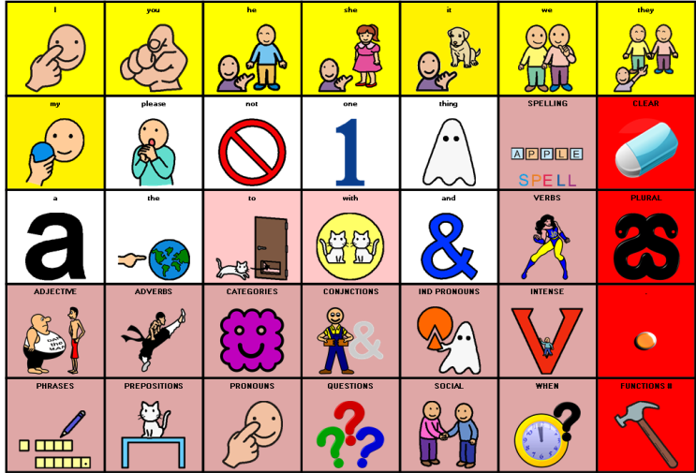
On opening SmartAAC, the very first page seen is the Home Page. There is actually not a lot of vocabulary here; in fact less than half of it (just 17 words). Most of the Home Page is comprised of the light purple Transporting Cells and the red function cells. The Transporting Cells on the Home Page lead to ‘part of speech’ pages such as adjectives or prepositions or verbs. These are represented by ‘characterised symbol’ as detailed earlier. Typically, transportation cells live in the bottom two rows of any overlay but may ‘overflow’ into other areas if there is no available space.

As many sentences begin with a pronoun (I want to ..., you are not having ..., she is coming to ..., etc) the top row of the Home Page comprises the English subject pronoun set (I, you, he, she, it, we, they) colour coded yellow together with just one of the possessive pronouns ‘my’ (the others are on the Pronoun Page. Selecting a subject pronoun will cause the system to:

- Speak the word;
- Write the text for the word to the Message Window;
- Draw the symbol for the word above the text in the Message Window;
- Move to the verb page.

That is four actions from a single activation. To say the phrase ‘I want it’ for example:

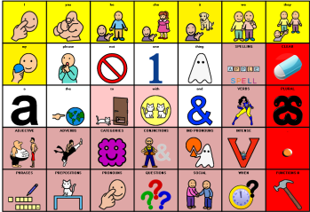
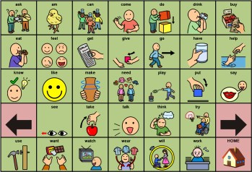
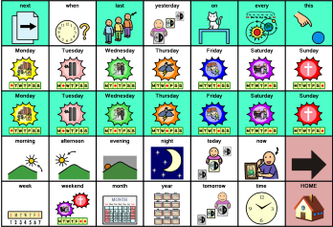
- Select ‘I’ from the home page (system moves to verb page);

- Select ‘want’ from the verb page (system moves to home page);
‘want’ is on the bottom row.

- Selected ‘it’ from the home page (system stays on home page).

That’s three words in three activations: that is one activation per word.

If I wanted to extend the phrase a little to say when I wanted it (for example, ‘I want it now’) then I can use the WHEN transporting cell from the bottom row of the home page (The WHEN symbol is a clock face with a question mark signifying ‘at what time?’). This will take me to a page of ‘time words’ from where I can select ‘now’ (fourth row). On selection of ‘now’, the system returns automatically to the home page.

I have built a little sentence of four words (I want it now) in five activations. If I wanted to repeat that sentence as a whole, there are a couple of options:

- Use the red period/full stop function key from the last column of the Home Page. The period adds a full stop to the message window and speaks the previous sentence.

- Select the message window itself. By default, the message window will speak everything that has been selected (it is possible to set the function of the message window: see the Voice Symbol manual for instructions on how to do this).

There are also other options for speaking the message window but these will be covered in a later section of this manual.
The Home Page is a major terminal from where all things are possible. Often, when vocabulary is selected from a page, the SmartAAC system will return to the home page for the next selection. However, if the system believes it can predict the next most likely page it will go there instead. If it predicted incorrectly then the home key can be used to return home at any time.

What if I wanted to say that last sentence in the past tense?

It’s a pretty similar set of actions with just one additional selection.
Let’s do it! ‘I wanted it now’...

- Select I

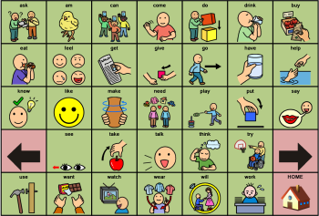

- The system moves to the Verb Page. However, this page is in the present tense. To go back in time and select the past tense, activate the Left or Back Arrow.

- The page changes to the past tense! Now we can select ‘wanted’.

- The rest of the sentence is exactly as previously detailed

Selecting the red period cell completes the sentences and speaks it as a whole.

That’s not very polite, can we use ‘please?
Sure we can! However, a little word of warning ... ‘please’ is not a very concrete word form. It’s a social thing rather than an object we can pick up and actually give to someone. As such, it may be difficult for some learners to understand. If this is the case, it might be better left until a later, more appropriate time.

If the Learner is OK with the use of ‘please’, it can be found on the home page in the second row. Simply add it to the end of the sentence.

What if I want to ask a question such as ‘Please can I have it now?’?

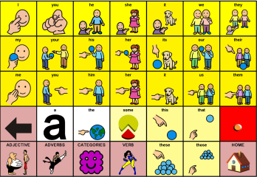
We are jumping forward a long way! Many Learners will not be ready for interrogative use when they begin working with SmartAAC. If there is doubt about this aspect, consult your local Speech and Language Professional (SLP) for advice. However, let’s not avoid the question because it illustrates an important concept within SmartAAC:

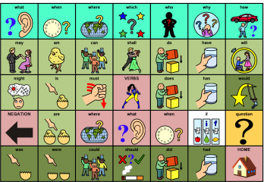
- Select ‘Please’ from the Home Page

- The system moves to the Questions page! Previously, when we used the word ‘please’ in the early example, the system stayed on the Home page but now it decides to move elsewhere! From the Questions page we can select ‘can’.

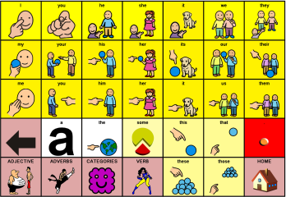

- The system moves to the Pronominal Page. However, ‘I’ is in exactly the same position on this page as on the Home Page and so it should not worry the Learner. Select ‘I’

- The system moves to the verb page. See the hand holding the glass of water? S/he obviously HAS a glass of water. Select ‘have’.

- The system moves back to the Pronominal Page from where ‘it’ may be selected. You will notice that there are TWO ‘it’ symbols on this page: one in the top row and one in the third. That is because the English Subject Pronoun and the English Object Pronoun for this particular word are identical. We actually require the Object Pronoun which resides in the third row. Subject Pronouns live in the top row. If the top row ‘it’ was selected by mistake, the system would work out that it shouldn’t be treating the selection as a Subject Pronoun and do exactly the same thing as if the correct ‘it’ form had been selected! However, it is NOT good practice to teach a Learner this because the system will NOT always be able to figure out the error and will go to a different page than is required.

- The system will move back to the Home Page from where we can complete the sentence as in the earlier examples:

That’s a six word sentence in seven activations which is pretty good for a tiny little 35 location overlay!

The Object Pronouns on the Pronominal Page typically return to the Home Page such that a sentence may be terminated. The Subject Pronouns on the Pronominal Page will nearly always move to the verb pages.

If I use ‘please’ twice in the same sentence, once at the beginning and, once at the end, the system will do different things each time ‘please’ is selected: On the first activation, at the beginning of the sentence, the system will move to the Questions Page and, on the second activation, at the end of the sentence, the system will remain on the Home Page. Try it!

As can be seen, SmartAAC is smart! It tries to figure out where it should go and to provide the Learner with the next word in just one keyboard activation.

Page Layout

Pages are generally arranged ALPHABETICALLY beginning in the top left hand corner and moving down the page. However, there are times when pages have been arranged in a different manner if it was believed that this would be more logical. For example, let’s look again at the WHEN page used in the previous examples:

Here things are arranged in some other order. For example, the days of the week are arranged beginning on Monday and working through until Sunday. Also the times of the day (Morning, Afternoon, Evening, and Night) are sequenced.

Why are some things in light BLUE and some things in WHITE?

The light BLUE items will remain on the page whereas the White items will move on to another page (normally the Home Page). Thus, if the prepositional phrase ‘on Thursday night’ was required simply select:

On (BLUE) Thursday (BLUE) night (WHITE)

However, if ‘on Thursday’ was required then select:

On (BLUE) Thursday (WHITE)

The system is not that intelligent, it cannot predict if I want to use the past tense after ‘I’ is selected for example.

That’s correct but that would mean that you Mr. Questioner are also not very intelligent! If I say ‘I’, please predict what am I going to say next: ‘want’ or ‘wanted’? You cannot possibly know unless you can read my mind. We do not claim that SmartAAC is a mind reader! However, Smart AAC will move to the past tense automatically following ‘I’ if it believes that the past tense is required...

- Select the WHEN Page from the Home Page. The system move to the When page as in the earlier examples.

- Select ‘Yesterday’ from the When Page. The system will move to the Pronominal Page.

- Select ‘I’ from the Pronominal Page.

- The system moves to the Past tense page! It does not simply go to the Root Verbs page. Select ‘wanted’ and then select ‘it’ from the Home Page to complete the sentence as in the earlier examples.

Once again, we have a four word sentence produced in just five activations.

Noun Categories

As previously detailed, the noun categories within SmartAAC have been arranged in Super-ordinate, ordinate and, subordinate groupings. This may seem rather complex. However, with the limitations imposed by a 35 location overlay, it was necessary to find a mechanism by which a large volume of vocabulary could be managed.
As was explained earlier, the noun categories page can be reached by selecting ‘Ping the Thing’ (detailed earlier) from the Home Page. There are 32 noun categories. Why 32? That is because one cell is the Home Key, one cell is used to move to the Adjective Page (Dan the Man) and one cell is used to go to the Colours Page (Colours are not grouped with adjectives within SmartAAC).
Each of the noun category keys will not speak when selected; it simply transports the system to a specific Ordinate Page. On the Ordinate Page, there may be more transporting links to subordinate pages. If we select the Animal Key from the top row as an example:

- It moves to the Animal Page
- On the Animal Page are sixteen (subordinate) further links to:
Amphibians Bacteria Birds Classes of animals Dinosaurs Fish
Habitats Insects Mammals Mythological creatures Parts of animals
Reptiles Sea creatures Shelled animals
Young animals Listen

On the Animal Page, with an orange background (nouns), are various animals that might be commonly spoken. Of course, if the Learner has a pet snake, the word ‘snake’ may be spoken more frequently than the word ‘bee’. It is possible to edit the system such that ‘snake replaces the bee which is already contained within the Insects page such that, words that a Learner is likely to say more often are contained on the Ordinate Page rather than the Subordinate Pages. In this way, the number of activations required for any sentence can be reduced even further.

Note that the bottom two rows assigned to the light purple Transportation Cells are completely used on the Animals Page and, therefore, it was necessary to overflow into the general vocabulary area for ‘amphibians, ‘bacteria’ and ‘birds’. However, the colour encoding makes the distinction very clear: on this page (and all noun pages), the orange keys speak and the purple keys move to other pages.

Does that mean it requires at least three activations to speak any noun? Yes, if you are speaking the word from a standing start (if it was required to say only the word ‘dog’ for example). However, typically, we are not speaking from a standing start individual words; we create sentences into which words occupy specific positions. SmartAAC tries to minimise the number of key strokes by predicting the page required.

Consider the sentence, “I want to wear my jeans”. Let’s create it in SmartAAC and see how the system copes:

- Select ‘I’ from the Home Page

- Select ‘want’ from the Verb Page

- Select ‘to’ from the Home Page (the cat is running TO the door)

- Select ‘wear’ from the Verb Page

- Select ‘my’ from the Pronominal Page

- Select Jeans from the Clothes Page

As can be seen, SmartAAC was able to generate this six word sentence in just six hits: that’s just one activation per word! If we had tried to say the word ‘jeans’ on its own it would have required 3 activations (PING – CLOTHES – JEANS) but, within a sentence, ‘jeans’ only requires a single activation.

What if I want to say, “I want to wear my old pale blue denim Levi jeans’?

Ok, that is a little more demanding but still quite straightforward.

- The ‘I want to wear my’ part of the sentence is exactly the same as detailed above;

- We are now already on the Clothes Page;

- notice that, on the Clothes Page, there is a Transport Cell called COLOUR. When this is selected, the system moves to the colour Page as shown.

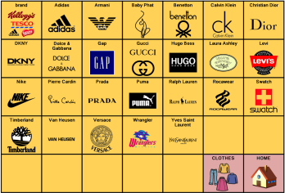
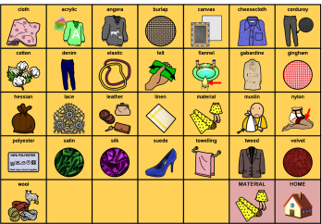
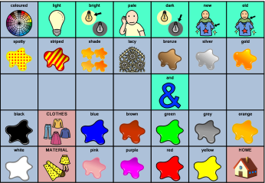
- From the Colour Page we can build the mini phrase ‘old pale blue’. Both ‘old’ and ‘pale’ are on light blue stay-on-page keys whereas the colour ‘blue’ itself if coloured as an adjective and returns us to the Clothes Page!

- The next word is ‘denim’ which is not a colour but, rather, a MATERIAL. Note that there is a Transport Cell that will take us to a page of Materials.

- From this page, we can select ‘denim’ and then the system automatically return us to the Clothes Page .

- The next word required is ‘Levi’ which a brand name. On the Clothes Page there is a link to brands.

- This moves the system to the Brand Page, from where ‘Levi’ can be selected.

- Finally, we are returned to the clothes page, from where ‘Jeans’ can be selected.

Thus, an eleven word sentence can be created using just fourteen activations from a tiny thirty five cell overlay system.

We have seen how pages are arranged into Super-ordinate, Ordinate and, Subordinate categories and that SmartAAC assists speeds access to the pages by automatically jumping to the correct page when it thinks it can predict what might be the next word. To assist understanding of SmartAAC’s architecture further, the following is a guide to Ping (noun) page categories:

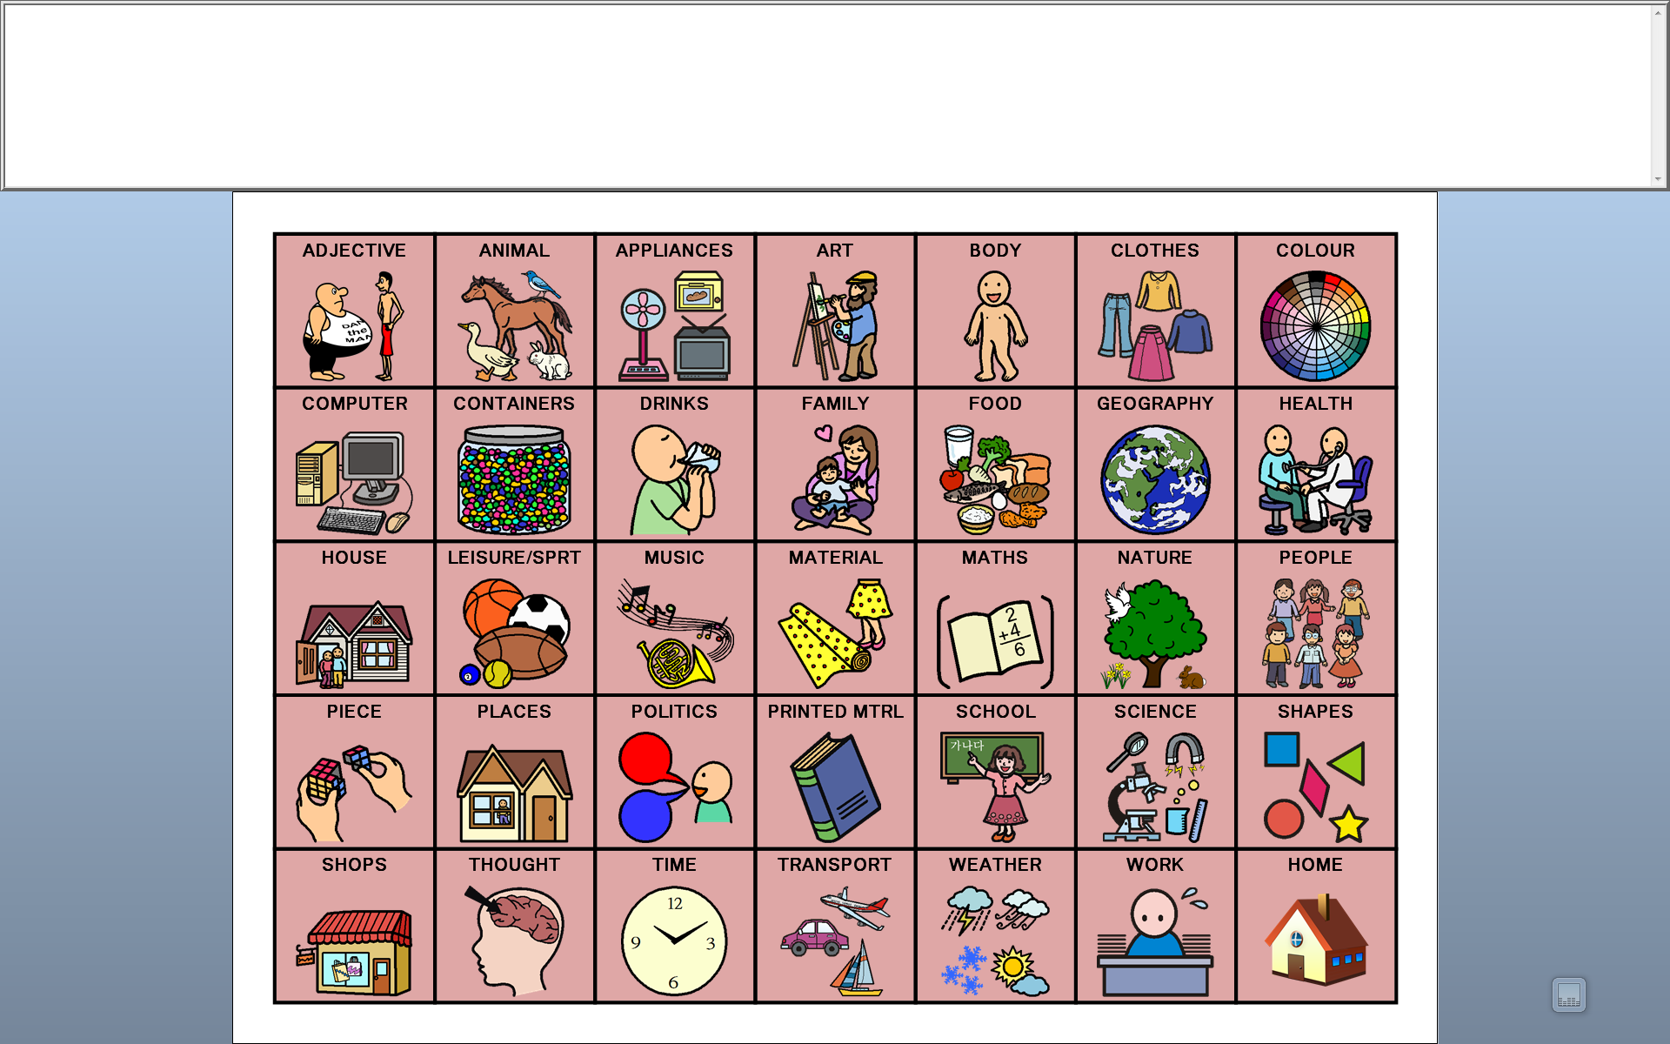
Page Categorisation

ANIMALS
  - Amphibians
    - Animals
    - Reptiles
  - Bacteria
    - Animals
  - Birds
    - Animals
  - Classes of animals
    - Animals
  - Dinosaurs
    - Animals
  - Fish
    - Animals
    - Sea
    - Salt Water Fish
  - Habitats
    - Animals
  - Insects
    - Animals
  - Listen
    - Animals
  - Mammals
    - Animals

  - Mythological creatures
    - Animals
  - Parts of animals
    - Animals
    - Body
    - Biology
  - Reptiles
    - Amphibians
    - Animals
  - Sea creatures
    - Animals
    - Fresh Water Fish
    - Salt Water Fish
  - Shelled animals
    - Animals
    - Sea Creatures
  - Young animals
    - Animals

Note: All Categories have links back to the Animals Page such that, if a mistake was made, there is no need to return to the Home Page, select ‘Ping’, select ‘Animals’ and start over. Most pages have such ‘returning’ links to save Learner effort. Although such links (returning to the super-ordinate page) have been detailed in the above they will not be detailed in the descriptions below; it will be assumed that is understood such links are in place.

Note also: Pages may have secondary pages where the category is too large to fit on a single page. To move to additional pages select the RIGHT ARROW (meaning ‘more’). On selection, more of the chosen category is displayed. On such additional pages a LEFT ARROW (meaning ‘back’) returns to the originating page.

Such arrows always appear in the same position and, on noun pages, function in an identical manner to move back and forth between pages where there is a surplus of vocabulary; more than can fit on a single page.

Note that on other than noun pages the left arrow may serve another function.

APPLIANCES
- Computer
  - AAC
  - Aids
  - Internet
  - Parts
  - Program

ART
- Artists
- Colour
- Material
  - Building
  - Cloth
  - Ingredient
  - Jewellery
  - Metal
  - Mineral
  - Rubbish
  - Wood

BODY
- Arm
- Colour
- Face
- Hair
- Internal
- Leg
- Private
- Senses

CLOTHES
- Brand
- Colour
  - Material
- Female
  - Colour
- Footwear
- Colour
- Jewellery
- Male
  - Colour
- Material
- Outdoor
  - Colour
- Part

COLOUR

COMPUTER
- AAC
  - Aids
  - Appliances
  - Company
- Aids
  - AAC
  - Appliances
- Internet
- Parts
- Program

CONTAINER
- Drink
  - Alcohol
  - Food
  - Fruit
  - Other
- Intensifiers

DRINKS
- Alcohol
  - Number
- Food
  - Add
  - Bread
  - Cereals
  - Cooking
  - Desserts
  - Fruit
  - Meals
  - Meat
  - Misc/Dairy
  - Nuts
  - Potatoes
  - Seafood
  - Soup
  - Sweets
  - Vegetables
- Fruit
  - Nuts
- Other
  - Categories
  - Shops

FAMILY
- Pet (See Animals)
- Marriage
  - Family
  - People
  - Titles
  - Wedding

FOOD
- Add
  - Spices
  - Categories
- Bread
  - Cooking
  - Fruit
  - Meat
  - Vegetable
- Cereals
- Cooking
- Desserts
  - Fruit
- Fruit
  - Nuts
- Meals
  - Drink
- Meat
  - Chicken
  - Fish
  - Seafood
  - Soup
- Misc/Dairy
  - Crisps ( Potato Chips)
  - Fruit
  - ‘and’ FRUIT (says ‘and’ and moves)
  - Meat
  - Vegetable
  - ‘and’ Vegetable (says ‘and’ and moves)
  - Soup
- Nuts
  - Fruit
- Potatoes
  - Crisps (Chips)
    - Soap
    - Tools (used in ‘a bag of ...’
    - Cereals
    - Food
    - Fruit
    - Nuts
    - Sweets (Candies)
    - Vegetables
Note: this page is multi-functional and therefore has diverse links!

- Seafood
  - fish
- Soup
  - Food
  - Meat
  - Vegetable
- Sweets
- Vegetables
  - Potatoes
  - Soup

GEOGRAPHY

- Area
- Cities (World)
  - UK
  - USA
- Cities (UK)
  - Cities (World)
- Cities (USA)
  - Cities (World)
- Compass
  - Directions
- Countries
  - Africa
  - Asia
  - Europe
  - North America
  - Oceania
  - South America
- Mountains
- Oceans
- Rivers
- Terrain
  - Water
- UK Counties
  - Ireland
  - Northern Ireland
  - Scotland
  - Wales
- US States
- Water
  - Ice
- Weather
  - Adjective
  - +ing
  - Disaster
  - Ice & Snow
- World

HEALTH
- AAC
  - Aids
  - Appliances
  - Computer
  - Company
- Ache
- Adjective
- Aids
  - AAC
  - Appliances
  - Computer
- Body
  - Arm
  - Colour
  - Face
  - Hair
  - Internal
  - Leg
  - Private
  - Senses
- Condition
  - Disease
- Death
  - Adjective
- Exercise
  - Health
- First Aid
  - Medicines
  - Health
- Medicines

HOUSE
- Appliances
  - Computer
- Bathroom
- Furniture
  - Office
  - Outdoor
  - Soft Furnishings
- Kitchen
  - Appliances
  - Soap
- Parts
- Rooms
- Tools

LEISURE & SPORT
- Equipment
  - Sport
- Games
  - Cards
- Holidays
  - Christmas
  - Easter
  - Halloween
  - Independence day
  - MORE... Carols
  - New Year
  - Thanksgiving
  - Time
    - Months
    - Occasions
    - Seasons
    - Tell Time
    - Special
    - Holidays
- Music
  - Adjective
  - Appliance
  - Composer
  - Favourites
  - Instruments
  - Notation
  - Number
  - Orchestra
  - Part
  - Player
  - Pop
  - Song
  - Style
- People
  - Sport
- Sport
  - Leisure
  - Equipment
  - Teams
- Teams
- Toys
  - Games
  - Sport
- TV Programs
  - Country
  - Number
  - Pronouns

MUSIC
- Adjective
- Appliance
  - Computer
- Composer
  - Adjective
- Favourites
- Instruments
  - Adjective
- Notation
  - Adjective
- Number
- Orchestra
  - Adjective
- Part
  - Adjective
- Player
  - Adjective
- Pop
  - Adjective
- Song
  - Carols
- Style

MATERIAL
- Building
  - Wood
- Cloth
- Ingredient
  - Cook
  - Fruit
  - Kitchen
  - Meat
  - Number
  - Preposition
  - Time
  - Verb
  - Vegetable
- Jewellery
  - Clothes
- Metal
- Mineral
- Rubbish
- Wood

MATHEMATICS
- Fraction
  - Number
- Measure
  - Number
- Money
  - Adjective
  - Number
- Multiple
  - Music
  - Number
- Number (%)
- Number
- Ordinal
  - Number
- Piece
- Shape
  - Adjectives
  - Circle Parts
  - Polygons
- Size
- Talk Maths
  - Number
- Time
  - Months
  - Occasions
  - Seasons
  - Tell Time
  - Special
  - Holidays
- Vocabulary

NATURE
- Animals
  - Amphibians
    - Reptiles
    - Sounds
  - Bacteria
  - Birds
  - Classes of animals
  - Dinosaurs
  - Fish
    - Sea
    - Salt Water Fish
  - Habitats
  - Insects
  - Mammals
  - Mythological creatures
  - Parts of animals
    - Body
    - Biology

  - Reptiles
    - Amphibians
  - Sea creatures
    - Fresh Water Fish
    - Salt Water Fish
  - Shelled animals
    - Sea Creatures
  - Young animals
- Crops
- Disaster
- Flowers
  - Part
- Fruit
  - Nuts
- Fungi
- Geography
  - Area
  - Cities (World)
    - UK
    - USA
  - Cities (UK)
    - Cities (World)
  - Cities (USA)
    - Cities (World)
  - Compass
    - Directions
  - Countries
    - Africa
    - Asia
    - Europe
    - North America
    - Oceania
    - South America
  - Mountains
  - Oceans
  - Rivers
  - Terrain
    - Water
  - UK Counties
    - Ireland
    - Northern Ireland
    - Scotland
    - Wales
  - US States
  - Water
    - Ice
  - Weather
    - Adjective
    - +ing
    - Disaster
    - Ice & Snow
  - World
- Group
- Herb
  - Spices
- Nuts
  - food
  - Fruit
- Parts
  - Biology
  - Flower
- Plants
  - Flowers
  - Trees
  - Weeds
- Trees
  - Part
- Vegetables
  - Potatoes
  - Soup
- Weather
- Adjective
- +ing
- Disaster
- Ice & Snow
- Weeds

PEOPLE
- About me
  - Social
  - Favourite
- Bad
  - What a
  - Adjective
- Composer
  - Adjective
  - Music
- Family
  - Pet
  - Marriage
- Female Name
- Foreigner
- Friends
  - School
- Good
  - What A
  - Adjective
- Idiots
- Jobs
  - Entertainment
  - Forces
    - History
  - Law
  - Medical
    - Work
  - Promotion
    - Work
- Male Name
- Scientist
  - Science
- Staff
  - School
- Titles
  - Family
  - Politics
  - Religion
  - Ranks

PIECE

PLACE
- Adjectives
- Countries
  - Africa
  - Asia
  - Europe
  - North America
  - Oceania
  - South America
- Events
  - Funeral
  - Holiday
  - Party
  - Wedding
  - Bonfire Night
  - Christmas
  - Easter
  - Halloween
  - Independence day
  - Thanksgiving
- Going
  - Adjective
  - To The
  - To <City>
  - To <Country>
  - When
- House
  - Appliances
    - Computer
  - Bathroom
  - Furniture
    - Office
    - Outdoor
    - Soft Furnishings
  - Kitchen
    - Appliances
    - Soap
  - Parts
  - Rooms
  - Tools
- Jobs
  - Entertainment
  - Forces
    - History
  - Law
  - Medical
    - Work
  - Promotion
    - Work
- Roads
  - Number
  - Signs
- Shops

POLITICS
- Law
  - People Bad
  - Politics
  - Work
- People
  - About me
    - Social
    - Favourite
  - Bad
    - What a
    - Adjective
  - Composer
    - Music
  - Family
    - Pet
    - Marriage
  - Female Name
  - Foreigner
  - Friends
    - School
  - Good
    - What A
    - Adjective
  - Idiots
  - Jobs
    - Entertainment
    - Forces
    - Law
    - Medical
    - Promotion
  - Male Name
  - Scientist
    - Science
  - Staff
    - School
  - Titles
- Religion
  - Buildings
  - Events
  - Faiths
  - Figures
  - People
  - Parts
- Titles
- Family
- Politics
- Religion
- Ranks

PRINTED MATERIALS
- Author
- Cards
- Certificates
- Education
- Harry Potter
- Money
  - Adjective
  - Mathematics
  - Number
- Part
- Poetry
  - Poems
  - Nursery Rhymes
  - Poets
- Story

- Religion
  - New testament
  - Old testament
- Ticket
- Titles
- Travel

SCHOOL
- Art
  - Artists
  - Colour
  - Material
    - Building
    - Cloth
    - Ingredient
    - Jewellery
    - Metal
    - Mineral
    - Rubbish
    - Wood
- Equipment
  - Computer
- Friends
- Geography
  - Area
  - Cities (World)
    - UK
    - USA
  - Cities (UK)
    - Cities (World)
  - Cities (USA)
    - Cities (World)
  - Compass
    - Directions
  - Countries
    - Africa
    - Asia
    - Europe
    - North America
    - Oceania
    - South America
  - Mountains
  - Oceans
  - Rivers
  - Terrain
    - Water
  - UK Counties
    - Ireland
    - Northern Ireland
    - Scotland
    - Wales
  - US States
  - Water
    - Ice
  - Weather
    - +ing
    - Disaster
    - Ice & Snow
  - World

- Grammar
  - Punctuation
  - Figure Of Speech
- History
  - American
  - Egyptians
  - Forces
  - Monarchs
  - Presidents
  - Prime Ministers
  - Romans
  - Wars
  - Weapons
- Language
- Maths
  - Fraction
    - Number
  - Measure
    - Number
  - Money
    - Adjective
    - Number
  - Multiple
    - Music
    - Number
  - Number (%)
  - Number
  - Ordinal
    - Number
  - Piece
  - Shape
    - Adjectives
    - Circle Parts
    - Polygons
  - Size
  - Talk Maths
    - Number
  - Time
    - Months
    - Occasions
    - Seasons
    - Tell Time
    - Special
    - Holidays
  - Vocabulary
- Science
- See Science Below
- Subject
- Staff
- Timetable
- Type

SCIENCE
- Astrology
- Astronomy
  - Astrology
- Biology
  - Animals
  - Body
  - Health
  - Nature
  - Plant Part
  - Animal Part

- Chemistry
  - Periodic table
- Computer
  - AAC
    - Aids
    - Appliances
    - Company
  - Aids
    - AAC
    - Appliances
  - Internet
  - Parts
  - Program
- Electricity
  - Number
- Equipment
  - Appliances
- Adjective
- Maths
  - Fraction
    - Number
  - Measure
    - Number
  - Money
    - Adjective
    - Number
  - Multiple
    - Music
    - Number
  - Number (%)
  - Number
  - Ordinal
    - Number
  - Piece
  - Shape
    - Adjectives
    - Circle Parts
    - Polygons
  - Size
  - Talk Maths
    - Number
  - Time
    - Months
    - Occasions
    - Seasons
    - Tell Time
    - Special
    - Holidays
  - Vocabulary
- Periodic table
  - 1 – 28
  - 29 – 56
  - 56 – 84
  - 85 - 112
- Physics
  - Atom
  - Electricity
  - Heat
  - Laws
  - Light
  - Magnetism
  - Motion
  - Quantum Theory
  - Size
- Psychology
- Scientist

SHAPES
- Adjectives
- Circle Parts
- Polygons

SHOPS

THOUGHT

TIME
- Months
  - Date
- Occasions
- Seasons
- Tell Time
  - Number
- Special Days
  - Funeral
  - Holiday
  - Party
  - Wedding
  - Bonfire Night
  - Christmas
  - Easter
  - Halloween
  - Independence day
  - Thanksgiving
- Holidays
  - Christmas
  - Easter
  - Halloween
  - Independence day
  - New year
  - Right Arrow
    - Carols
  - Thanksgiving

TRANSPORT
- Air
- Land
- Water
- Part
- Roads
- Signs

WEATHER

WORK

As it can be seen from the extent of the above pages, the noun categories are quite comprehensive. However, they don’t begin to cover the volume of nouns that exist within the English language which run into the tens of thousands (at least!). It is not necessary to cover the whole structure with any Learner; indeed, the system can work just as well with the Learner being oblivious to the majority of these noun pages!

Note: Noun vocabulary that is frequently required by any Learner should obviously be contained on the Ordinate Pages (if possible) such that it is easier to reach. This may necessitate swapping some words from the subordinate pages with vocabulary from the ordinate categories to customise the system for the needs of a particular Learner. It is not that difficult to do providing the full editing version of SmartAAC is being used. Deciding which words can be ‘moved down’ (swapped) to a lower level may be a little problematic at times but, remember, even if moved down; the words are just another click away.

Parts Of Speech
Nouns are not the only things that occupy more than a single page, many other Parts of Speech (PoS) also occupy more than a single page, especially the adjectives and the verbs. Such structures obey certain rules to make their navigation easier. These rules are outlined in the various sections below.
ADVERBS

Adverbs are stored in two ways. The first type of adverbial page is reached by activating the Kwik Lee Categorised symbol from the Home Page. These are typically the adverbs that do not end with –ly although that is not always true and, indeed, there is page of –ly suffixes programmed here as a subcategory.

The second method for storing Adverbs is under the Adjectives symbol. This will be explained in the next section following immediately below.

ADJECTIVES

The English language contains very many adjectives, too many to fit onto a single page and even too many to fit onto several pages. Therefore, choices had to be made which to include and which to omit. The adjectives are arranged over eight pages. Each page contains links to the comparative and superlative forms and a further link to the adverbial (ly) form that begins with the adjective. Common adjectives are found on the main adjective page from which other adjectives are grouped alphabetically. Some pages are full and some have a few spaces remaining for additions. Remember, if an adjective is added to any page, it’s comparative and superlative and adverbial forms must also be added.
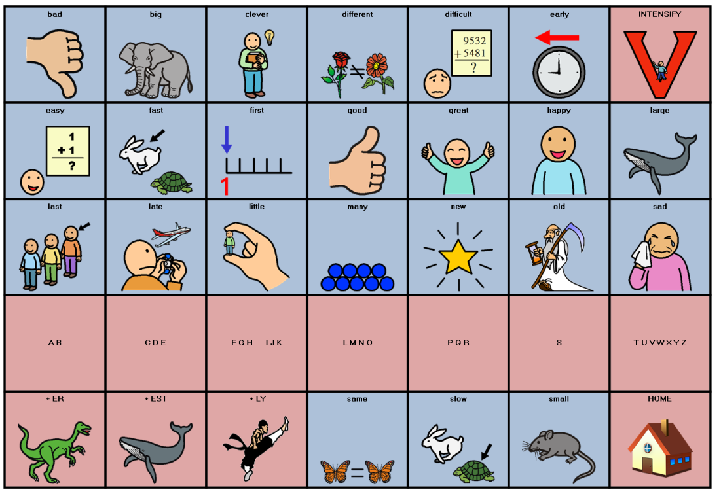

CONJUNCTIONS

Conjunctions occupy a single page only. The Conjunctions Page can be reached by activating the ‘Jim the Joiner’ symbol from the Home page. As it is possible to concatenate some conjunctions (but if, and if, so as, and although, but because ...) they are repeated on the page (light blue remains on the page, white moves on to another page)

Also on the conjunctions page are a set of six links to miscellaneous pages were additional vocabulary may be stored as necessary.

INDEFINITE PRONOUNS

Indefinite pronouns are words which take the place of nouns without specifying which noun they replace. However, in this instance there are only a limited set beginning with ANY, EVERY, NO, and SOME (for example; anybody, everyone, nowhere, something ...). Indefinite pronouns can be reached by activating the ‘Gary the Ghost’ symbol from the Home Page or by selecting the left arrow key from the pronominal page.

Indefinite Pronouns are BUILT by activating the first part of the word (Any, Every, No, or Some) and then selecting the second part from the following page which appears automatically. This makes each of these words require two activations. However, such a methodology reduces the space requirement considerably.

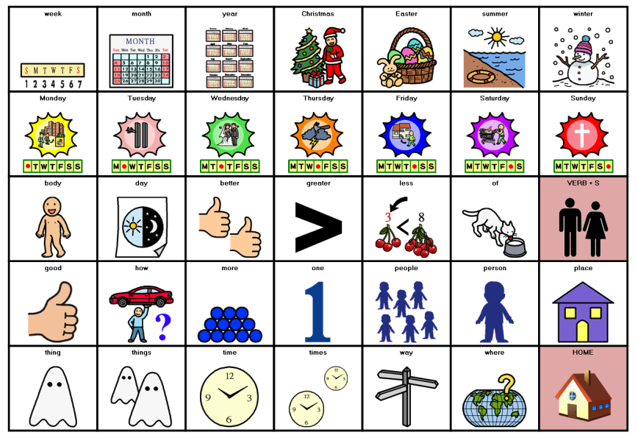
It will noted that some of the words appear twice on the page. This is to allow access to both ‘any’ and ‘any-body’, ‘every’ and ‘every-one’ etc. The purple keys are the ones that allow building the remaining cells say the word and move to other pages to continue building the phrase. As such, not all the words on the page are actually indefinite pronouns (and all indefinite pronouns cannot be found here).
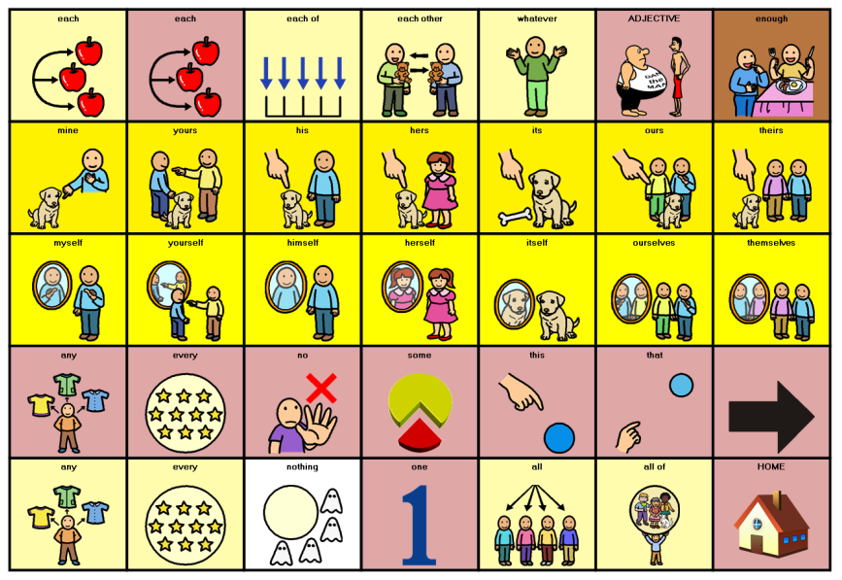
INTENSIFIERS

An intensifier is an adverb that acts to modify an adjective in order to give it more power (more intense). Thus, such words as ‘very’ (very happy), ‘really’ (really great), and even ‘dead’ (dead good) all can act as intensifiers. Intensifiers are reached from the adjectives page and automatically return there after a selection has been made.
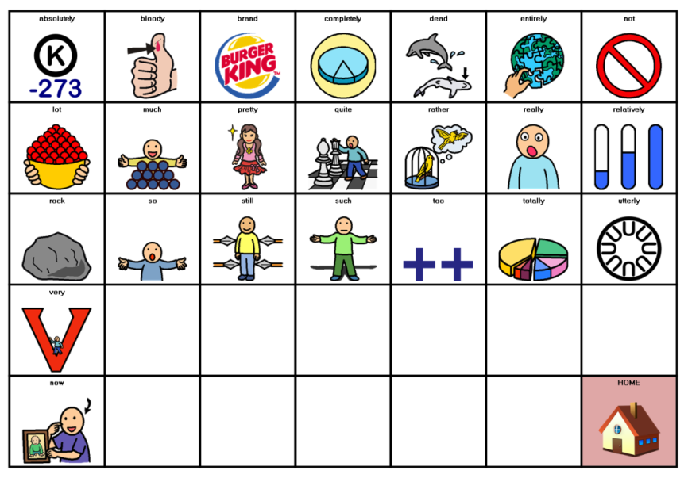

PREPOSITIONS

Prepositions occupy a single page only and are arranged in alphabetically order. The Prepositional Page can be reached by activating the ‘Sat the Cat’ symbol from the Home Page. Sat the Cat illustrates each preposition on the page and, thus, by using a toy cat, it should be possible to teach prepositional notions to the Learners that haven’t already acquired such concepts. Remember, many Learners with significant physical disabilities may have not developed prepositional concepts at the same rate as more able peers. Thus, prepositional concepts should be checked and taught. Some lesser used prepositional concepts will need to be built from constituent parts; for example, ‘without’ can be built by combining ‘with’ and ‘out’

PRONOUNS

The main Pronouns occupy three pages. Subject Pronouns can be found on the Home Page (top row colour coded in Yellow) as well as on the top row of the Pronominal Page itself. The Pronominal page can be reached by activating the ‘I’ icon from the Transportation Cells at the bottom of the Home Page (light Purple NOT yellow).

It will be noted that the pronominal page contains vocabulary other than pronouns! This is because, as a sentence is being created and a pronoun form is a likely next word so are the other words on the page! Thus, the system can predict with a degree of accuracy knowing that, if not a pronoun then, at least, it may be one of the other words available. In using some of the available space for vocabulary other than pronouns, some of the lesser used pronominal forms as well as the indefinite pronouns had to be placed on another page. This page is reached by selecting the Left Arrow key (see also indefinite pronouns).
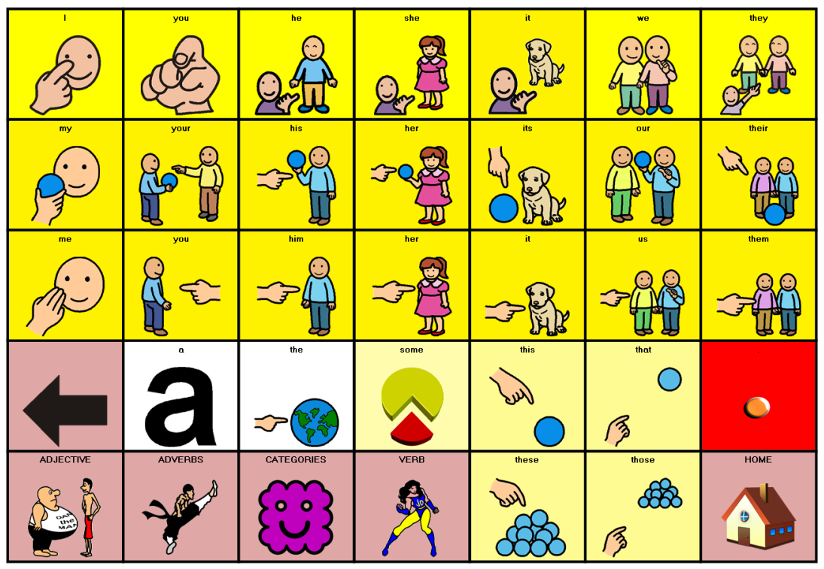

Sometimes, SmartAAC does not know if the intention is to continue a particular sentence or to finish it. Thus, the Learner may find that the system predicts a pronoun as the next word when, in fact, the learner has completed speaking. If this is the case then, the red period/full stop will terminate the sentence, speak the message and return to the home page.

Note that some other parts of speech can be reached directly from the pronominal page (Adjectives, Adverbs, Categories, and Verbs). These are useful when the system decides incorrectly that the next word is likely to be a pronoun when, in fact, another part of speech is required.

QUESTIONS

Question forms can be reached by activating the question key (as shown) from the main page. It can also be reached by starting the sentence with the ‘please’ key from the main page. ‘Please’ will ONLY move to the question page if it occupies the first position in a sentence: ending a sentence with ‘please’ for example, will remain on the main page. Thus, “Please can I have a cup of tea?” will move from ‘please’ to the question page directly but “Can I have a cup of tea please?” will not move to the question page.
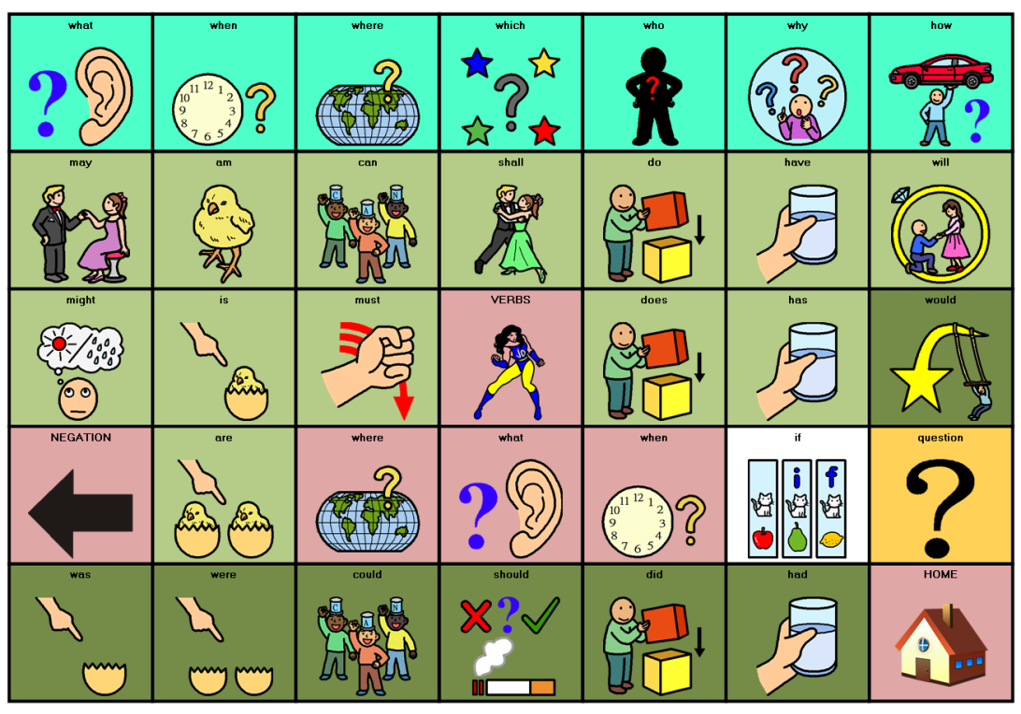

As with other pages, the light blue keys stay on page although the page may be modified when certain of the blue cells are accessed. To generate a negative interrogative (for example, ‘Don’t you?’) use the right arrow key to move to the negations page. There are also light purple keys on the page, use of these will move to another page to say such things as ‘what a time...’, ‘when the big hand...’, ‘where that person went...’ etc. Selecting a green verb from the page (can, do, will, etc) will move to the pronominal page such that such interrogative phrase as ‘Can I go...’, ‘Do you have...’, and ‘Will he get...’ can be built.

Note that selected cells on the page may change if a particular ‘start’ word is chosen. For example, if ‘how’ is selected then ‘about’, ‘soon’, ‘far’, ‘long’, ‘much’, and ‘old’ appear (How about, how much, ...

SOCIAL

The social page allows the building and use of social communication. For example, it is possible to build ‘Hello. How are you?’ The light blue cells remain on page while all others move to other pages. The white cells return to the main page but the light purple cells access other areas of the system for example: personal information, favourite items, or to talk about the weather. Please note that ‘yes’ and ‘no’ are to be found on this page. Accessing ‘yes’ or ‘no’ returns to the main page where ‘please’ and ‘thank you’ may be selected as
following vocabulary if required.
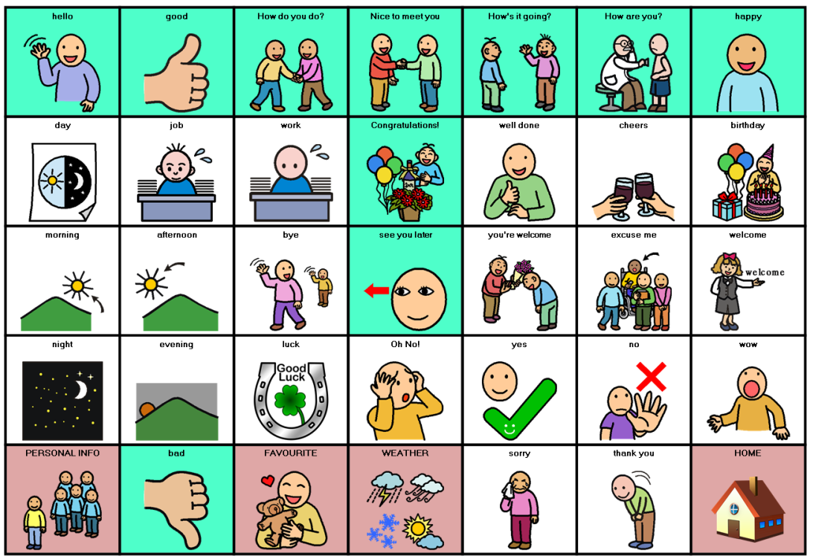

There is no need to return to this page to use the ‘thank you’ (located under the ‘no’) if ‘no’ is used to begin the phrase. However, if the Learner simply wanted to say ‘thank you’ on its own, it may be found on the social page. There is no secondary social page and thus, if additional social vocabulary is required it must be built from its constituent words using the whole system.

To say ‘Good morning, how are you’, the Learner must move to the social page, select ‘good’ and then select ‘morning. The system will return to the main page. The Learner must move back to the social page to select ‘how are you?’ This requires five activations. However, the phrase is five words long and therefore it represents one selection per word only. Note that it is also possible to say ‘bad morning’ as in the phrase ‘It has been a bad morning’.

VERBS

The verb structure of SmartAAC is both simple and complex! Verbs tenses and aspects are predicted were possible and a range of 31 commonly used verbs shown for selection. However, if the required aspect, tense or verb is not on the selected page then it becomes necessary to navigate to the correct page.

Typically on the verb pages, the word ‘not’ is to be found on the light blue cell in the top right hand corner. This allows the Learner to negate the verb (not go, not be, not see, ...).
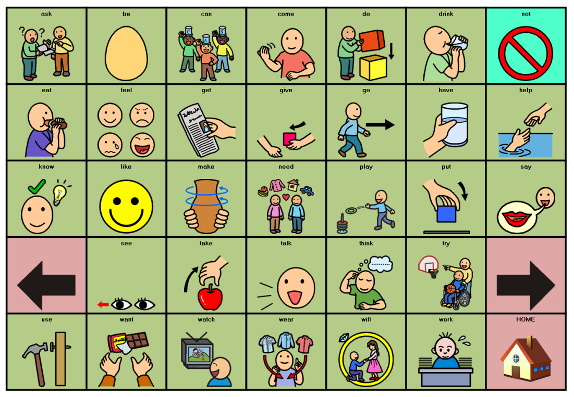

The right arrow →moves to the verb selection pages (of which there are eight) arranged in alphabetical groupings. Select the correct grouping for the required verb and then select the required verb from the page displayed.

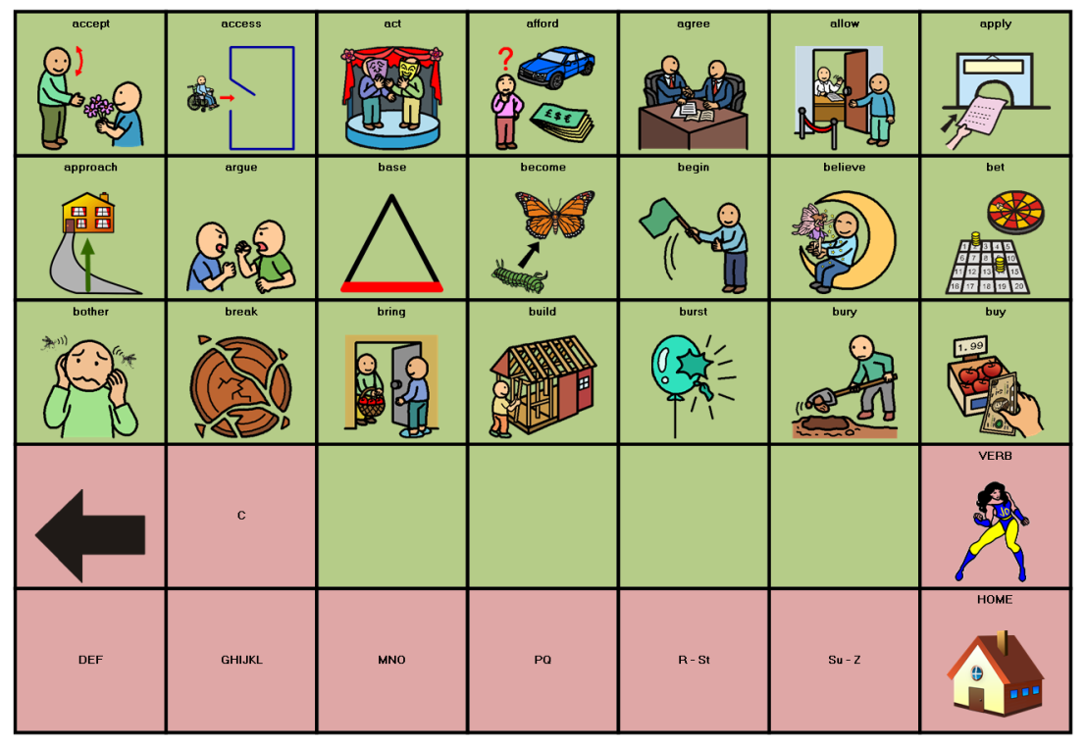

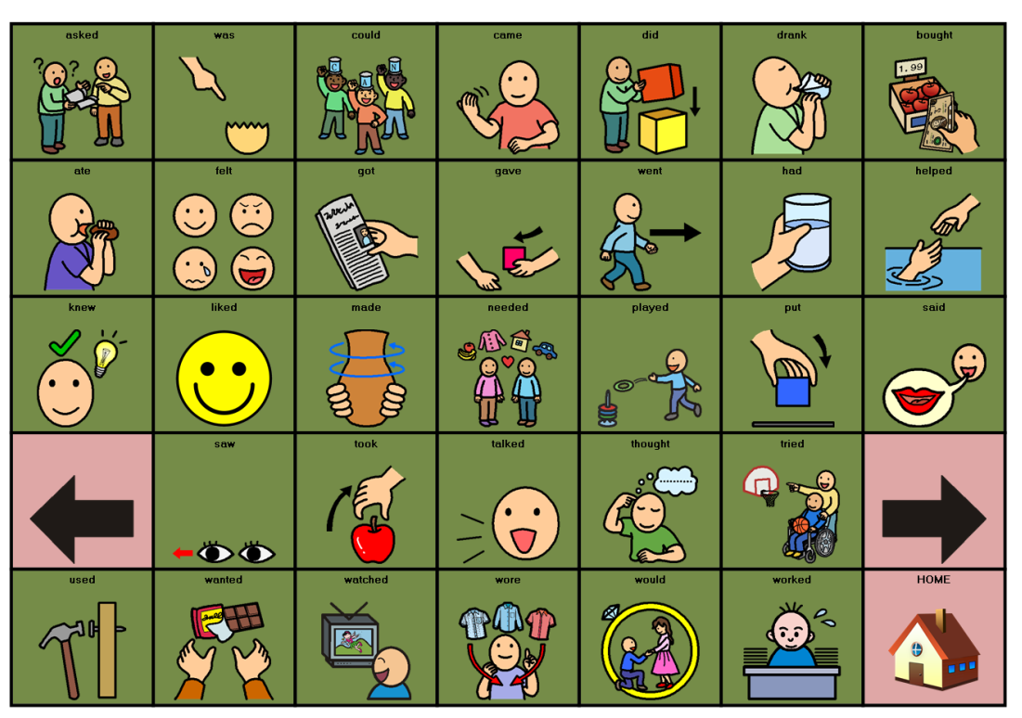
The left arrow ← moves to the past tense of the current verb page (unless it is already on a past tense page). The past tense is also marked by using a darker shade of green to colour code the cells.

Selecting the left arrow again from the past tense page will move the system to the verb tense choice page from which a particular tense or aspect can be selected. On this page are also selected contractions (wasn’t, isn’t, don’t ...)
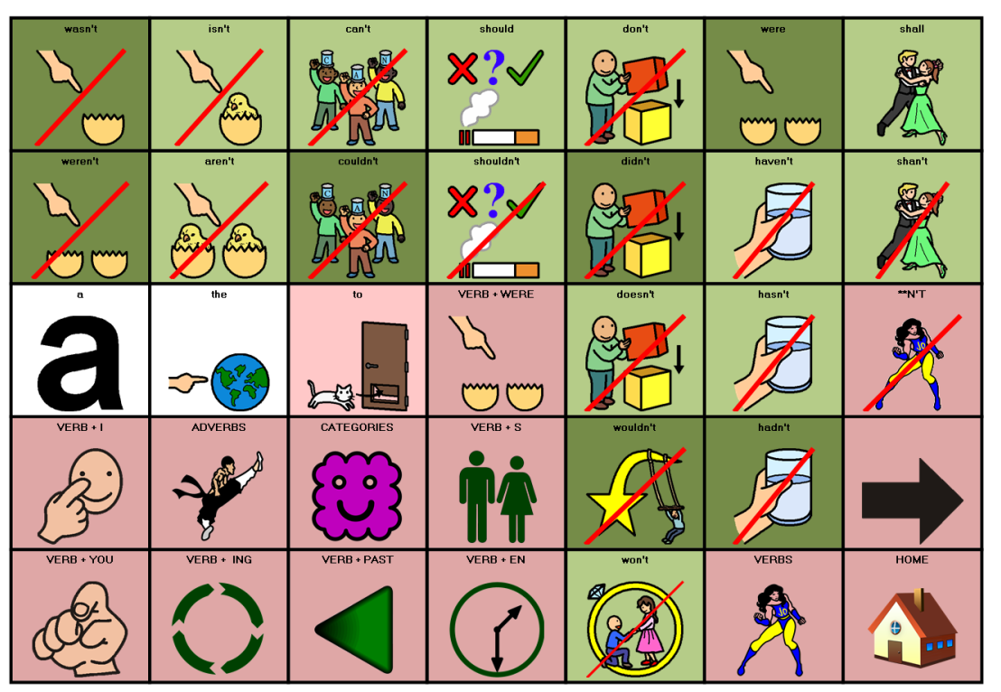

The right arrow → from any past tense page moves to the alphabetical verb sort pages for the past tense. The right arrow → from the Verb tense sort page moves back to the original verb page.

If an interrogative verb form is required (won’t you, don’t you want, can I go, will you get me ...) then the verb pages should not be used. Interrogatives forms are found on the question page (see earlier in this document).

WHEN

Often, in spoken English, it is necessary to specify a particular time for an occurrence (next Friday morning, this Wednesday evening, last Thursday). The ‘When Pages’ makes doing this easier. The light blue cells stay on the page allowing small phrases to built without returning back and forth to the home page. Further ‘when’ constructions are available by selecting the right arrow →.

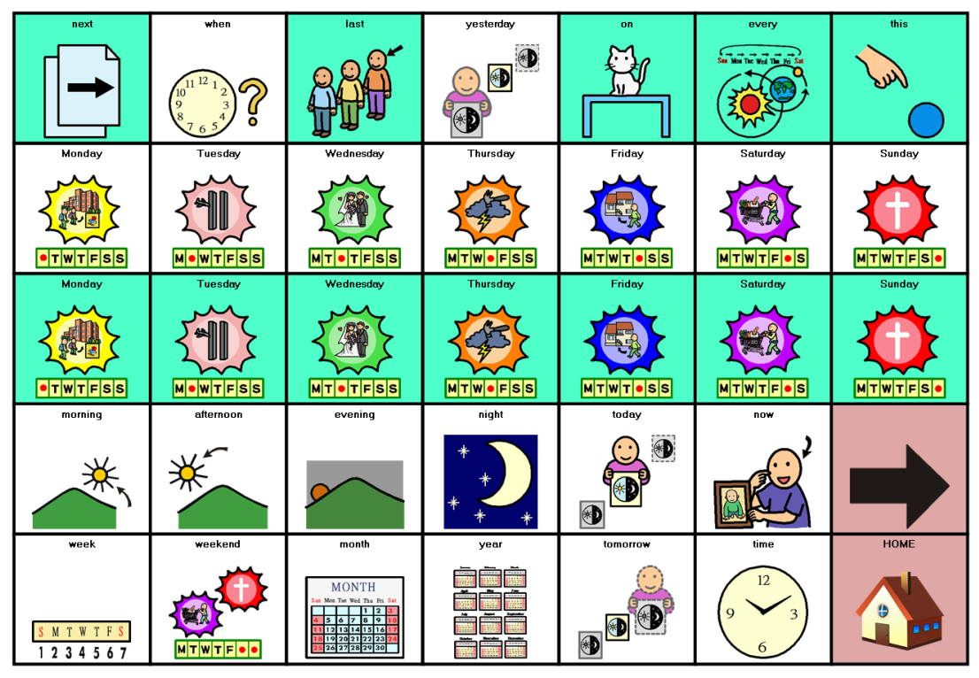

If a past tense form is used (last Friday night, yesterday) SmartAAC will automatically move to the past tense verb form (Last Friday night I went shopping) following a pronoun selection.

SPELLING

There may be an occasion on which a particular word is required which is either not stored in SmartAAC or cannot be located. If the Learner is literate then the Spelling pages may be utilised to spell out the particular word required. The Spelling pages are reached by selecting the Spelling Key from the Home Page.

Selecting the Spelling key moves the system to the Spelling Pages. There are three pages; one for letters, one for numbers, and one for punctuation. Uppercase letters can be achieved by either selecting the CAPS key or by selecting the Shift Key. The keyboard is NOT QWERTY as there was not enough space for this type of layout. On returning to the Home Page after a word has been typed, the system will speak out the word. Presently there is no word prediction to accompany spelling within SmartAAC.
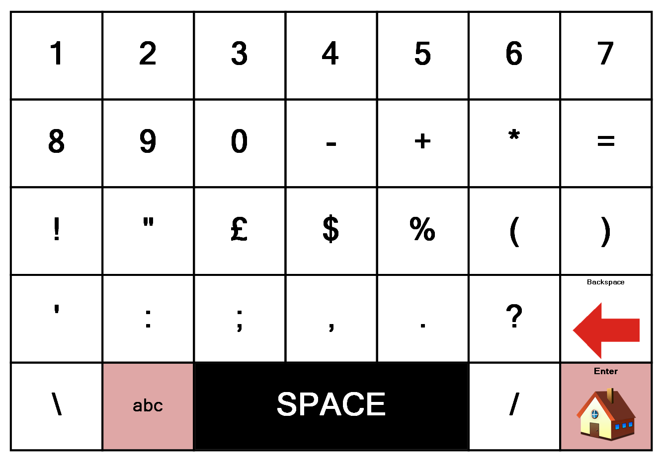
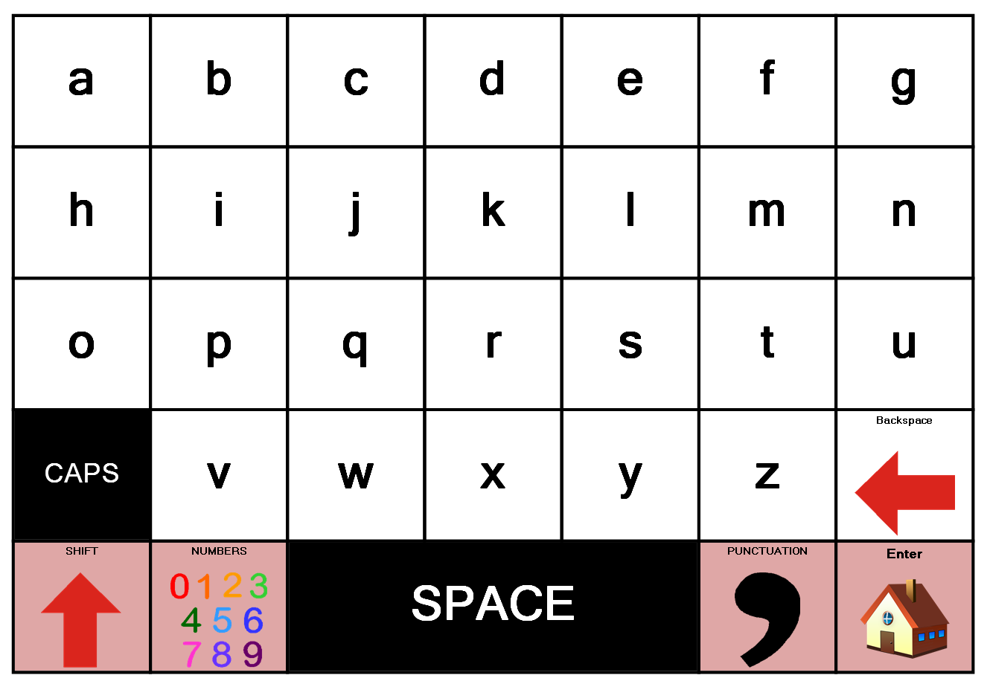

IMPLEMENTATION

Where did it all go wrong?

The field of AAC is growing rapidly. There are a plethora of systems in the marketplace and undoubtedly there are more waiting to enter. For example, there are over 250 systems presently for the iPad alone. The figure has multiplied by a factor of five in approximately a year! There must be a suitable system out there somewhere for any Learner and, if not, it is possible to either adapt an existing system or create a bespoke one anew. Today’s issue, therefore, is one of implementation. It is usually through incorrect or poor implementation practices that systems fail. However, the blame for failure in acquiring new AAC skills is often directed at:

- the person using the system (He’s not motivated. She’s just lazy. They’ve got learning difficulties.);
- the system itself (The device is too cumbersome, too big, too small. It is always breaking down. It is not loud enough ...);
- the software (Too difficult);
- the language encoding system used (Nobody understands those squiggles. It’s just too difficult for him. She can’t remember all that lot. It’s too complicated...).

However, this is rarely the case. If the person using the AAC system has been competently assessed by a qualified AAC professional and a system has been recommended on this basis, then, the reason for any subsequent failure is likely to lay in poor implementation. It is easier to place the blame anywhere but at our own feet. We must examine our working practices to see what can and what must be changed if we want to help people become efficient and effective users of AAC.

The author has spent a great deal of time ‘shadowing’ individuals (using communication systems) throughout typical days in schools, in colleges and elsewhere. This involved observation only: a strict non-interference policy was operated. Afterwards, a constructive report on the day’s observations was written which often ran into tens of pages. The one thing that noted time and time again was the number of opportunities for the development of augmentative communication that were missed.

“I took the cap, which was missing a price tag, to the register. The clerk said he was sure it cost $45, but he couldn’t ring it up without a tag. In a couple of moments, he caught the eye of a fellow employee, whom he asked to check the price. She retraced my steps to the hat table, found nothing, and came back a moment or two later, claiming she’d contacted a manager to sort things out. Another three or four minutes passed. Nothing happened. I left. It’s not the shoddy service that got my goat. It’s the missed opportunity.” (PETERS T. 1994 pp. 78 - 79)

How long will it take?

Implementing augmentative communication consumes an enormous amount of time and energy from therapists, teachers, parents and the child. This is especially true if it is an addition to the curriculum instead of an integral part of it. (BURKHART L. 1990, page 11)

The implications are that, if the children’s long-standing communication deficits are to be overcome, they will need to be involved in training for much longer than just 12 hours a week, and schools will need to make a far greater commitment to using the augmentative communication systems, not only in formal sessions but throughout the school day. (UDWIN O. & YULE W. 1991 page 160)

The final element that we need when working on communication .... is time. Many opportunities for the child to take control are sadly missed if they are not given the chance to operate at their own level and in their own time scale. For some children it may literally take minutes for them to process what has been asked of them and to create a response. (KNIGHT C. 1992 page 26)

One of the most common barriers in language training is that the teaching can be extremely time-consuming. Some people with communication disorders may take years to learn even seemingly simple skills. (VON TETZCHNER S. & MARTINSEN H. 1992)

It is easier to get an assessment and recommendations about appropriate equipment than it is to find the support and training that must be part of any plan to provide augmentative communication. Providing effective augmentative communication demands much time, sustained interest, and talent on the part of both facilitator and augmented communicator. The time commitment is both intensive and extensive, perhaps requiring many hours each week for several months. (STUMP R. 1993)

How long it will take a person to learn to use a new system is like asking ‘How long is a piece of string?’: there is no simple answer. Perhaps we should reply to the question with yet another question:

To what goal?

For, there are many goals that may be set within the individual’s timetable of tuition and study. Semantics, syntax, pragmatic skills, as well as counselling the individual and the Significant Others involved for this endeavour, all have parts to play. Whatever the goal set, it should be stressed, the path travelled will take both time and effort. Tuition in AAC cannot be ascribed to half an hour per week with an itinerant speech professional. No matter how gifted such a speech professional, this practice is doomed to failure. Nothing is gained without effort. A commitment to the effort is required by every Significant Other the Learner encounters.

To make the point about the time and effort involved an analogy is made with a child learning to play the piano (see below). Ask the staff to work through the tasks one by one. Then use their notes as a source of information for the subsequent discussion. What does it tell us about learning a new AAC system? Is there a difference between learning to play the piano and learning to communicate? A PICK analysis may help to make things clearer to all staff if they feel that there is no comparison between the two.

Sammy’s parents decide to buy their son/daughter Sammy a piano. Sammy is musically illiterate but mum and dad have a vision that one day Sammy will be a concert pianist. They take a trip to their building society and draw out all their savings. They visit the local music store and pick the best grand piano their money will buy. It is delivered the next day. Arriving home from school Sammy is blindfolded and guided into the living room. The piano is presented.

What will Sammy do? Express great surprise. Sit down at the keyboard and hit the keys randomly making a great noise.

How long will Sammy do this? On the first day for a long time until the novelty wears thin. On the second day for a shorter time ....

What will Sammy’s parents have to do? They will need to engage a tutor to provide lessons.

How often? At the very minimum an hour once a week. If they expect Sammy to become a concert pianist then more often.

What else should they do? Encourage Sammy to practise.

How often? Every day

For how long? Half an hour to an hour at least.

How long do professional (musicians, sports players, etc) have to practise? Hours every day.

Suppose every time uncle Fred came round he criticised Sammy for playing wrong notes every now and again. Sammy would be self-conscious in his presence and probably not play when he was around.

Suppose every time aunty Freda arrived she criticised Sammy for only playing American tunes or for the piano being slightly out of tune. Sammy would be self-conscious in her presence and probably not play when she was around.

Will Sammy begin to play tunes overnight? No! Although perhaps Sammy will learn to parrot a tune by rote in a few days.

How long will it take Sammy to become a concert pianist? A long time even if Sammy is naturally gifted at music. Maybe Sammy will never be a concert pianist although Sammy may continue slowly to improve with training and support.

Let’s change the beginning to this story. Sammy’s parents have no savings but believe Sammy to be musically gifted so they fund-raise for the money for the piano. Neighbours, friends, indeed the whole community is involved in raising thousands of pounds/dollars. Everyone works hard. The media is involved. Everyone tells Sammy how wonderful it will be when the piano arrives and how brilliant the music will be. How clever Sammy is. Charley Dikkens, owner of the Great Expectations Restaurant, throws a free party when the money is raised. Sammy gets a piano. A week goes by. The media make contact with Sammy’s parents; they want to film the beautiful music to show to the people of Hopeville. Sammy’s parents state that Sammy is not too well at the moment and will require a little more time to practise. A month goes by, then two months. People are heard to mutter under their breath, Ten thousand we spent on that darn piano and not a note.” The press discover from Nora Nosey (Sammy’s neighbour) that Sammy is refusing to play. They demand a statement from Sammy’s parents. They say that the music they have chosen is not to Sammy’s taste and it will be alright once they change from Chopin to Mozart. Later they say that the piano itself is at fault because the piano strings keep breaking. Neighbour Nora Nosey goes on record to say that Sammy was always a lazy little so-and-so who lacked motivation. The following week it is announced that Doctor Speshelnead has examined Sammy and found that Sammy is suffering from a rare disease - Music Inept Syndrome with Total Absence of Kinaesthetic Experience (more commonly known by the acronym MISTAKE). He states,

Sammy’s MISTAKE is a rare congenital condition affecting the right musical hemisphere of the cerebrum. A person with such a condition can hardly be expected to produce any sort of musical sense.”

Sammy’s piano is given to the Hopeville Amateur Music Society for others to use.

What did all the hype do for Sammy? It raised Sammy’s expectations.
What is wrong with that? Nothing - if the expectations are realistic.

The beginning of the story changes again. The good people of Hopeville raise the money for the piano. However that is all they raise. Nobody considers the cost of piano lessons. Sammy needs many such lessons especially when the MISTAKE is discovered. Specialist lessons cost extra. Sammy’s parents are not wealthy. Sammy’s school could give the lessons but staff report that they are too busy with the demands of the curriculum. The demands of the curriculum are indeed high. Sammy does not get the number of lessons needed. Sammy does not play well. The staff say she is unmotivated and lazy. They criticise her poor playing. They keep her away from the piano. Doctor Speshelnead says it is the MISTAKE that is the problem and suggests transferring her to a school which specialises in MISTAKES. They are thought to have a magical solution .....

There is yet an additional twist to this tale. Sammy’s piano tutors believe that a full keyboard will be too much for Sam to cope with. They remove all but 8 keys in an effort to make it easier. Sam finds s/he can only play very simple tunes! (See JACKENDOFF R. 1993 chapter 13). The tutors comment that Sammy only plays simple tunes because of the MISTAKE.

Questions

The following are some of the frequently asked questions that have occurred during presentations of SmartAAC to a variety of audiences.

Is SmartAAC available in other languages?

No, sorry, not at the present time. It is not simply a matter of translating all the words on each of the pages as grammar rules in other languages can be very different from those of English.

Is SmartAAC available with other symbol sets?

No, sorry, not at the moment although it is possible to change the symbols yourself but this would take some time to do. In the future we are looking to provide an automated symbol change system which will allow a facilitator to exchange all the symbols for those from another set.

Will there be additional versions of SmartAAC available with smaller or larger grid sizes?

This is a possibility but, at present, it is only available in the 35 cell location size. If this proves successful then investment will be made in provision of other overlay structures.

Can I change the background colours throughout the system in a single action?

No, sorry, that is not possible presently. The colours represent a modified Fitzgerald colour coding system. However, it is possible to change the colours of individual cells in the basic editing version and whole groups of cells in the full editing version.

Is there a keyguard for the system?

Please contact your local dealer to see if this is available.

Can the system be accessed via switches?

Some versions of the system can be accessed by scanning through the use of switches. Please contact your local dealer to enquire about availability.

Can I add my own pages to the system?

It depends on which version of the system has been acquired. In the basic editing version the answer is no but in the full editing version it is possible to add extra pages.

Can I sing with the system?

Yes, you can play any MP3 file or record a voice singing a song.

Can I swear with the system?

Not presently other than such simple things as ‘bloody hell’. Swearing is a controversial issue and, as such, it was decided not to include pages of expletives although the author does support the right of an individual to swear and to freedom of speech. However, it is possible to add expletives to any page as required even in the basic editing version.

Can I book training in the system for my establishment?

Yes, please contact your local dealer. There is a charge for this service.

Can it say ‘I shopping’ rather than ‘I go shopping’ or ‘I want to go shopping’ as my Learners are not at the stage when they can build such complex structures?

The simple answer to this question is no. The system will not predict shopping after the use of ‘I’. I do not believe there is any system ‘out there’ that will predict ‘shopping’ after the use of ‘I’. If a Learner is selecting ‘I’ from a communication book and then moving to another page containing ‘shopping’ and selecting then there are a number of issues that follow:
- Such a Learner should be capable of learning ‘I go shopping’ which is possible from the system.
- Why is deviant language being accepted and encouraged? Surely no system should promote this? If a communication board was simple and both ‘I’ and ‘shopping’ were contained words then, most people would understand a Learner’s use of the two together. However, while functional communication is a stepping stone on the route towards language, it should not be seen as an end in itself (although it is understood that some Learners may not progress beyond this point because of time constraints). Deviant language forms should never be completely accepted and encouraged (however, it does NOT follow that they should be punished and or criticised) but, rather, Learners should be shown acceptable alternatives which are equally as simple (‘go shopping’ for example).
- While accepting deviant structures is acceptable within a framework of creating a responsive environment (see for example the work of Jean Ware) the intention is always to progress beyond this point and not simply to stop once this is achieved.
- A predictive system cannot predict deviant forms by definition. If, after ‘I’ was selected, a page full of words which didn’t follow ‘I’ in everyday communication appeared there would be lots of complaints! Furthermore, the possible number of deviant structures is infinite and, as such, unpredictable.
- The system can be modified by the facilitator to enable such a construction to be made. However, we would advise against it in favour of teaching a more acceptable language form.

Can I change the page links such that a particular prediction is provided?

Yes you can do this within the full editing version of the system. However, if you have the basic editing version this is not possible.

How do I know if a particular word is contained in the system?

Consult the system dictionary. This contains all the vocabulary that has been stored together with the page references.

Editing SmartAAC
Basic Editing on the iPad

Setting Preferences
A range of preferences may be set by entering the Preference Mode from the top of the Selection Screen.

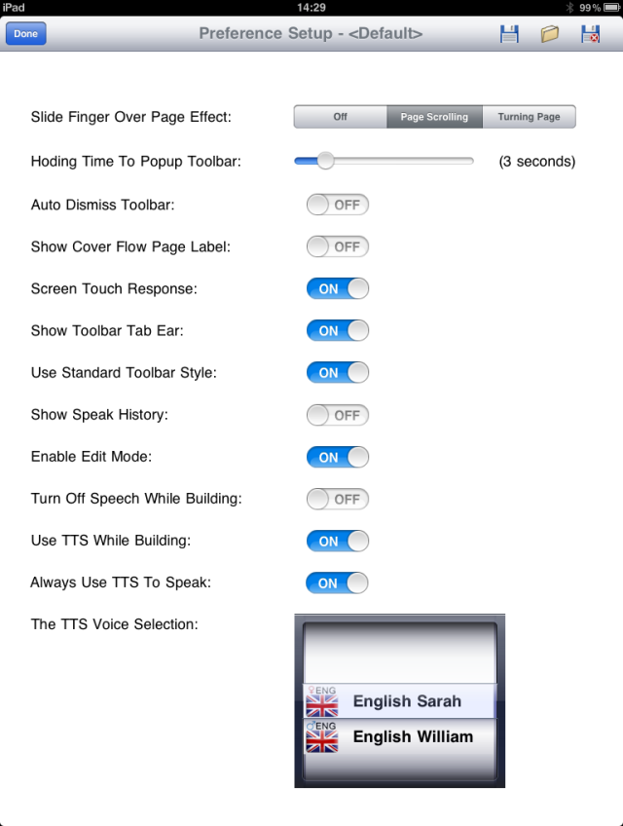
The following preferences may be set:

Slide finger over page effect:
Off /Page Scrolling /Turning Page. Some learners may require this to be in the OFF position to prevent accidental turning of pages.

Holding Time to Pop Up Toolbar:
The toolbar may be accessed by a continual screen activation which may be set using the slider bar. Used in conjunction with other toolbar features (see below) the toolbar can be hidden from all Learners.

Auto Dismiss Toolbar:
The toolbar can automatically hide itself when not required if this feature is set to ON

Show Cover Flow Page Label:
Cover flow page label shoud be set to off for SmartAAC

Screen Touch Response:
This provides additional feedback when a cell is selected through shading of the chosen cell. It is not necessary to have this feature turned on.

Show Toolbar Tab Ear:
The toolbar tab may be hidden such that Learners cannot accidentally (or otherwise) activate it. This should be used in conjunction with the hoding time feature above.

Use Standard Toolbar Style:
There are two toolbar styles available: the blue bar across the bottom of the screen (non standard) and a page view (standard) which is activated by sliding the tab with the finger. It is a matter of personal preference as to which is selected.

Show Speak History:
Records eveything that is spoken using the system. As this feature can be intrusive on a person’s privacy it can be turned off and no recording made.

Enable Edit Mode:
Edit mode is detailed below. To add the Edit Mode icon to the toolbar ENABLE the edit mode.

Turn of speech while building:
Some people prefer to construct a sentence and then speak it out as a whole. Thus, a preference can be made to turn off speech for individual word selections and to only speak when communicating as whole.

Use TTS while building:
There are four voices within the system: two male and two female. Two of the four are recordings of real people and the remaining two are Text To Speech computer voices. Using TTS while buiding ensures that EVERY word is spoken as the real people recordings may not contain the sound file for every word selected especially if the word is not commonly used.
Always use TTS to speak:
The system is locked into Text To Speech mode which ensures that everything is spoken with the same vocie and no word remains unspoken.

TTS Voice Selection:
Select either the Male or the Femal voice for TTS use.

Done:
Select ‘Done’ from the top of the Preference Setup Screen when options have been set. Options will remain set even when iPad is turned off.

Toolbar
All Unlimiter products working on the iPad system presently share the same tool bar. However, some features on the toolbar may be specific to a particular application. The toolbar can be accessed by activating the red tool icon tab in the bottom right hand corner of the screen (or sliding the tab ear up the screen in Standard Mode). The toolbar may contain any of the following elements:

Exit: Exit the current application and return to the selection screen.
Home: go to the home page of the current application.
History P: Go to previous screen.
History N: Go to the Next Page.
Del Last: Delete the last selection.
Clear All: Clear the text screen.
Speak: Speak All that has been written since last clear.
TTS: Use Text To Speech
Language: Change into another language
Keyboard: Call up the on screen keyboard.
Edit/Finish: Enter/Exit Edit Mode. See below.
Red Tool Icon: Open close the tool bar

Edit Mode
Edit mode permits basic editing of existing applications. For example, an image on a cell may be replaced with another or the text may be amended.

Entering Edit mode
Edit mode is enter by selecting the ‘Edit Mode’ icon from the blue toolbar. On entry, the screen will dim and the frame surrounding the cells will change to red.

Selecting a cell to edit
Touch the cell to edit. The edit mode box (as shown) appears.

Edit mode box
The Edit Mode box permits the editing of key features of the selected cell. The following items may be edited:

Text to be spoken:
To alter the text on any cell, simply type in the new text to be displayed and spoken in the window provided. Tap the text box to open the keyboard.

Image for Cell:
Tap the window and an iPad navigation window appears. Select the item to be displayed. A symbol or image or photograph may be added to any cell. The image will retain its original proportions. However, an image may be stretched by using the two finger iPad technique within the edit window.

Play Sound / Movie:
Three options appear when this box is selected – sound / record / movie. Sound allows an .mp3 file to be attached to a cell such that the cell when selected will play the sound file (music, song, etc). Record permits the recording of a message. The recorded message will be spoken when the cell is selected. Movie allows a video to be attached to any cell such that the video will play when the cell is selected. It is possible to take a video with the iPad and then attach it to a cell within Voice Symbol.

Background Colour: Select from a set palette or from the colour wheel to change the background colour of any cell.

Do not show in text bar:
Item is not written to text bar

Delete:
Delete will appear when a box has been edited and then reselected. Delete will return the box to its original state.

Leaving Edit Mode
Two things have to be completed to leave Edit Mode. The first is to select the TICK at the top left of the Edit Window to confirm the changes in settings. The Edit Mode window will be removed. To exit mode altogether and to return to Run Mode, select FINISH from the tool bar.

A common mistake is to attempt to operate the system while still in EDIT MODE! This is because it is easy to forget that edit mode must be dismissed after use by selecting FINISH from the toolbar. If an attempt is made to select a cell while remaining in Edit Mode, the edit mode window will reappear. No harm will have been done.

Full Editing

For full editing of SmartAAC, please consult the Voice Symbol manual available from your local dealer.

Appendices

Contact your local distributor for further details:

Australia

Communicate AT
Address: PO Box 389, BROOKVALE BC NSW 2100, Australia
Telephone: 02 9948 2665
Fax: 02 9948 2669
Website: www.communicateat.com.au
E-mail: Adam@communicateat.com.au

New Zealand

Zabonne Ltd
Address: 4271 Great North Rd., PO Box 69 203, Glendene, Auckland 0645, New Zealand
Telephone: 0800 351 151
Fax: +64 9 836 4668
Website: www.Zabonne.com
E-mail: sales@zabonne.com

Taiwan
Assistive Technology Engineering Lab Inc.(‘Unlimiter’)
Address: Level 5-1, No.18.1, Section 3, Ren-ai Rd., Taipei 106, Taiwan
Telephone: +886-2-2704-7620 ext.20 or +886-2-7729-7950 ext.20
Fax: +886-2-2703-5359 or +886-2-2703-4723
Website: www.unlimiter.com.tw
E-mail: Service-Unlimiter@Unlimiter.com.tw

United Kingdom
Ability World Ltd
Address: 66 Culley Court, Orton Southgate, Peterborough, PE2 6WA, United Kingdom
Telephone: 0845 47 47 245
Fax: 0845 26 97 245
Website: www.ability-world.com
Email: enquiries@ability-world.com

USA
PCI Education
Address: 4560 Lockhill Selma Rd., Ste. 100, San Antonio, TX 78249-2075
Telephone: 210-377-1999 (Local) OR 800-594-4263 (Toll-Free)
Fax: 888-259-8284
Website: www.pcieducation.com
Email: via website

STAR: Shelton Technologies and Resources
Address: 213 E Bay St., Lakeland, FL 33801
Telephone: 863-603-7827
Fax: 863-603-0255
Website: www.staraac,com
Email: info@staraac.com

